Press release
Düsseldorf, 13/03/2025
Between rising costs and falling demand: Causes of the supplier crisis
The crisis in the automotive industry is affecting not only manufacturers but, in particular, suppliers. Even well-established companies are struggling when orders decline, material and energy costs rise, and major customers adjust their supply chains. A Czech plastics supplier was forced to cease production—now, around 150 high-quality machines are being auctioned off due to insolvency.
The European automotive industry is undergoing a transformation. Manufacturers are facing increasing cost pressures, fluctuating market demand, and the challenge of balancing electromobility, new environmental regulations and changing customer expectations. However, it is the suppliers who are being hit hardest: barely a week goes by without reports of declining revenues, job cuts, plant closures or insolvencies.
Why are even versatile suppliers affected?
It is not only companies producing traditional combustion engine components that are struggling—even specialised businesses with a broad product range or drivetrain-independent parts are finding themselves in difficulty. The crisis can be attributed to several factors:
- Declining revenue
In the automotive industry, OEMs set the pace: manufacturers often pass on their cost increases to suppliers. When they cut back production—whether due to fluctuating demand, rising costs or shifting market conditions—suppliers feel the impact immediately. Existing orders are reduced, scheduled deliveries postponed or even cancelled altogether. At the same time, some manufacturers are restructuring their supply chains, increasing in-house production or switching to cheaper suppliers.
- High energy costs
The plastics, glass and metal processing industries are among the most energy-intensive sectors. The sharp rise in electricity and gas prices has significantly increased production costs. Many companies struggled with the sudden surge in energy prices following the Ukraine war, facing financial burdens that continue to affect them today.
- Market pressure on small and medium-sized enterprises
The automotive industry relies heavily on small and medium-sized suppliers. While large corporations have financial reserves and greater negotiating power, smaller suppliers are particularly vulnerable. The smaller the company, the harder it is to absorb sudden drops in orders or rising costs.
- Long transition periods for new markets
Many suppliers could, in principle, shift their production to industries beyond automotive manufacturing, but such a transition takes time. Certifications, machinery adaptations and establishing new customer relationships are not immediate processes.
When companies close, high-quality machinery remains
The ongoing market shifts have already forced several automotive suppliers into insolvency. When a production site shuts down, it not only leads to job losses and the disappearance of expertise but also results in high-quality equipment entering the used machinery market.
A current example is the upcoming industrial auction following the insolvency of an automotive supplier in Linhartice (Czech Republic). The company specialised in manufacturing transparent plastic components, primarily for car headlights, but also for packaging, sanitary equipment, medical technology and electrical engineering. By 26 March, around 150 high-quality machines will be available for sale—including modern injection moulding machines, CNC deep hole drilling machines, 5-axis machining centres as well as a variety of milling and drilling machines. Interested buyers can arrange a viewing by appointment.

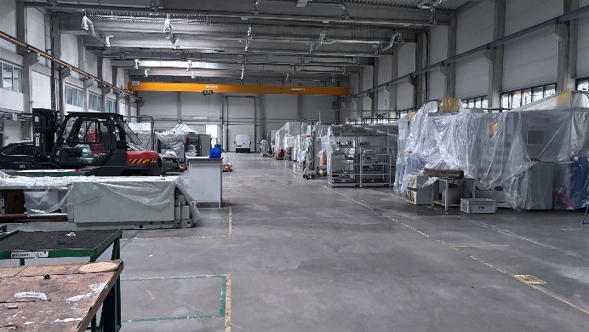 | Photo 1  The ongoing crisis in the industry: Production has come to a standstill in the hall of an insolvent automotive supplier.  (©Surplex).
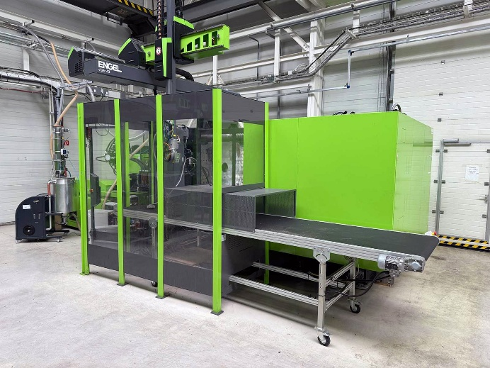 | Photo 2  The insolvency of a Czech automotive supplier has led to high-quality plastics processing machines being offered on the used market. Pictured: ENGEL Duo 2460/600WP injection moulding machine.  (© Surplex).
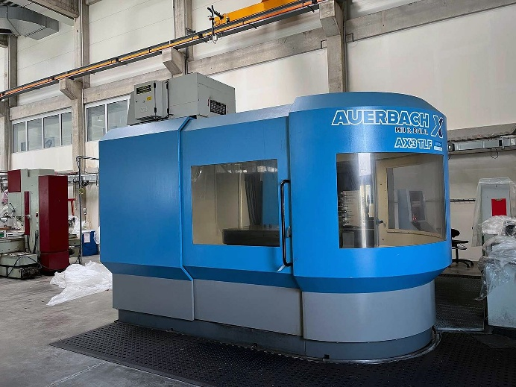 | Photo 3  Plastics manufacturers rely on precise metal processing machines for mould making—which is why this auction also includes high-quality CNC milling and drilling machines. Pictured: AUERBACH AX3 TLF CNC deep hole drilling machine.  (© Surplex).

