**New CLAAS telehandlers in the 3- and 4-tonne class feature more power and more comfort**

*Harsewinkel, August 29, 2024. CLAAS has launched five new SCORPION telehandlers in the 3- and 4-tonne class. These models feature significant improvements in comfort and convenience, as well as improved stability and more lift capacity. The new VARIPOWER 3 drive with boosted tractive force is optionally available for the SCORPION 738 and 742..*

The eight SCORPION telehandlers in the CLAAS product portfolio cover lift capacities from 3.3 to 6.0 t and lift heights from 6.7 to 10 m. Five new models with lift capacities from 3.3 to 4.2 t – SCORPION 733, 1033, 638, 738 and 742 – have breathed new life into the range with a host of performance- and comfort-boosting features designed to offer more customer benefits than ever before.

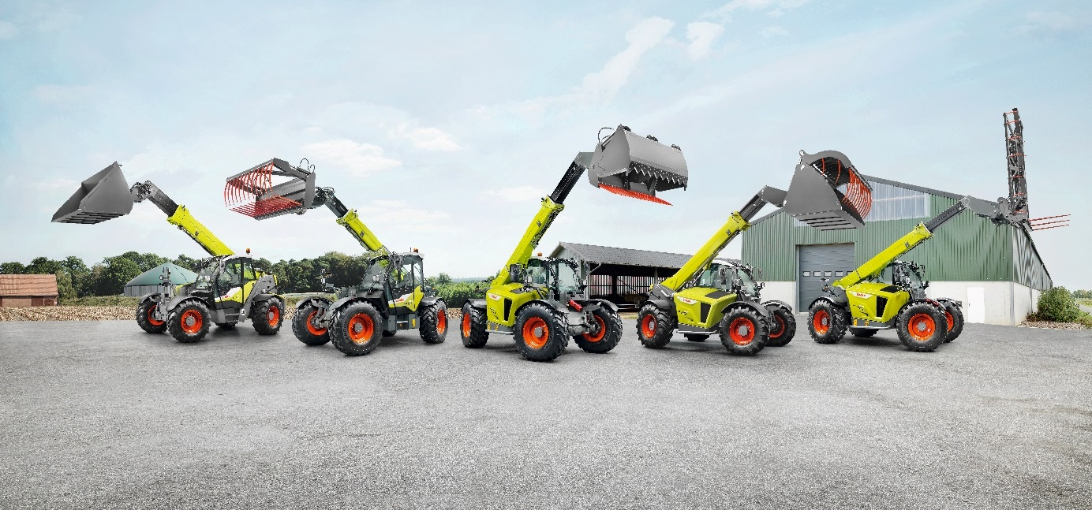

**Cleverer, stronger and more stable**

Thanks to higher hydraulic pressure, the new SCORPION telehandlers deliver up to 300 kg more lift capacity – 3.3 t in the 1033 and 733 entry models and 4.2 t in the SCORPION 742. At the same time, to ensure the customary balance and stability, the wheelbase has been increased by 100 mm, with corresponding modifications to the counterweight at the rear.

This machine class now benefits from SMART LOADING functions too, thanks to new hydraulic controls with electronic pilot control. The following automatic functions and assistance systems are now available to operators:

* *Automatic bucket return to the previously saved position: saving significant time and effort when performing repetitive tasks close to the ground.*
* *Automatic bucket shake function: the tilt rams ensure reliable emptying of clumping materials and even distribution of loose materials.*
* *Automatic retraction of the telescopic arm (not for SCORPION 1033): the mast automatically retracts as the telescopic arm is lowered – significantly reducing the operator's workload.*

The 105 kW/143 hp, 550 Nm Liebherr four-cylinder diesel engine delivers a hydraulic output of max. 160 l/m at a quiet and fuel-efficient 1,600 rpm. During loading, DYNAMIC POWER automatically adjusts the engine speed to the joystick angle and so to the desired lift and loading speed. This unique feature ensures faster, even more efficient load cycles.

VARIPOWER 2 and VARIPOWER 3: JAGUAR tractive power, applied with precision

All models are driven by the powerful and efficient VARIPOWER 2 hydrostat – the strong, effective and reliable drive that has been used in CLAAS JAGUAR forage harvesters for years. Furthermore, the new VARIPOWER 3 is optionally available for the SCORPION 738 and 742 models. With a larger dual hydraulic motor, this version transfers up to 68 kN tractive force to the wheels – an increase of round 20 per cent compared with the VARIPOWER 2 (57 kN). Despite this extra power, the drive retains its familiar fingertip precision. The VARIPOWER 2 and VARIPOWER 3 can achieve a top road speed of up to 40 km/h.

**Focus on the operator: optimised cab ergonomics and powerful air conditioning**

The cab in the SCORPION 733 - 742 has had a complete make-over. The first thing you notice is the external safety guard. Then the partially glazed access door, which swings open by a full 180 degrees and features a quarterlight to improve cab ventilation. New compartments and cargo nets provide ample storage space on the inside of the door. Furthermore, sound insulation in the door has been increased to reduce noise levels in the cab.

The redesigned steering column makes accessing the cab easier and also creates more foot room for the operator. The height and angle of the steering wheel can be fully adjusted to perfectly accommodate the operator's needs. The display is now positioned above the steering wheel, making it easier to read. The suspended brake/inch pedal with larger tread surface improves foot ergonomics and ensures an optimum foothold. The relocated pedal also makes it easier to remove the floor mats for cleaning and replace them.

To the right of the steering wheel is the repositioned and resigned dashboard with a 3.5-inch colour screen (optional 7-inch screen). In front is a handy smart phone shelf and to the left, the new control unit for the heating and air conditioning system. The temperature and now the fan too can be adjusted continuously instead of incrementally in three stages. The air conditioning unit has been replaced with a new, larger version designed to significantly improve cooling performance – ensuring that the interior remains cool at all times even on hot days.

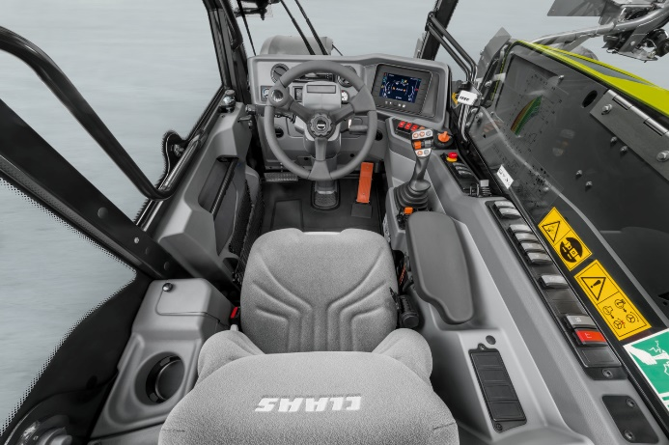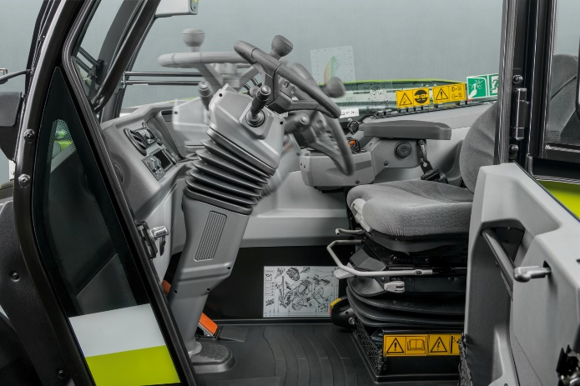

Outstanding comfort and ergonomics: the new cab with enhanced all-round view, re-arranged controls and powerful air conditioning. The joystick is handily positioned just in front of the right armrest.

The joystick has been relocated to the right of the operator's seat to further enhance comfort. The joystick and other key controls such as the controller for the speed ranges now move with the operator's seat, allowing the right arm to remain comfortably on the armrest during load cycles.

After long working days, especially as the nights start drawing in, an extra LED headlight on the left-hand A pillar with Coming Home function provides additional safety when parking up in poorly lit areas. Before parking the SCORPION, the driver presses the Coming Home activation button once and the headlight stays on for an additional 60 seconds after the engine has been switched off to illuminate the area on the left side of the machine. So even in the dark, the driver can close the cab door and leave safely.

**Practical features to make the working day easier**

Another new feature is the pressure relief button on the left of the rear light bracket. One press is all it takes to depressurise the rear connections – making it easy to insert and remove hydraulic connectors.

SCORPION can be fitted with a range of practical additional equipment for cleaning and maintenance. Models fitted with air brakes have a connection for an air blow gun by the cab step. So soiled areas can be cleaned and blown out away from the machinery shed or yard. Talking of cleaning, a brush and shovel holder can be factory-fitted at the rear on the left-hand side for carrying up to two items. On the opposite side, there is room for a removable 5 l water tank for quick on-site hand-washing.

**Key new features at a glance:**

* *Five new SCORPION with 3.3 to 4.2 t lift capacity and 6.7 to 10 m lift height.*
* *Designed for faster, more efficient load cycles.*
* *Longer wheelbase, modified counterweight and larger steering lock ensure maximum stability for increased lift capacities without compromising manoeuvrability.*
* *DYNAMIC POWER for efficient engine speed management.*
* *SMART LOADING for convenient automation and operator assistance across a wide range of applications.*
* *Optional VARIPOWER 3 drive for SCORPION 738 and 742: 20 percent more tractive power for the most demanding tasks. New cab with optimised ergonomics: slender steering column with adjustable height and angle and suspended brake/inch pedal.*
* *New armrest with joystick integrated into the operator's seat*
* *New air conditioning system with precise temperature and fan control.*
* *Partially glazed cab door with quarterlight window, 180-degree lock and storage pockets on the inside.*
* *Additional LED headlight with Coming Home function.*
* *Practical additional equipment such as pressure relief button, water tank and brush and shovel holder at the rear.*

**You can download high-resolution images for print and web here:** <https://dam.claas.com/pinaccess/showpin.do?pinCode=IUs2JC7CGERx>

**Please note the following in your journalistic work:**

This is an international press release. The product range and feature options may vary in some countries. Please ask the CLAAS sales company or the CLAAS importer in your country in case of doubt.

**About CLAAS**

*CLAAS (www.claas.com) is a family business founded in 1913 and is one of the world’s leading manufacturers of agricultural machinery. The company, with Head Office in Harsewinkel, Westphalia, is the European market leader for forage harvesters. CLAAS dominates the European market in another core segment as well – combine harvesters. CLAAS also holds the top spots in global agricultural technology with its tractors as well as its agricultural balers and grassland harvesting machines. Cutting-edge agricultural information technology also forms part of its product range. CLAAS employs more than 12,000 staff worldwide and generated a turnover of 6.1 billion euros in 2023.*