BULLET FOR MY VALENTINE ANNOUNCE NEW ALBUM, SOCIAL APOCALYPSE, OUT MARCH 19TH VIA SPINEFARM - DIGITAL PRE-SAVE

EXTREMELY LIMITED WHITE-LABEL FIRST PRESSING AVAILABLE TO PRE-ORDER FOR 72 HRS ONLY – HERE

BAND SHARES NEW SINGLE/TITLE-TRACK ‘SOCIAL APOCALYPSE’ AND ACCOMPANYING VIDEO - WATCH

ANNOUNCE UK & EUROPEAN HEADLINE TOUR, INCLUDING AN APPEARANCE AT LONDON O2 ARENA – TICKETS
PENDULUM WILL PERFORM ACROSS ALL SHOWS AS VERY SPECIAL GUESTS
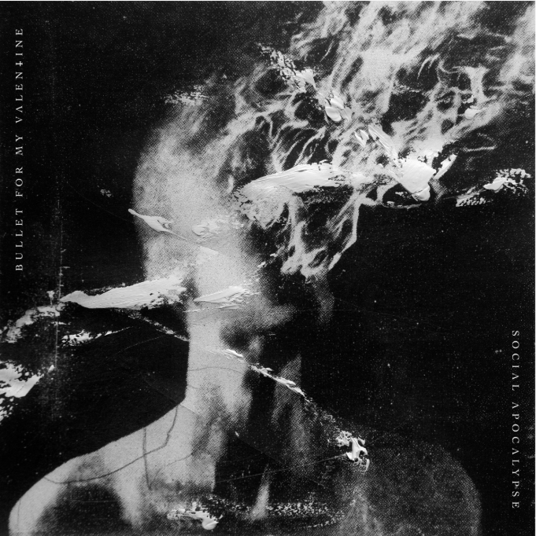
[album artwork, created by Dutch multi-media artist @Yossip]

London, Sept. 24, 2026 – Bullet For My Valentine will release their new album, Social Apocalypse, on March 19th, 2027, via Spinefarm. The announcement arrives with a towering new single by the same name. ‘Social Apocalypse’ is the band’s first new song in four years; on the title track, Matt Tuck rages against “the end of the world as we know it”, when “all hope has faded”.
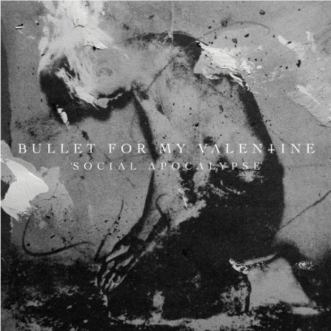
[single art, created by @Yossip]
An accompanying video for ‘Social Apocalypse’ (track) is available HERE.

Thematically, Social Apocalypse [album] combines the bare-faced lyrical introspection of people weathered and worn by the modern world with wide-eyed observations on a planet that feels as if it is coming off the rails at every turn. “Everything in life is changing at such a rapid pace, and it is hard to find a great deal of positivity when you look at events in the world,” Tuck says. “People are being pitted against each other. The world is full of conflict instead of unity. As a father, I look at what the world is like for younger people, and how completely different it is now.”
Working once more with producer Carl Bown – a veteran of four Bullet albums, alongside work with Sleep Token, While She Sleeps, Malevolence and more – each new album track was diligently scrutinised, constructed and polished to its immaculate final form. “Carl doesn’t let you settle,” Tuck notes. “He is always ready to speak up, push and challenge you to be the best version of you.”
There are two collaborations on Social Apocalypse – a rarity for Bullet that brings thrilling new dynamics to the record – with Against The Current vocalist Chrissy Costanza stepping in to duet on ‘In The Absence Of You’ and a hair-raising vocal turn from Lorna Shore’s Will Ramos on ‘I Don’t Trust Tomorrow’.

Social Apolcalypse tracklist
- Social Apocalypse
- In The Absence of You ft. Chrissy Costanza
- I Don’t Trust Tomorrow ft. Will Ramos
- Here Without You
- Acid Rain
- Fragile
- CVLT
- Masquerade
- Read Between The Lines
- Enough Is Never Enough

A very special limited white-label first pressing of Social Apocalypse [album] is available for pre-order exclusive via Ceremony of Roses, HERE, for 72 hrs only. For digital listeners, you can now pre-save the album HERE.
Then, on September 28th, a full range of offerings go on pre-sale, including standard and deluxe vinyl variants and a signed version of the CD. Head to bulletformyvalentine.com for more information.

Bullet For My Valentine have today announced their biggest tour yet; taking in arenas all over the UK & Europe. Having sold-out The O2 arena, London, last year as part of their co-headline run with Trivium, they are now returning as the sole headline act.
Pendulum will perform as very special guest across all shows, with Dark Devine appearing as openers.
January 2027
Thu 21 Sagres Campo Pequeno, Lisbon
Fri 22 Palacio Vistalegre, Madrid
Sat 23 Sant Jordi Club, Barcelona
Mon 25 Forum, Milan
Tue 26 Hallenstadion, Zurich, Switzerland
Wed 27 Mitsubishi Electric Halle, Dusseldorf
Fri 29 Sporthalle, Hamburg
Sat 30 K.B. Hallen, Copenhagen
Sun 31 Annexet, Stockholm

FEBRUARY 2027
Tue 02 Ice Hall, Helsinki
Thu 04 MCK, Katowice, Poland
Sat 06 Zenith, Munich
Sun 07 Zenith, Paris
Tue 09 Rockhal, Luxembourg
Thu 11 Festhalle, Frankfurt
Fri 12 Hanns-Martin-Schleyer-Halle, Stuttgart
Sat 13 Stadthalle, Vienna
Mon 15 Budapest Arena, Budapest
Tue 16 O2 Universum, Prague
Wed 17 Velodrome, Berlin
Fri 19 AFAS Live, Amsterdam
Sat 20 Forest National, Brussels
Tue 23 Glasgow OVO Hydro
Thu 25 Birmingham bp pulse LIVE
Fri 26 London The O2
Sat 27 Manchester AO Arena

Bullet For My Valentine
+ Very Special Guest Pendulum
+ Dark Divine

UK tickets go on-sale Wednesday 30th Sept @ 9am here: http://myticket.co.uk/artists/bullet-for-my-valentine

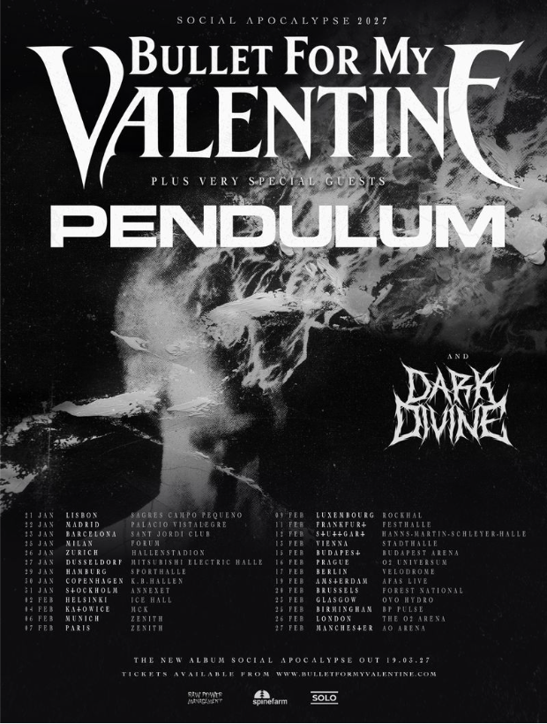

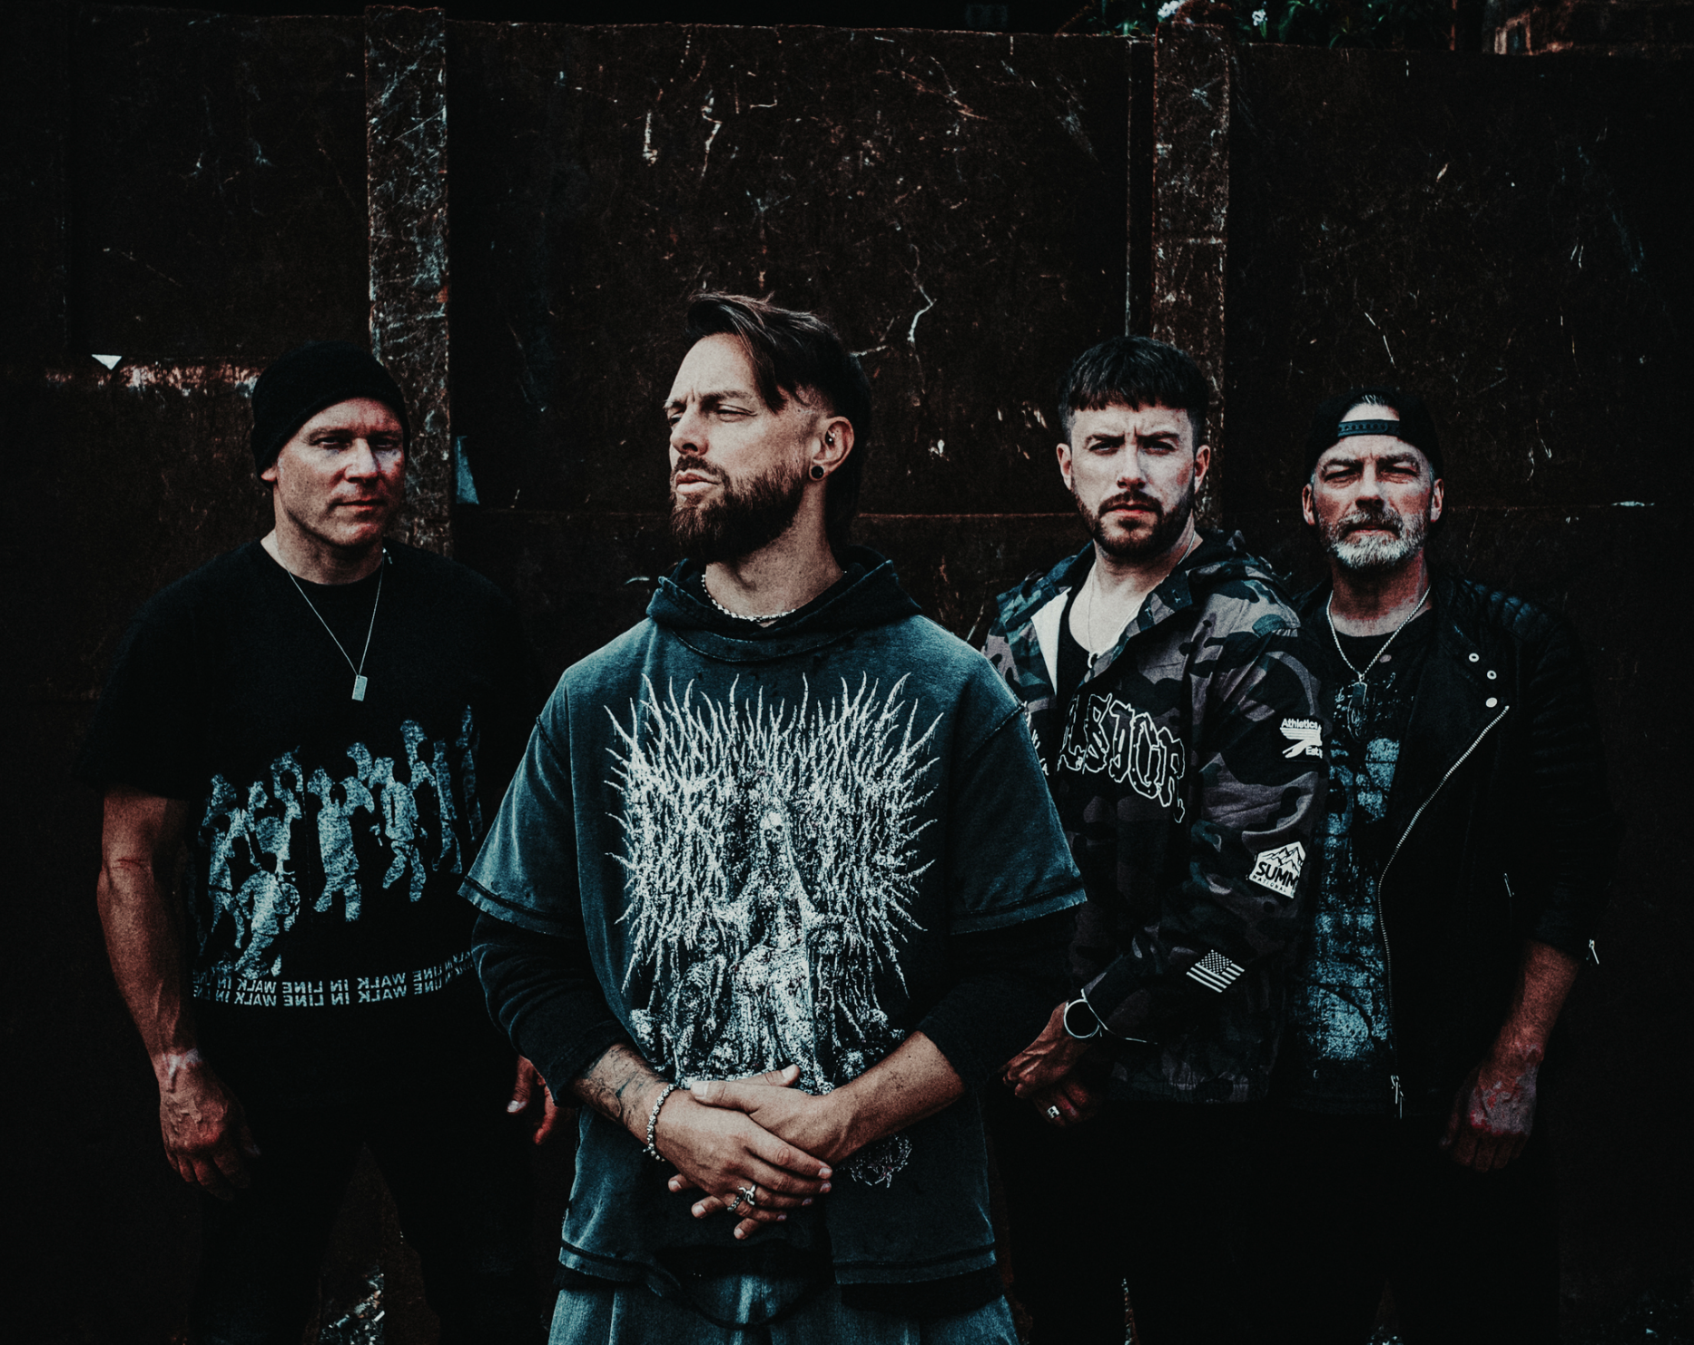
Photo credit: Federica Burelli
# # #

Matt Tuck describes the creation of every Bullet For My Valentine album as a “journey”. Each, the frontman attests, is about capturing the essence of a moment in time; a freeze-frame snapshot of its creators and the world around them. Nothing forced, nothing scripted, nothing disingenuous. Such purity of creation is a methodology that has led to Bullet For My Valentine establishing themselves as one of Britain’s all-time most celebrated rock and metal exports. A truly global phenomenon, their multimillion album sales, multibillion streaming numbers, a glut of awards and regular appearances on the biggest stages across the globe remarkably only go some way to telling the story of their influence and impact.
The culmination of those experiences and achievements is writ large across ‘Social Apocalypse’, their eighth full-length album, which comprises a lifetime’s learnings and inspirations and definitively captures every facet of the Bullet For My Valentine sound in masterfully-honed results. Reminiscent of the band’s storied past without ever being repetitive of it, it’s with a steely-eyed determination to break new ground that the beloved hallmarks of Bullet For My Valentine past and present are now refocused and reenergised for the future.

# # #
Bulletformyvalentine.com
Instagram.com/bfmvofficial
Facebook.com/BulletForMyValentine
tiktok.com/@bfmvofficial

