**Embargoed until 22nd January, 10AM GMT**

**RÖYKSOPP ANNOUNCE *TRUE ELECTRIC***

**OUT 11TH APRIL 2025**

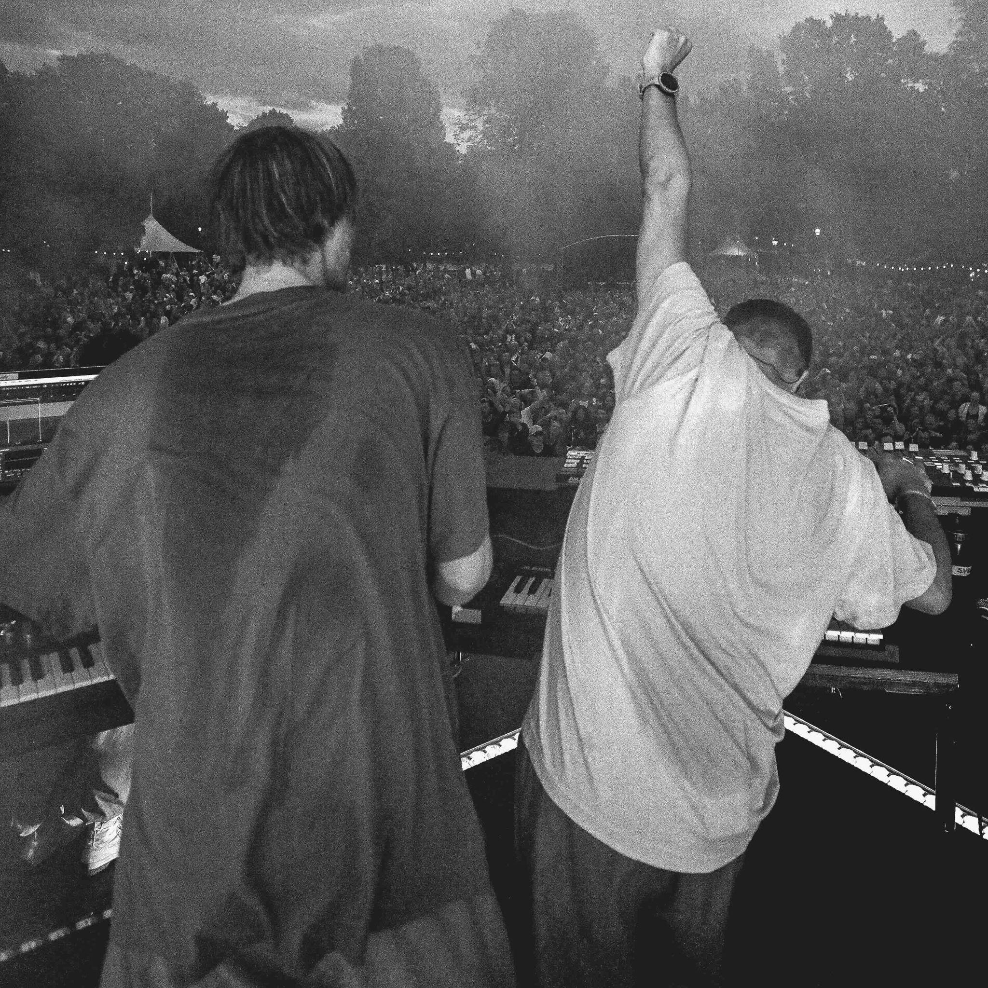

*True Electric* artwork *h*[*igh res*](https://www.dropbox.com/scl/fo/o2k1x2g3apqbyd2nyncs5/AFUyDmjJfPE0XrTGHPzeD2Y?dl=0&e=1&preview=TrueElectric-AlbumArt-Digital_NoSticker.jpg&rlkey=r3e9jpvepc5y8br0gkwkrtsp0&st=p2ox9l62)

**ACCLAIMED NORWEGIAN DUO BRING THEIR *TRUE ELECTRIC* LIVE SHOW TO THE TRIPLE LP FORMAT**

**ACCOMPANIED BY THRILLING NEW TAKE ON CLASSIC**

***WHAT ELSE IS THERE?***

***(FT. FEVER RAY) [TRUE ELECTRIC]***

***(WATCH HERE)***

**U.S DATES ADD TO *TRUE ELECTRIC-*DJ WORLD TOUR**

Following the surprise December 2024 release of Röyksopp’s ambient album [*Nebulous Nights (An Ambient Excursion into Profound Mysteries)*](https://royksopp.lnk.to/nebulous-nights)*,* the acclaimed electronic duo of Svein Berge and Torbjørn Bruntland begin 2025 with details of a new album, *True Electric,* due outon 11th April 2025. Pre order *True Electric*.

Svein and Torbjørn introduce the *True Electric* album project with *What Else Is There?* (ft. Fever Ray) [True Electric], a pulsating, intense new version of the classic Röyksopp track from their 2005 album, *The Understanding.* A high-energy visualiser edit for the single, directed by regular Röyksopp collaborator Stian Andersen, was recorded on location at the band’s 2023 *True Electric* show in Athens featuring the live show in full kinetic flow.

*True Electric gathers together* 19 studio versions of the music from Röyksopp’s *True Electric* tour in 2023, featuring previously unreleased track *The “R”* as well as newly-reworked versions of originals and remixes taken from their acclaimed catalogue. These include the celebrated Robyn collaboration *Do It Again* featuring Robyn *(from the 2014 Röyksopp & Robyn EP Do It Again )* and *Running To The Sea* featuring Susanne Sundfør *(from the 2014 Röyksopp album The Inevitable End)* as well as several tracks from their critically acclaimed *Profound Mysteries* creative universe that resulted in three albums released across 2022.

Speaking on the album, Svein and Torbjørn explain:

*“****«True Electric» consists of recordings and renditions, meant to capture the essence of our live shows bearing the same name. The idea was to put an emphasis on the clubbier aspects of our music, as well as returning to our roots within the realms of electronic music.”***

*True Electric* will be released on streaming platforms on 11th April. Physical versions across limited edition 3LP vinyl w/ fold-out poster and 2CD w/8 page booklet will arrive on 9th May. LA-based art director [Christina Huang](https://cxlhuang.com/) was commissioned to design the album which features photography from Röyksopp’s Tflorencerue Electric tour by Stian Andersen and Suie Le.

Röyskopp have also announced nine new dates across the U.S, as part of their DJ world tour, including Elsewhere, New York on 17th May and The Fonda Theatre, Los Angeles on 23rd May. Röyksopp play HERE at Outernet, London on 21st February.

**U.S ticket sale details:**

Artist Pre-Sale & Sign-Up Registration - Wednesday, January 22nd, 2025 @ 10am PST/1pm EST

Pre Sale - Thursday, January 30th, 2025 @ 10 am Local

General On Sale - Friday, January 31st, 2025 @ 10 am Local

*\*\*All presales end Thursday, January 30th @ 10pm local time*

**True Electric DJ dates (U.S dates announced in bold):**

​​Fri 24 Jan 2025 BASE Milano, Milan

Sat 25 Jan 2025 Lula Club, Madrid

Thu 6 Feb 2025 CITY RECITAL HALL, Sydney

Fri 7 Feb 2025, Melbourne Pavilion, Melbourne

Sat 8 Feb 2025 Perth Festival, Perth

Fri 21 Feb 2025 HERE at Outernet, London

Sat 22 Feb 2025 Paradiso, Amsterdam

Fri 28 Feb 2025 Ritter Butzke, Berlin

**Thu 15 May 2025 CODA, Toronto**

**Fri 16 May 2025 Metro, Chicago, IL**

**Sat 17 May 2025 Elsewhere: Rooftop, Brooklyn, NY**

**Fri 23 May 2025 The Fonda Theatre, Los Angeles, CA**

**Sat 24 May 2025 ReelWorks Denver, CO**

**Sun 25 May 2025 ZeyZey, Miami, FL**

**Fri 30 May 2025 The Regency Ballroom, San Francisco, CA**

**Sat 31 May 2025 The Concourse Project, Austin, TX**

**Sun 1 Jun 2025 It'll Do, Dallas, TX**

All live tickets here

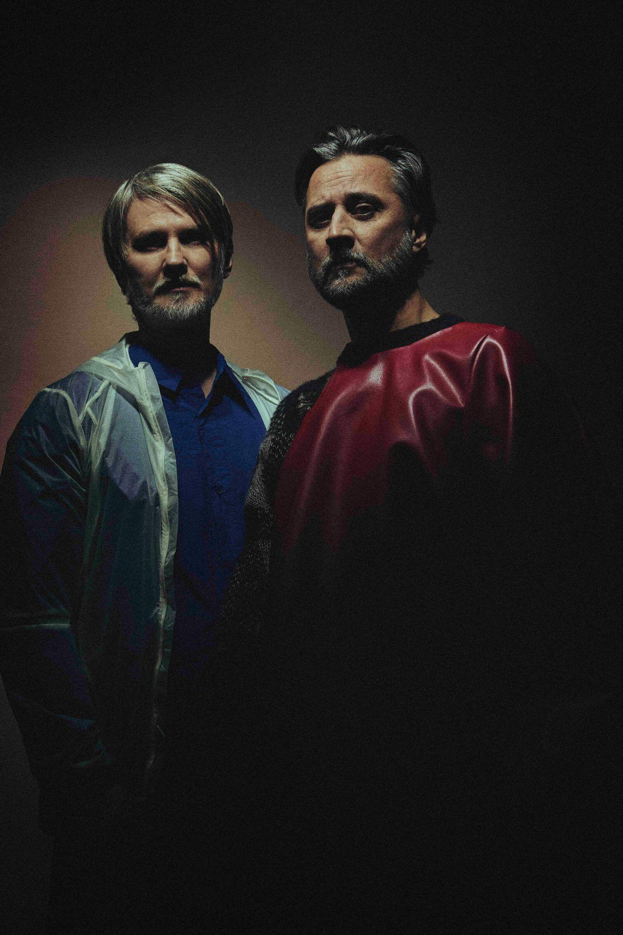

[*Photo credit: Stian Andersen*](https://www.dropbox.com/scl/fi/2n3mefl5zvgaiulx9hg8q/Rxyp-November-20240781.jpg?rlkey=dut1kcw40jk2glyl4be6vpz5c&st=62ojziwm&dl=0)

***True Electric* tracklisting:**

1. The Ladder [True Electric]
2. Impossible (ft. Alison Goldfrapp) [True Electric]
3. This Time, This Place (ft. Beki Mari) [True Electric]
4. The Girl And The Robot (ft. Robyn) [True Electric]
5. Here She Comes Again (ft. Jamie Irrepressible) [True Electric]
6. Monument (ft. Robyn) [True Electric]
7. Oh, Lover (ft. Susanne Sundfør) [True Electric]
8. Unity (ft. Karen Harding) [True Electric]
9. You Don't Have A Clue (ft. Anneli Drecker) [True Electric]
10. The "R" (True Electric)
11. Breathe (ft. Astrid S) [True Electric]
12. Running To The Sea (ft. Susanne Sundfør) [True Electric]
13. What Else Is There? (ft. Fever Ray) [True Electric]
14. Never Ever (ft. Susanne Sundfør) [True Electric]
15. Sordid Affair (ft. Man Without Country) [True Electric]
16. I Had This Thing (ft. Jamie Irrepressible) [True Electric]
17. Feel It (ft. Maurissa Rose) [True Electric]
18. Do It Again (ft. Robyn) [True Electric]
19. Like An Old Dog (ft. Pixx) [True Electric]

[Facebook](https://www.facebook.com/Royksopp/) | [Twitter](https://twitter.com/RYXP) | [Instagram](https://www.instagram.com/royksopp/?hl=en)