**PRESS RELEASE**

**RELEASE: Thursday, 27 February 2025, 10.00 a.m**

**New brand developed for the next generation camper: NEXT - light, compact and reduced to the essentials**

* Attractive price: only 18,900 euros (in Germany)
* 1,000 kg technically permissible total mass
* Ideal for smaller towing vehicles and electric vehicles
* Wash area with WC
* Optional packages for individual requirements

*Mertingen (Germany), 27 February 2025: ‘Get in, arrive and enjoy - camping can be this easy’ - this is the motto under which a new lightweight caravan under the NEXT brand will be launched: the NEXT 380 will conquer the caravan world from 15 March 2025 with a technically permissible maximum weight of just 1,000 kg. It fits perfectly with the lifestyle of the next generation of campers for whom it was developed: suitable for small or electric vehicles, with no frills. ‘Today's generation of holidaymakers only needs a place to sleep, a cooker and a table for breakfast coffee, a washing area and space for luggage and a barbecue. The new NEXT has all of this, no more and no less, with high-quality workmanship and proven top quality,’ says Thomas Kamm, Head of Marketing and Communication at Fendt-Caravan. This is also reflected in the price: the ideal travelling companion costs just 18,900 euros (in Germany). Special packages are available for individual requirements such as an external storage hatch, bicycle rack or additional cushions.*

Conventional caravans are often too heavy for electric vehicles and small cars. With this new, particularly lightweight model, there is now a solution that adapts to the changing requirements of mobility: the NEXT 380, the first model of the NEXT brand, specially developed for the new generation of campers. The compact and lightweight caravan with a technically permissible total mass of 1,000 kg can also be towed effortlessly by smaller towing vehicles and electric vehicles and is easy to handle, whether on the campsite, in the city or on company premises. “The NEXT is an attractive option for anyone looking for innovative solutions for modern travelling. It offers enough space for two people or a small family and impresses with its well thought-out room layout,” emphasises Thomas Kamm. Functionality takes centre stage: the caravan focuses on the essentials without compromising on top-quality comfort.

**The facts in brief:**

* Living with a view: cosy seating area with large windows. The seating area becomes a third bed in a flash. Roller blinds provide protection, an LED lighting concept creates atmosphere.
* Sleeping & dreaming: Excellent bed with comfort foam mattress and dimmable LED reading light with USB-C connection, storage space under the bed.
* Cook & enjoy: 2-burner gas hob, fridge with double-sided door opening, clever storage space solutions.
* Freshen up & feel good: Integrated wash area with WC for complete independence. Plenty of space for bathroom and cosmetic items.
* Price: 18,900 euros (in Germany)

The sandwich construction with smooth sheet metal ensures high stability in the lightweight caravan. Thanks to intelligent insulation, travellers can enjoy an all-round feel-good climate inside. “During the Caravaning Days from 15 to 29 March 2025, the NEXT 380 can be viewed and inspected at participating dealers. We are very much looking forward to finally being able to present our latest development and are already very excited about the response,” says Thomas Kamm.

**Clever extras**

The requirements for the ideal camping holiday are as individual as the travellers themselves. That's why the NEXT 380 scores points with practical special equipment packages:

**Exterior package:**

External stowage flap for convenient loading from the outside, a bike rack on the drawbar and the option to increase the weight to 1,100 (NXtec 1.1 package) or 1,300 kg (NXtec 1.3 package)

Price: 1,390 euros (in Germany)

**Interior package**

Fly screen for the entrance door, hot water heater, cosy cushions and felt baskets

Price: 990 euros (in Germany)

“The NEXT brand is not only a game changer for campers, but also for retail partners. It hits the nerve of the new camping generation, is perfect for beginners and ideal for minimalists,” summarises Thomas Kamm.

**The NEXT 380 at a glance:**

First presentation during the Caravaning Days from 15 to 29 March 2025

* Price: 18,900 euros (in Germany), excluding registration costs
* Weight: 1,000 kg technically permissible total mass
* Sleeping places: 3
* Overall length: 588 cm
* Overall width: 219 cm
* Standing height: 198 cm
* Optional: Additional equipment for inside and outside

**Further information and press contact:**

Thomas Kamm, Head of Marketing and Communication

Fendt-Caravan GmbH

Industrial Park East 26

86690 Mertingen

E-mail: marketing@fendt-caravan.de

**Pictures**

Copyright: Fendt-Caravan GmbH, photographer: Stefan Stelzer

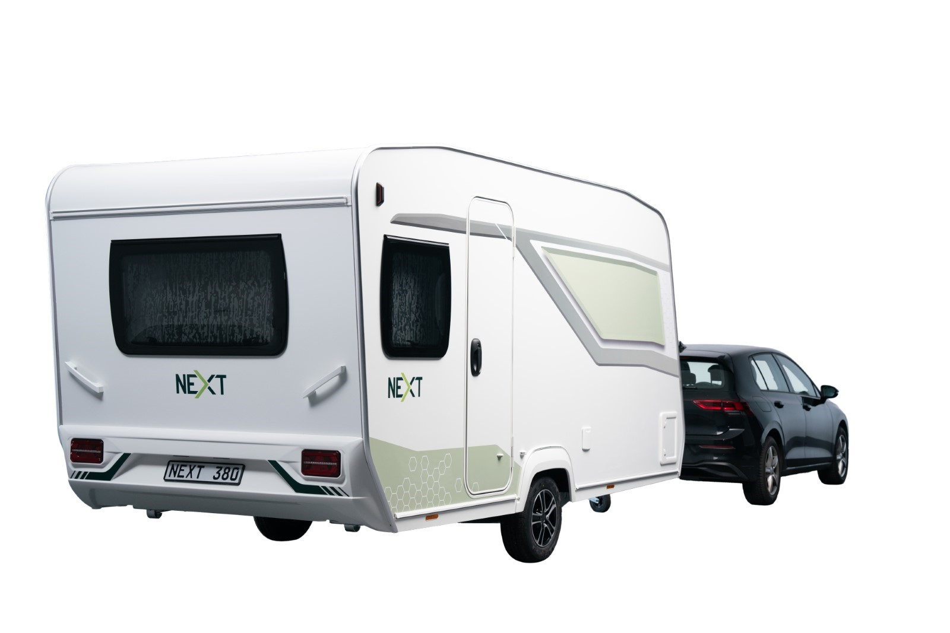

The new “NEXT” brand: With a technically permissible gross weight of 1,000 kg, the NEXT 380 Caravan can be towed by an electric car or small car.

Ein Bild, das Im Haus, Mobiliar enthält.

Cosy seating area with large windows

Ein Bild, das Im Haus, Wand, Person, Computer enthält.

Storage space with high-quality hinges and soft-close flap

Ein Bild, das Im Haus, Wand, Badezimmer, Hahn enthält.

Wash area with elegant tap and plenty of space for bathroom and cosmetic items

Ein Bild, das Küchengerät, Im Haus, Haushaltsgerät, Gerät enthält.

Chic and functional: gas hob and sink with smoked glass lid

Ein Bild, das Im Haus, Küchengerät, Haushaltsgerät, Waschbecken enthält.

Everything included: perfectly organised storage space for the kitchen

Ein Bild, das Im Haus, Wand, Decke enthält.

Top quality: ventilation in the cupboards and high-quality hinges

Ein Bild, das Im Haus, Wand, Bettdecke, Bettwäsche enthält.

Sleeping area for two with cosy dimmable LED reading lights with USB connection

Ein Bild, das Im Haus, Wand, Mobiliar, Inneneinrichtung enthält.

3rd sleeping area: the converted seating area

Ein Bild, das Rad, Reifen, Landfahrzeug, Fahrzeug enthält.

Optional: Bicycle carrier on drawbar (part of NXtec 1.1 or NXtec 1.3)

Ein Bild, das Fahrzeug, Wohnmobil, Wohnwagen, Verkehrsmittel enthält.

Optional: fly screen for the entrance door (part of NXcom)