Press release
Düsseldorf, 19/11/2024
5 reasons why the end of the year is the best time to sell machinery
Why is the end of the year the ideal time to sell unused machinery? Beyond financial and tax benefits, selling now offers a chance to free up space and budget for next year’s investments. On top of that, high year-end demand makes it easier to find buyers quickly and achieve attractive prices.
The end of the year is often a time for companies to review their financials and set the course for the coming year. Right now is the ideal moment to sell unused machinery from inventory – here are five compelling reasons to make the most of this opportunity.
Reason 1: Take advantage of tax benefits
Selling machinery before the end of the year can not only lower your tax burden but also open up targeted deduction opportunities. For industrial companies, this can optimise expenditure by strategically allocating profits and losses within the current year. This creates a clear foundation for planning investments in the new financial year.
Reason 2: Optimise year-end balance sheets
Selling unused machinery frees up capital and reduces stock – especially valuable for manufacturing companies with high machinery inventory. This step streamlines the balance sheet, improves liquidity, and provides a solid financial base for the year-end close.
Reason 3: Free up space for modern technology in the new year
Unused machinery often takes up valuable operational space. By selling it, companies can free up room to implement modernisations and production adjustments in the coming year.
Reason 4: Secure budget for new acquisitions
Selling surplus machinery can help secure budgets for new investments. Competitive companies are already planning their investments for next year.
Reason 5: Favourable market conditions for sellers
As the year ends, demand rises for machinery that’s immediately available, as many companies seek to allocate their remaining budgets to investments. Used machinery has the advantage of immediate availability, while new machinery often requires ordering and customisation. Companies seeking swift investment turn to the used machinery market, where high year-end demand makes it the ideal time to sell machinery profitably.
For this, you need a partner with the right reach. The auction houses Surplex and Troostwijk work together as a strong team across continental Europe. Sellers benefit from the region’s largest buyer network – spanning industries from metalworking and woodworking to construction, agriculture, food, pharmaceuticals, transport, and logistics.

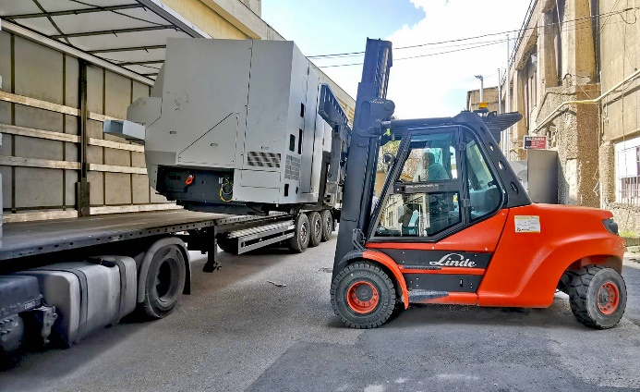 | Photo 1  Selling unused machinery at year-end frees up budget for future investments.  (© Surplex).
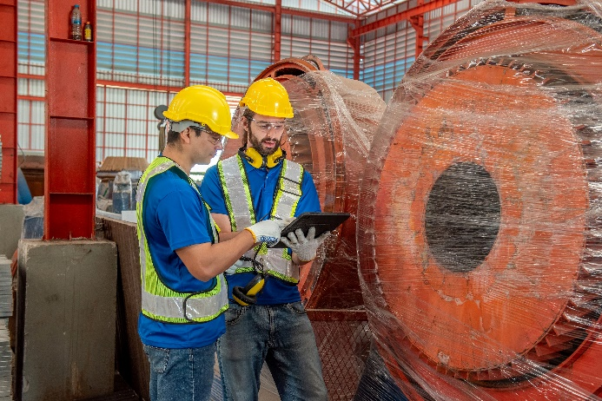 | Photo 2  Industry auction houses Surplex and Troostwijk offer the ideal buyer network for European companies looking to sell their machinery.  (© Worradirek /Shutterstock.com).

