*Chopping quality, efficiency and documentation at the highest level*

**Innovative features for the CLAAS JAGUAR: V-FLEX chopping cylinder, new PICK UP and CSPS analysis in the field**

*Harsewinkel, October 15, 2024. CLAAS has raised the bar even higher in terms of chopping quality, efficiency, reliability and comfort with the introduction of several new technologies for forage harvesters. JAGUAR customers can now take advantage of new options such as the V-FLEX chopping cylinder and CSPS analysis via CLAAS connect, as well as various improvements to the crop flow and drive provided as standard.*

The latest JAGUAR forage harvesters from CLAAS embody over 50 years of operational and customer experience with over 46,000 machines now sold worldwide. A legacy that demands systematic foresight, uncompromising customer focus and continuous technological advances. To honour our commitment, CLAAS has developed a range of market-ready innovations for the JAGUAR 900 series to make forage harvesting even more efficient, cost-effective and convenient for our customers. Feedback from pre-series customers working in particularly challenging conditions confirms that these new solutions provide impressive added value for customers.

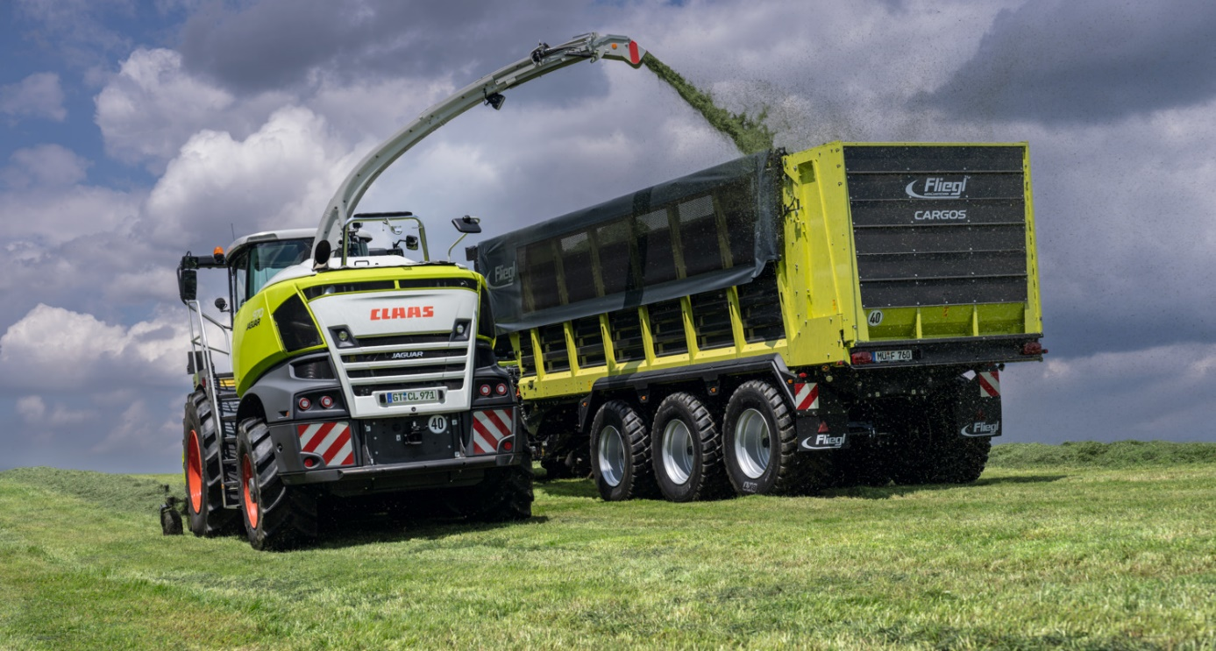

Innovative new features for the JAGUAR from CLAAS set new standards for added customer value in terms of productivity, economy and comfort.

**V-FLEX chopping cylinder for JAGUAR 900: maximum flexibility, minimum wear**

The completely redesigned V-FLEX cylinder marks a new milestone in chopping cylinder technology. Available as an optional alternative to the V-MAX chopping cylinder, it offers unrivalled versatility when it comes to knife configuration.Together with the new V-FLEX knives, it sets new standards for smooth running and knife service life. In addition, it enables high throughputs and further enhanced chopping quality.

Until now, CLAAS JAGUAR forage harvesters have operated with the tried and tested V-CLASSIC (JAGUAR 800) and V-MAX (JAGUAR 900/900 TERRA TRAC) chopping cylinders. With the launch of the V-FLEX, another optional cylinder is now available for the JAGUAR 900/900 TERRA TRAC series. The new design with optimised V-angle and the new V-FLEX knives enable this chopping cylinder to achieve higher throughputs while at the same time reducing the noise level and ensuring smoother running. Crop flow is noticeably more consistent, especially for chop lengths over 12 mm. High knife stability and the triple bolted connection also means that the distance between the cylinder and the shear bar can be reduced to achieve even better chopping quality. All these improvements also deliver greater efficiency: with further reductions in fuel consumption per tonne of throughput.

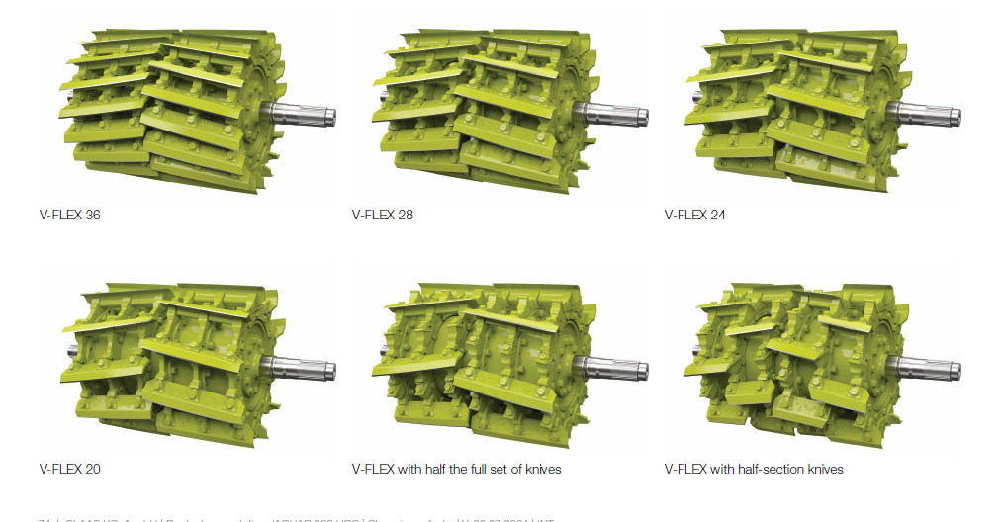

The new V-FLEX chopping cylinder offers unparalleled versatility for all applications and chop lengths with a full and half set of knives as well as half-knives.

The V-FLEX chopping cylinder is available in four versions with 20, 24, 28 and 36 knives and can be configured with a full set of knives, or half or one third the number of knives to extend the length of cut, or with a half knife set. With the V-FLEX 36, for example, this enables a flexible configuration with 36 knives in full-knife mode, 12 knives in the one-third-knife mode, 18 knives in the half-knife mode or with the new variant with 36 half-knives to double the length of cut for optimum crop flow and outstanding chopping quality. The V-FLEX 20, 24, 28 and 36 therefore provide a unique, universal length-of-cut range from 3.5 to a maximum 53 mm. All chopping cylinders can be used for harvesting maize in combination with the MCC CLASSIC and MCC MAX as well as the MCC SHREADLAGE corncrackers.

**New V-FLEX knives: less wear for longer operating intervals**

The newly developed and patented knives on the V-FLEX chopping cylinder are angled at 10 degrees to the shear bar for outstanding precision and agility. The extended 23 mm thick anti-wear coating makes the knives extremely robust and wear-resistant in all conventional chopped forage crops. This significantly extends the service life of the knives based on throughput, which further optimises process costs in the forage harvesting chain for farmers and contractors. *"Thanks to their unique features, the V-FLEX knives are currently the most durable on the market,"* explains Stefan Look, Product Manager Self-Propelled Forage Harvesters at CLAAS Self-Propelled Harvesting Machines in Harsewinkel. *"That means that our customers spend more time forage harvesting as they don't need to resharpen the knives as often. Reduced setup times, longer knife service life and reduced fuel consumption improve the performance and efficiency not only of our JAGUAR forage harvesters, but the entire harvesting chain as well."*

Riveted accelerator paddles ensure uniform crop intake. Available for grass and maize, the V-FLEX knives are fastened to the highly wear-resistant base with three bolts and corresponding clamps (half knives: two bolts and clamps per knife). The predefined position of the knives on the chopping cylinder makes for fast knife changes as there is no need to align the knives with the shear bar.

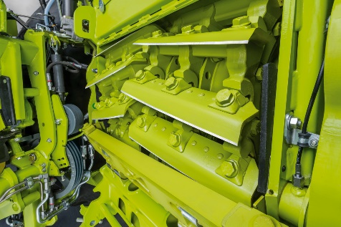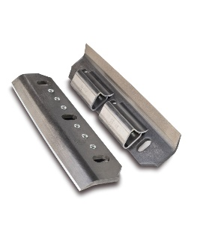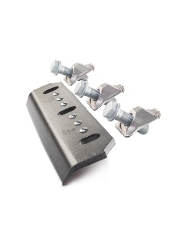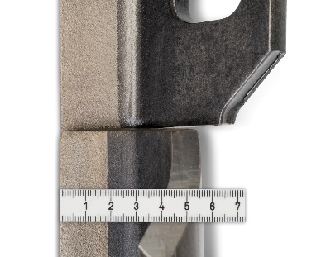

*The newly developed V-FLEX knives feature several outstanding improvements in terms of wear protection, throughput and smooth running.*

CLAAS has reconfigured the knife sharpening operation to make it even more user-friendly. In addition to the control options 'knife sharpening' and 'individual shear bar adjustment', operators can now select one that is even more convenient: knife sharpening and shear bar adjustment combined can be completed in just one minute for pre-determined sharpening cycles – at the touch of a finger in CEBIS. The sensor-based shear bar adjustment has also been optimised. A status display showing the process time, status description and visualised process is now available in CEBIS for all sequences. This enables operators to better estimate downtimes and make optimal use of waiting times. As before, the sharpening interval can be pre-programmed according to time or throughput based on the QUANTIMETER throughput readings.

**CLAAS Corncracker: more speed difference and more space**

For years the CLAAS MULTI CROP CRACKER concept (MCC) comprising the MCC CLASSIC, MCC MAX and MCC SHREDLAGE has offered the widest choice of corncracker options for highly efficient processing of kernels, leaves and stalks from short cut to long cut and SHREDLAGE®. For more intensive kernel processing, the differential speed has now been increased from 30 to 40 per cent in the MCC CLASSIC with sawtooth profile and the MCC MAX with unique ring segments with cutting and shearing effect. Furthermore, the MCC CLASSIC is optionally available with a 190-sawtooth profile for particularly small kernels such as sorghum.

The maintenance compartment now offers more space for fitting and removing the corncracker, making it easier to change the rollers. Less downtime during campaigns means more time for harvesting.

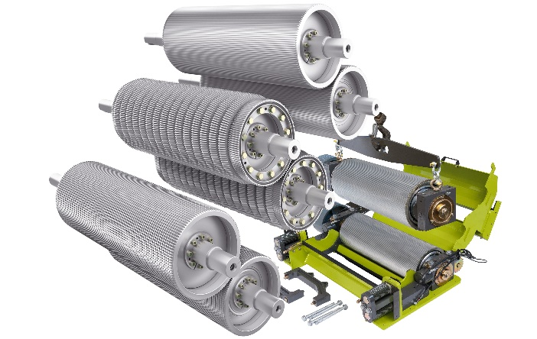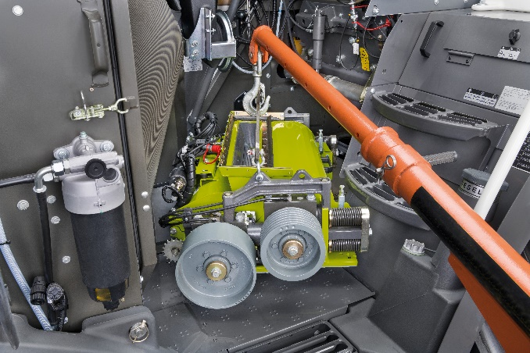

The MCC CLASSIC and MCC MAX now work with a speed difference of up to 40 percent, and the MCC CLASSIC is also available with fine gearing. Thanks to the larger maintenance space, installation and removal of the corncracker module is quicker and less stressful.

**Determine processing intensity in the field: CSPS analysis by smartphone and CLAAS connect.**

The CSPS value (Corn Silage Processing Score) is an important indicator of kernel processor performance. Previously, this could only be determined in the laboratory. Now for the first time, CLAAS can offer a solution for farmers and contractors in the form of an app in CLAAS connect which calculates the CSPS in a matter of minutes in the field while harvesting is underway.

To calculate the scores, a litre sample of chopped material is collected and divided into a minimum of five individual samples on a blue plastic A4-sized tray that comes with the test kit. The samples are then photographed with a smartphone and transferred to a server for analysis. The results are sent back to the smartphone a few minutes later – enabling the settings to be adjusted on the corncracker while harvesting is underway. This makes it possible to consistently maintain the desired or required processing quality, and is especially useful for contractors having to meet customer requirements.

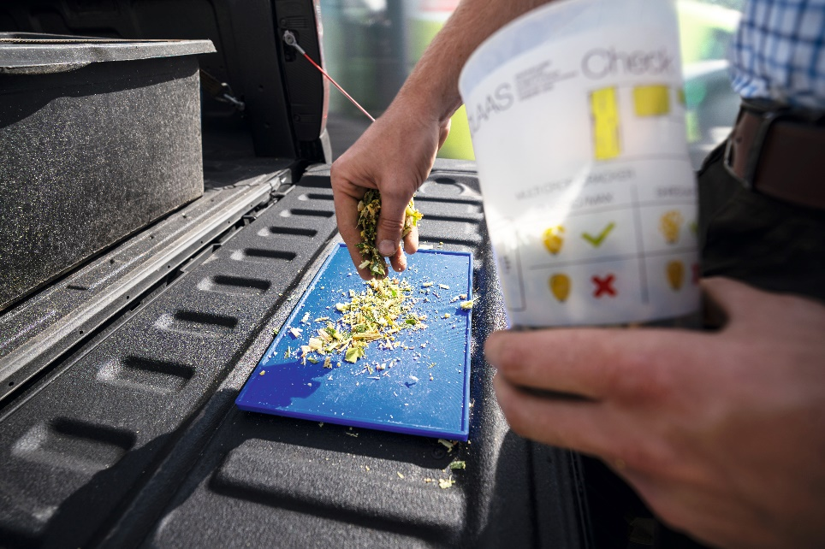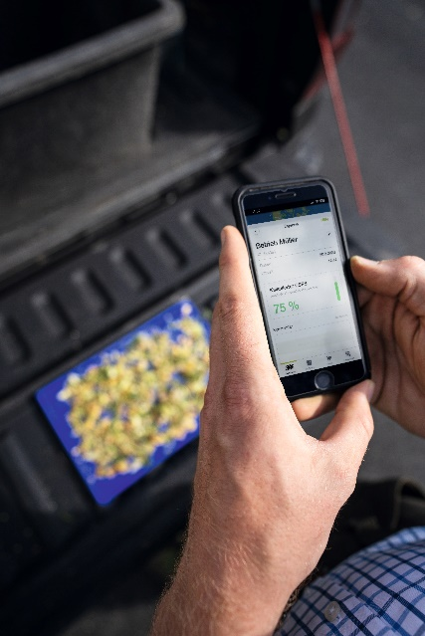

What previously required a laboratory can now be done directly in the field during the harvest: Determining processing intensity using the app in the new CLAAS connect.

**PICK UP 300: optimised crop flow and fewer losses**

When it comes to the PICK UP 300, the shape of the auger has been optimised in the middle and equipped with four offset paddles. This ensures even more uniform crop flow, which in turn has a positive effect on throughput. The flat or toothed cover or wear plates on the paddles are easy to replace.

The extended dust screen now covers the entire working width of the PICK UP. This reduces soiling in the intake and cylinder housings and on the windscreen, as well as effectively capturing crop fragments and alfalfa leaves, thereby avoiding harvest losses. However, the wide-mesh screen still affords a clear view of crop flow from the cab. Furthermore, the one-piece dust screen can easily be swung open for maintenance work.

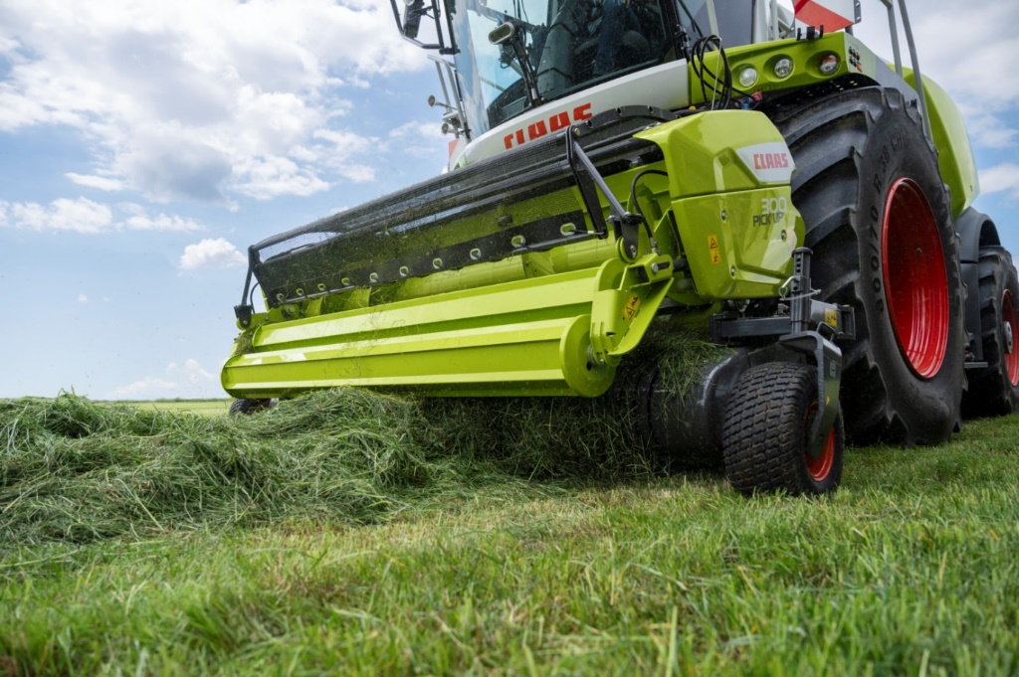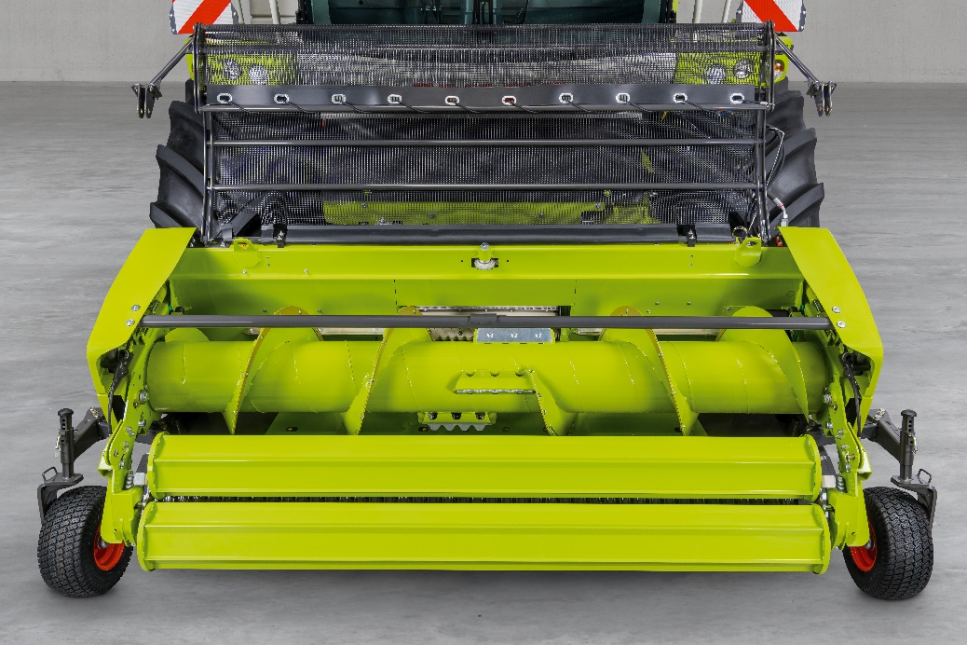

The new PICK UP 300 for JAGUAR 800, 900 and 900 TERRA TRAC is characterized by less soiling in the intake and more even, slightly increased throughput.

**Round-up of other new features:**

* A new Carraro rear axle with a load capacity of 9 tonnes and 10-hole rims in the POWER TRAC variant enables four-wheel drive to be engaged under load. Furthermore, wheel spacers of 460 mm for the standard axle and 620 mm for the POWER TRAC four-wheel drive axle are available to widen the track.
* By double-clicking a button on the CMOTION control lever, the operator can activate the 'automatic trailer changeover' function for the AUTO FILL automatic trailer filling system. The discharge flap then directs the crop stream to a preset position at maximum speed to ensure minimal losses and maximum comfort for forage harvester operators and trailer drivers alike.

**Key new features at a glance:**

* *New V-FLEX chopping cylinder for JAGUAR 900 / JAGUAR 900 TERRA TRAC as optional alternative to the V-MAX for even greater versatility.*
* *V-FLEX knives: 23 mm anti-wear coating for exceptional service life and new geometry with 10 degree cutting angle for precise cut in all crops. Significant reduction in noise levels and improved chopping quality.*
* *Optimised process management for knife sharpening and shear bar adjustment – now available as a combined option for even fewer downtimes.*
* *Factory-fitted speed differential of up to 40 per cent for MCC CLASSIC and MCC MAX corncrackers and new MCC CLASSIC with fine sawtooth profile for use in small-seeded crops such as sorghum.*
* *Larger maintenance compartment for faster, more convenient changeover of corncracker module.*
* *App-based CSPS determination in the new CLAAS connect: calculate the corn silage processing score in a matter of minutes while harvesting is underway – a digital tool to optimise corncracker settings*
* *PICK UP: new intake auger with four paddles ensures uniform crop flow with reduced torque peaks and higher throughput*
* *New Carraro rear axle with four-wheel drive engagement under load and option of extending track by 460 or 620 mm.*
* *New 'automatic trailer changeover' function by double-clicking button on the CMOTION control lever: time-saving trailer changeovers which minimise transfer losses and greatly reduce operator's workload*

***You can download high-resolution images for print and web here:***

<https://dam.claas.com/pinaccess/showpin.do?pinCode=DxQTGnd5f1Wk>

**Video:**

[CLAAS | JAGUAR: New Features for 2025 (youtube.com)](https://www.youtube.com/watch?v=1D-NLxOBfb8)

**Please note the following in your journalistic work:**

This is an international press release. The product range and feature options may vary in some countries. Please ask the CLAAS sales company or the CLAAS importer in your country in case of doubt.

**About CLAAS**

CLAAS (www.claas.com) is a family business founded in 1913 and is one of the world’s leading manufacturers of agricultural machinery. The company, with Head Office in Harsewinkel, Westphalia, is the European market leader for forage harvesters. CLAAS dominates the European market in another core segment as well – combine harvesters. CLAAS also holds the top spots in global agricultural technology with its tractors as well as its agricultural balers and grassland harvesting machines. Cutting-edge agricultural information technology also forms part of its product range. CLAAS employs more than 12,000 staff worldwide and generated a turnover of 6.1 billion euros in 2023.