**Embargoed until 13th Dec, 10am GMT**

***“*The most beautiful thing we can experience is the mysterious.**

**It is the source of all art and science."**

**Albert Einstein**

**TODAY RÖYKSOPP INTRODUCE *NEBULOUS NIGHTS (AN AMBIENT EXCURSION INTO PROFOUND MYSTERIES)***

**"Outside the pure listening pleasure, «Nebulous Nights» seeks to underline the importance of critical thinking and curious pondering. To foster a mindset that allows for exploration and personal growth, by not limiting one’s imagination and inquiry to a particular worldview or framework."(Röyksopp*)***

**CONTINUING THE EPIC JOURNEY OF ACCLAIMED AUDIO VISUAL PROJECT**

[***PROFOUND MYSTERIES***](https://profoundmysteries.royksopp.com/)

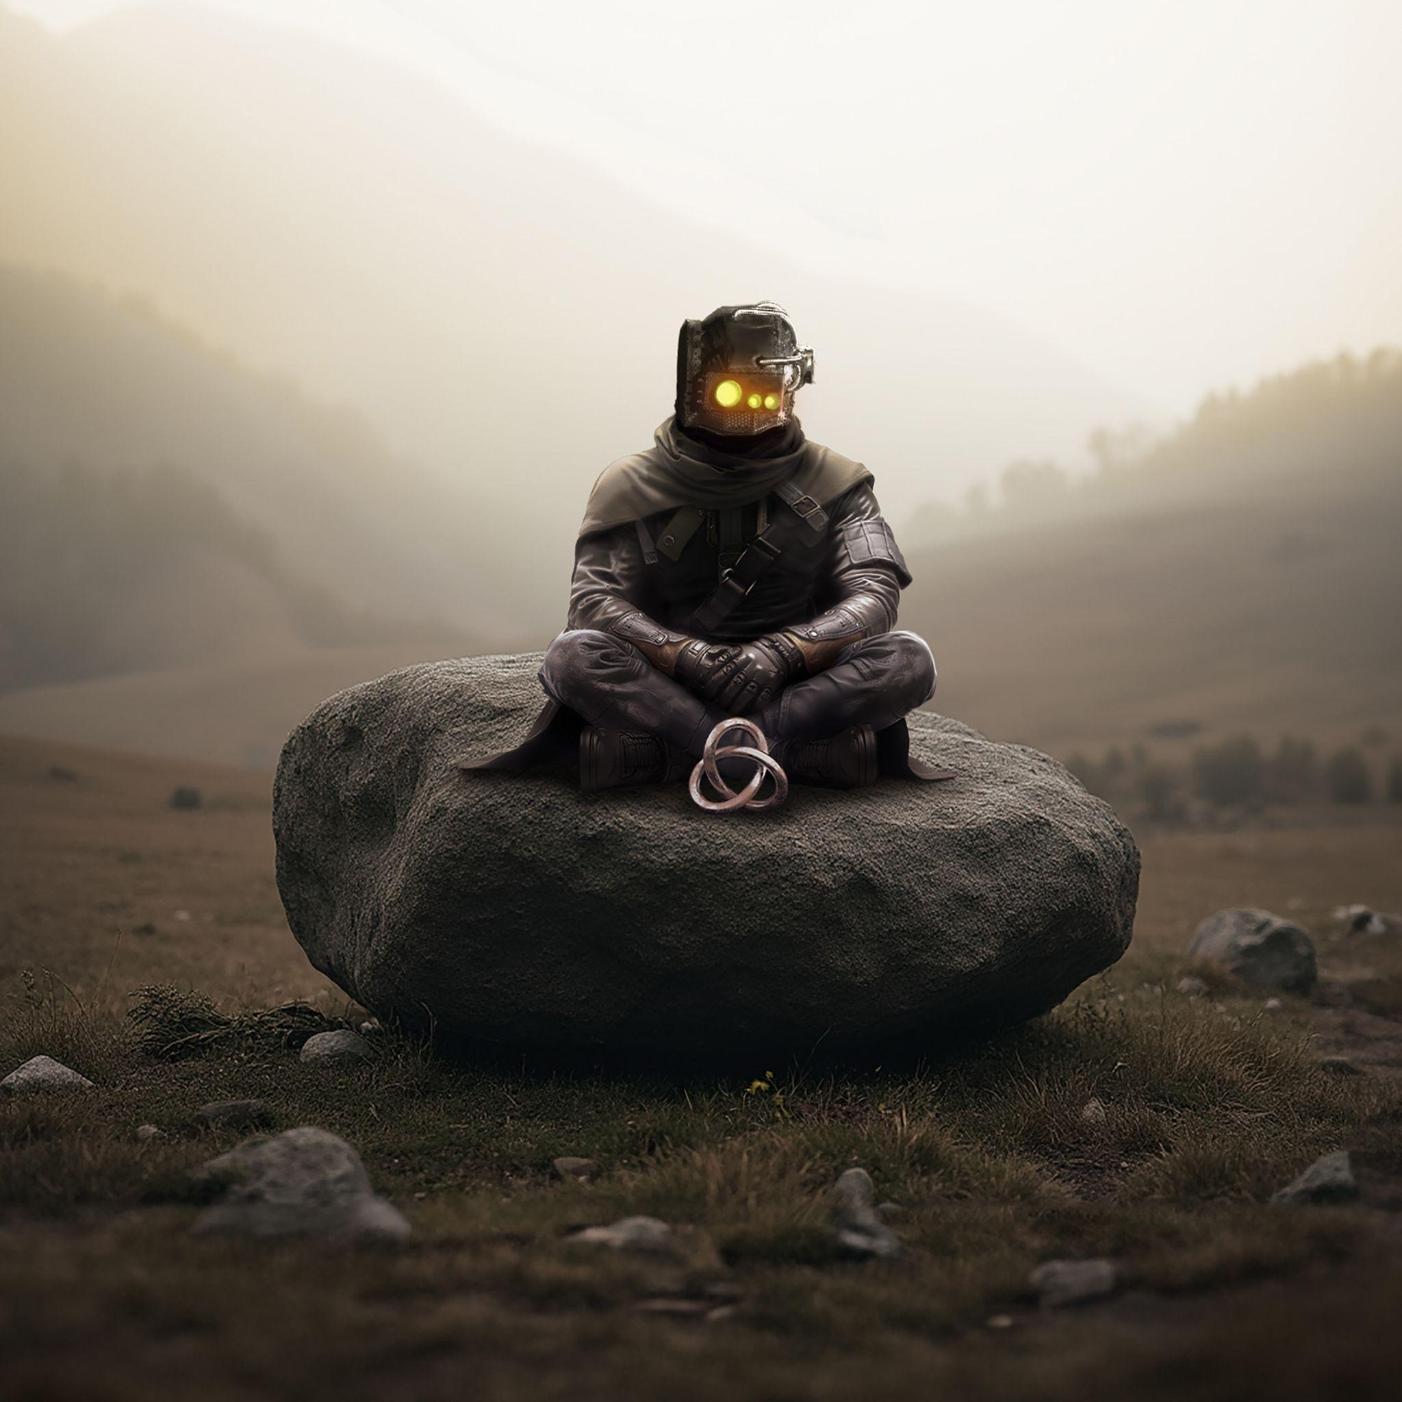

Download *Nebulous Nights (An Ambient Excursion into Profound Mysteries)* artwork [here](https://www.dropbox.com/scl/fo/xyji69pteekjk0cvq2b6z/AILzXUbU9OEYP19FhY6pdcU?rlkey=hjehvjhl5sce8ikw0lqgdl6bv&e=1&st=u0dwsljb&dl=0)

**Röyksopp** continue the *Profound Mysteries* journey with the release of *Nebulous Nights (An Ambient Excursion into Profound Mysteries)*, an ambient re-interpretation of the acclaimed 30 track project. Listen here. Fully immerse yourself in the visualiser created by Greedy Goons here. Headphones recommended for full effect.

Analogue, raw and immersive. This is «Nebulous Nights».

Recorded live, this after-hours session is filled to the brim with nods and tributes, as well as references back to different parts of Röyksopp lore. All neatly wrapped in an esoteric blanket - coated with analogue warmth, and many a chunky nugget for the keen and avid listener to find.

“*Outside the pure listening pleasure, «Nebulous Nights» seeks to underline the importance of critical thinking and curious pondering. To foster a mindset that allows for exploration and personal growth, by not limiting one’s imagination and inquiry to a particular worldview or framework. Encapsulated succinctly in this quote by Albert Einstein:* ***“*The most beautiful thing we can experience is the mysterious. It is the source of all art and science. To whom this emotion is a stranger, who can no longer pause to wonder and stand rapt in awe, is as good as dead; his eyes are closed*.”****”* (Röyksopp*)*

The extraordinary [Profound Mysteries project](https://profoundmysteries.royksopp.com/) was realised in 2022 bringing together a cast of global visual and musical collaborators including designer [Jonathan Zawada](https://www.instagram.com/zawhatthe/?hl=en), the film production house [Bacon](https://baconproduction.com/), Alison Goldfrapp, Susanne Sundfør, Pixx, Astrid S and many more, across an incredible 30 tracks, 30 artifacts, 30 visualizers and 30 films released in 3 parts, as well as ongoing series of remixes featuring Mind Against, &Me, Qrion, Baauer, LP Giobbi, Maceo Plex, Enrico Sangiuliano, Jan Blomqvist, NTO and many more.



*Photo credit: Stian Andersen*

[*High res*](https://www.dropbox.com/scl/fo/cbi21dyefnedgdvibkd1i/ABCOOvy2YwGv2CGAyZxlpis?rlkey=x9hs0yoc75l4hzi9mh58g4jmo&e=1&st=wf23dxfj&dl=0)

***Nebulous Nights (An Ambient Excursion into Profound Mysteries)* tracklisting:**

01 Waking Up From A Thousand Year Slumber (ft. Astrid S)

02 Slow Fade / R

03 We Enter / State Of Awareness (ft. Alison Goldfrapp)

04 The Uxtáca Bridge

05 Soft Ascension (ft. Pixx)

06 Flumen Aeternum (ft. Jamie Irrepressible)

07 Oh, The Vanity

08 Lethargic Shift / The String That Passes Through All Things

09 Moments We Lost (ft. Susanne Sundfør)

10 Beacons (ft. Susanne Sundfør)

11 Waiting Still (ft. Astrid S)

12 We Remain Hidden / Consolation (ft. Pixx)

13 Beyond Beyond / The Weathered Gate / The Head Of The Statue

14 I’m There With You

15 Come With Me (ft. Karen Harding)

16 The Veil

17 Misconceptions / The Crux Of It All (ft. Astrid S)

18 The House Of «R»

19 If Only For A While (ft. Susanne Sundfør)

20 Understanding The Inexplicable

21 Reaching For Secrets (ft. Maurissa Rose)

22 Dandelion Pleasantries

23 Camera Obscura (ft. Pixx)

24 Beside You (ft. Jamie Irrepressible)

25 Always And Forever (ft. Susanne Sundfør)

26 The Space Between Stars / Paramnesia

27 Gone, Dissolved Into The Night (ft. Alison Goldfrapp)

28 Back Then, Back When

29 All Things Passing

30 And So…

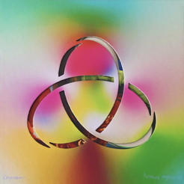

Download *Profound Mysteries* box set album artwork [here](https://www.dropbox.com/s/77ef6s8tewfmknl/MicrosoftTeams-image%252520(24).png?dl=0)

Listen to *Profound Mysteries* [here](https://royksopp.lnk.to/pro-mysEm)

Listen to *Profound Mysteries II* [here](https://royksopp.lnk.to/Profound-Mysteries-IIEm)

Listen to Profound Mysteries III [here](https://royksopp.lnk.to/pm-iiiEm)

Listen to all the *Profound Mysteries*  Remixes [here](https://youtube.com/playlist?list=PLXz0F2Zo_KsMgdSYk_4u0zT32Z5D1HYc-)

Watch the continuous visual experience [here](https://royksopp.com/rxyp-and-friends/red/)

***Profound Mysteries* track listing:**

*Profound Mysteries*

1. (Nothing But) Ashes…

2. The Ladder

3. Impossible (feat. Alison Goldfrapp)

4. This Time, This Place… (feat. Beki Mari)

5. How The Flowers Grow (feat. Pixx)

6. If You Want Me (feat. Suanne Sundør)

7. There, Beyond The Trees

8. Breathe (feat. Astrid S)

9. The Mourning Sun (feat. Suanne Sundør)

10. Press «R»

*Profound Mysteries II*

1. Demiclad Baboons

2. Let’s Get It Right feat. Astrid S

3. Unity feat. Karen Harding

4. Oh, Lover feat. Susanne Sundför

5. Sorry feat. Jamie Irrepressible

6. Control

7. It Was A Good Thing feat. Pixx

8. Remembering The Departed

9. Tell Him feat. Susanne Sundför

10. Some Resolve

*Profound Mysteries III*

1. So Ambiguous feat. Jamie Irrepressible

2. Me&Youphoria

3. Stay Awhile feat. Susanne Sundfør

4. The Night feat. Alison Goldfrapp

5. Lights Out feat. Pixx

6. Speed King

7. The Next Day feat. Jamie Irrepressible

8. Just Wanted To Know feat. Astrid S

9. Feel It feat. Maurissa Rose

10. Like An Old Dog feat. Pixx

[Facebook](https://www.facebook.com/Royksopp/) | [Twitter](https://twitter.com/RYXP) | [Instagram](https://www.instagram.com/royksopp/?hl=en)