2025-06-04

**PRESS RELEASE**

**Invisible waves heat space – new research shows the way**

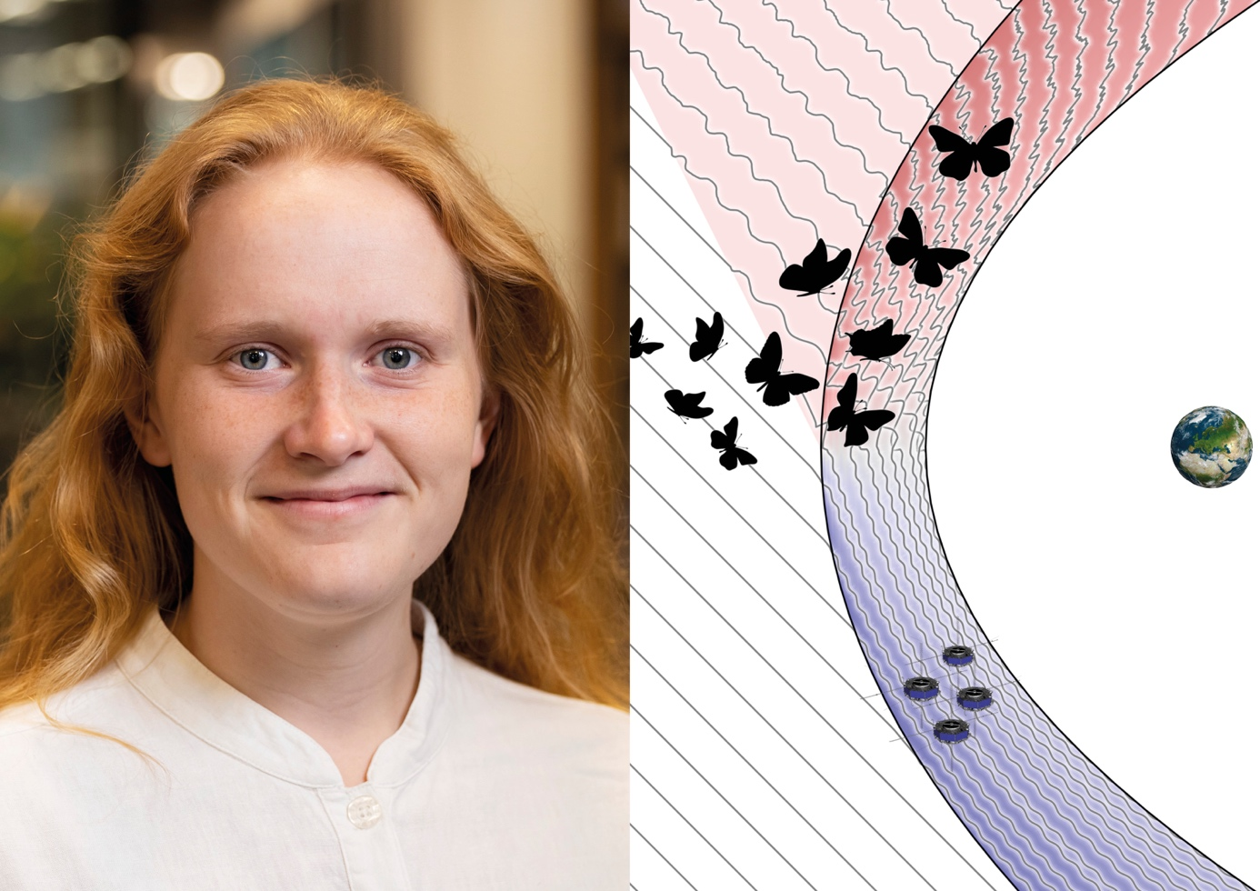

*Uppsala PhD student Ida Svenningsson has analyzed data from the four MMS satellites to increase knowledge about energy flows in space near Earth and in the solar system. Photo: Mikael Wallerstedt/Uppsala University. Illustration: Ida Svenningsson*

**Ida Svenningsson’s doctoral thesis shows that electromagnetic waves, known as whistlers, can influence how electrons move and how heat spreads in space near Earth. The findings contribute to our understanding of energy flows in space** – **both near Earth and further out in the solar system.**

Her research, conducted at the Swedish Institute of Space Physics (IRF) and Uppsala University, takes place in Earth's magnetosheath – a turbulent region where the solar wind, a constant stream of charged particles from the Sun, collides with Earth's magnetic field.

Ida has studied how waves and particles interact under different conditions, thanks to detailed measurements from instruments aboard NASA’s four Magnetospheric MultiScale (MMS) satellites.

The doctoral thesis presents how waves and plasma particles interact and transfer energy between each other – a key to understanding how space works on a deeper level. Plasma is the most common state of visible matter in the universe – it makes up 99 percent of everything we see. It is a charged state, in which electrons and ions move freely and are strongly influenced by electric and magnetic fields.

In space, plasma is often so sparse that particles almost never collide. Instead, their movements are governed by force fields, but how energy is transferred in this “collisionless” environment remains an open question for scientists studying collisionless plasma.

”*My research provides a deeper understanding of how small electromagnetic waves, known as whistlers, can influence electrons in space. It's fascinating because the waves only “communicate” with electrons moving at exactly the right speed. The process is both complex and exciting – and important for understanding how small-scale events can affect large parts of our solar system*”, says Ida Svenningsson.

Ida Svenningsson, born in Lund, Sweden, will defend her doctoral thesis *“Electron Heating through Wave-Particle Interaction in Turbulent Space Plasma”* 13:15 on Thursday, June 5 2025, in the Heinz-Otto Kreiss Hall at the Ångström Laboratory in Uppsala. The opponent is Professor Viviane Pierrard from the Royal Belgian Institute for Space Aeronomy in Brussels, Belgium.

**Link to the doctoral thesis:** <http://urn.kb.se/resolve?urn=urn:nbn:se:uu:diva-554332>

**Contact:**  
Ida Svenningsson, PhD student, Swedish Institute of Space Physics, Uppsala, and Uppsala University, [ida.svenningsson@irfu.se](mailto:ida.svenningsson@irfu.se)