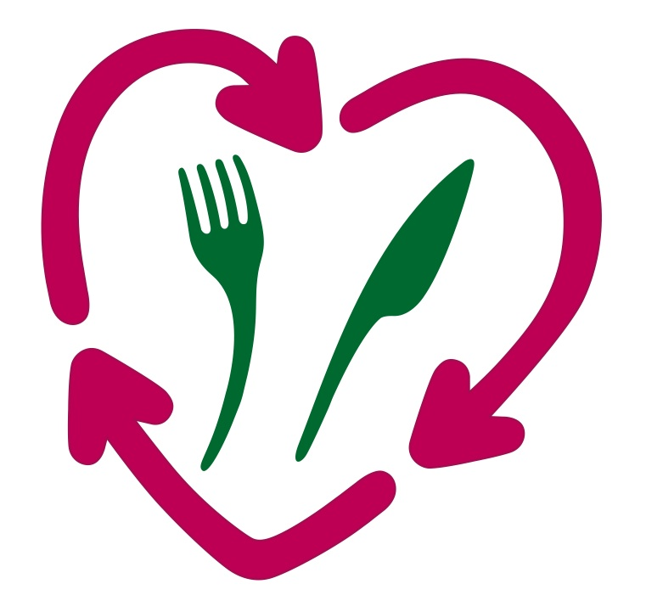
News release – Food Waste Network & Vegware

Edinburgh, 1st April 2012

New free zero-waste service helps caterers beat landfill tax rises

Summary:
Landfill tax rises to £64 per tonne on 1st April 2012. Landfill is the most expensive and environmentally harmful destination for UK waste, and all businesses can save money by maximising recycling. The first key step to going zero waste is introducing food waste recycling. The Food Waste Network is a new free service to help any UK business find its ideal food waste recycling services.

Food waste facts:
- On 1st April 2012, landfill tax rises from £56 to £64 per tonne.
- In 2011 the median cost of sending waste to landfill was £76 per tonne, compared to £43 per tonne for food waste recycling.
- Food waste breaking down in landfill can emit harmful greenhouse gases.
- Food waste recycling creates nutrient-rich natural fertiliser, reducing the need for petrochemical fertilisers. Food waste recycling can also create renewable energy – electricity or biogas.
- The Food Waste Network is a new free service to matchmake any UK business with its ideal food waste recycling services.

55% of UK waste still goes to landfill, even though landfill is both the most environmentally harmful and the most expensive destination for our rubbish. Landfill tax is still rising by £8 per tonne every year, with this year’s new rates kicking in on 1st April 2012. Even before this latest rise, last year’s figures are stark enough – £76 per tonne to send waste to landfill compared to £43 per tonne for food waste recycling (Gate Fees Report 2011, WRAP). With landfill charges only set to rise, now if the time to move over to a financially and environmentally sustainable approach to our bins.

The average caterer could recycle almost everything and reduce costs, but the first key step is introducing food waste recycling. If messy food waste is removed from the general bin, everything else is cleaner and far easier to recycle. Instead of wasting money filling the few remaining landfill sites, the contents of catering bins can be recycled, saving money and resources. Food waste can either be composted, creating compost, or anaerobically digested, creating biofertiliser and renewable energy.

The UK food waste recycling sector is burgeoning, with new services springing up every week. Now a new free service is helping any UK caterer find its ideal food waste recycling services. The Food Waste Network is the only single source of information on all organics recycling services, with accurate information on collection services and on-site recycling systems. Any UK business can email its food waste recycling needs and postcode to recycle@foodwastenetwork.org.uk or ring 03300 883 654. A free web-based service will be launched this summer.

This initiative came out of Climate Week award-winner Vegware, the UK’s first and only completely compostable food packaging firm. Since their entire range of catering disposables is certified compostable, Vegware can be diverted from landfill and recycled organically together with food waste. In order to help all UK customers divert catering waste from landfill, they started mapping and liaising with all food waste recycling services. In the course of their research it became apparent that there was no one single source of accurate information on this rapidly-changing sector. So Vegware opened up their information to non-customers to create the Food Waste Network, a free service to matchmake any UK business with its ideal food waste recycling.

Contact the Food Waste Network
recycle@foodwastenetwork.org.uk
03300 883 654

High-res images available on request

PR contact:

Lucy Frankel
Communications Manager, Vegware
Project Manager, Food Waste Network
lucy@vegware.co.uk
07906 635 139

