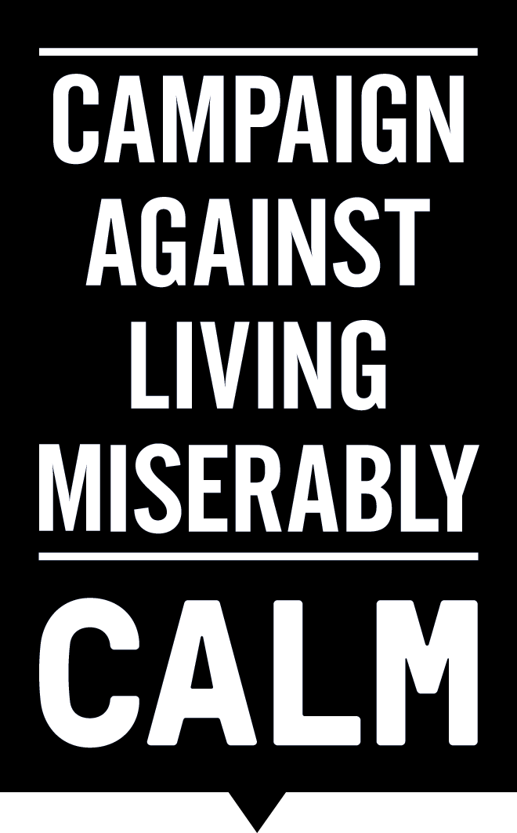
CALM ANNOUNCES FURTHER COLLABORATIONS WITHIN THE ARTS
3/11/15: CALM is delighted to announce further collaborations within the arts, with short film The Laughing King and hit play This Will End Badly releasing in January, plus support from Gloom Aid.
The Laughing King, starring BBC Merlin actor Colin Morgan, touches on the sensitive subject of male suicide, which accounts for 76% of all suicides in the UK and is the biggest single killer of men aged under 45. The 15 minute movie has been shortlisted in the London Short Film Awards, where it will screen for the first time on 12th January 2016 at 20:45, Hackney Picturehouse. Directed by the award-winning Lindy Heymann, whose own story of personal loss to suicide led her to co-write the script, it was produced without financial assistance, with talent and crew dedicating their time in kind.

BBC Merlin and The Laughing King star, Colin Morgan, said:

"The instant I read The Laughing King I was magnetically and emotionally pulled into its immense beauty and tragic power, the journey of a man on the edge, a man who is perhaps on his final journey but ultimately finds hope and a reason to go on living. It reminded me of how difficult and precious life can be and I felt compelled to communicate Jake's journey and to understand a man who finds himself in the place he does. Working closely with Lindy Heymann throughout was a hugely rewarding process, we came together by chance and everything about this project from everyone involved comes directly from the heart and I feel that's reflected in every element of it. The end result is a film that takes a snapshot of a much bigger issue on a very human and personal level and I feel truly proud to have been a part of this special project."

Also in collaboration with CALM, following a critically acclaimed sell-out run at Pleasance Edinburgh this August, This Will End Badly transfers to Southwark Playhouse for its London premiere for four weeks from 12th January. It stars Ben Whybrow (Punchdrunk’s The Drowned Man), whose performance is described as “heartrending, callous and funny by turns…as unsettling and brilliant a performance as you're likely to see this year.” (Fest magazine). To further raise awareness of the issues facing men, This Will End Badly will host post-show discussions with CALM, the first of which is to be held on 18th January.

This Will End Badly Writer Rob Hayes said:
"I'm thrilled to be working in co-operation with CALM on a project that I've always seen as an attempt to understand what drives men to extreme and depressive behaviour. CALM's commitment to making male depression and suicide part of the national conversation is crucial not just for young men, but for society as a whole."
Last but not least, CALM is pleased to report that this year's Gloom Aid, a night of comedy held on ‘Blue Monday’, marked by some as the "gloomiest day of the year", is in support of CALM. The line up for the event, which will be held at 100 Club on Oxford Street, so far includes the legendary Robert Newman, Horrible Histories favourite Adam Riches, Newsjack’s Nish Kumar and CALM Ambassador Dave Chawner.

CALM CEO, Jane Powell, said:
"The last couple of months at CALM have seen support from the public, celebrities and companies start to balloon. It feels as if we are finally making headway in our aim to ensure that everyone knows suicide is the biggest single killer of men in the UK, and that there is somewhere for guys to turn for help."
Ends

Notes to editors:

Contact: Jojo Furnival // Communications Manager, CALM // jojo@thecalmzone.net // 0203 697 9331

ABOUT CALM:

The Campaign Against Living Miserably, CALM, is an award winning charity dedicated to preventing male suicide in the UK. Founded in 2006 the charity seeks to prevent suicide by providing a service for men who are down or in crisis, and by fomenting cultural change so that any man considering suicide feels able to seek help.

CALM supporters and advocates include the likes of David Baddiel and Professor Green, Dizzee Rascal and Frank Turner, and its offbeat brand and challenging advertising have proven effective in reaching men across the UK. In the past 12 months, CALM has taken over 40,000 callers via its helpline and webchat. CALM’s free, confidential accredited helpline and webchat service are available every day of the week from 5pm to midnight, staffed by professionals, on 0800 585858 (national) 0808 802 5858 (London) and www.thecalmzone.net.

CALM is reg. charity no. 1110621.

There were 6,109 probable suicides in the UK in 2014 of which 76%, or 4,623, were male. Suicide is the biggest single killer of men aged under 45 in the UK (NISRA, GRO, ONS 2014).

The Laughing King is available to view online in a YouTube playlist of independently created videos spotlighting the issue of male suicide. The aim of the playlist is to, a) urge those that may need it to seek help – helpline numbers are included within the playlist description – and b) encourage viewers to share the content online, spreading the message #DontBeAStatistic: http://bit.ly/1OiTD3m

ABOUT THE LAUGHING KING:

For more on The Laughing King, visit www.thelaughingkingfilm.com or follow @TheLaughingKing on Twitter.

Claire Meadows, Founding Director of After Nyne magazine, reviewed The Laughing King:

“Poignant, yet hard-hitting, The Laughing King makes us confront the reality facing suicidal young men such as Jake - the isolation, desperation, and the societal pressure for men to 'cope' with whatever faces them. The film also highlights the fact that one person can make all the difference to a man in that position. A brilliant, and very necessary, piece of work.”

THE STORY BEHIND THE FILM
When I was 21 my younger brother Marcus, who was 19 at the time took his own life. It was shocking, frightening & heartbreaking – his funeral was crammed full of family and over 200 friends - I remember feeling that we were all too young to be dealing with such enormous emotions.

Overnight, I went from having a sibling that I shared my life with to suddenly being an only child – I was suddenly labeled – Lindy whose brother had killed himself – I received letters from people that I’d never met before and I was sent to therapy. I was graduating from Art School and supposed to be just beginning my life – but I felt overshadowed and overwhelmed – all I wanted to do was run away and so I did – I went to America where no one knew me and I didn’t have to explain anything.

I think I did a pretty good job of moving on – but in 2014, over 20 years later – one of my best friend’s Shaun, committed suicide and I was forced to face the loss all over again. This time though I was an adult grieving and I found that I couldn’t sweep away my feelings. In some ways it was harder to deal with as it brought up all the unprocessed grief of my brother’s death.

It led me to The Laughing King – an outline for a short film that my friend, Leigh Campbell had written. I pleaded with her to let me make the film. And that is exactly what happened. We wrote the script and then I set out to make it. The challenge was that we had no money - and we had to get everything - actors, locations, crew, camera equipment,
lights – everything for free. But as soon as I started speaking to people there was a strange serendipity about it.

I knew from the get go that I wanted Colin Morgan to play Jake but the crazy coincidence was that I was working on Humans directing 2nd Unit and I got to direct him – so I had to ask him. The same was true of all the cast & crew – everyone agreed instantly and the whole film gained a momentum of its own. This is definitely to do with the subject matter – everyone involved has been touched by someone that they have known who has taken their own life.

I feel very proud of the film and the way that it has brought people together – it has made a difficult conversation easier to have – and I now realise that it’s more people than I could ever have imagined who have been affected by suicide. I am hoping that our film will help lift the stigma that suicide brings with it.
LINDY HEYMANN

THE FILMMAKERS
15 minutes in length, the film was shot over a weekend entirely on location in Blackpool in May 2015. It was shot on a RED Epic camera using Anamorphic lenses.

CO-WRITTEN BY LINDY HEYMANN & LEIGH CAMPBELL
http://www.imdb.com/name/nm1095643/?ref_=fn_al_nm_1
http://www.imdb.com/name/nm1202909/?ref_=fn_al_nm_1
PRODUCED BY PAUL SPARROW & ANDY STEBBING (Suffragette, Submarine, The Double)
http://www.imdb.com/name/nm1302496/?ref_=fn_al_nm_3
http://www.imdb.com/name/nm0824217/
DIRECTED BY LINDY HEYMANN
http://www.imdb.com/name/nm1202909/?ref_=fn_al_nm_1
DOP - EDU GRAU (Suffragette, A Single Man, Buried)
http://www.imdb.com/name/nm1880996/
EDITOR - QUIN WILLIAMS
http://www.imdb.com/name/nm1183727/?ref_=fn_al_nm_1
SOUND DESIGN – JESSE ROTH
http://www.echoicaudio.com
COMPOSER – MARTIN DUFFY (Also Keyboardist with Primal Scream)
www.bbc.co.uk/music/artists/00d21293-62c1-4c43-a394-b8fd9fa49853
GRADE – TAREQ KUBAISI
http://www.raised-by-wolves.tv/#video

ABOUT THIS WILL END BADLY:

For more on This Will End Badly, visit www.southwarkplayhouse.co.uk or follow @WillEndBadly on Twitter.

Monday, 18 January post-show discussion details:
‘Hashtag’ In Social Media: Is social media causing people to become more lonely? Despite living in a modern world that is able to communicate more than we ever have before thanks to the technology and social media available to us, are we more alone than we ever have been? Join a panel of guest speakers in a discussion surrounding the debate on whether our social media hinders or helps us to make connections with others in an ever growing global society. Guest speakers include comedian Joe Lycett, director Clive Judd, cast member Ben Whybrow and Jane Powell, Chief Executive Officer at CALM (Campaign Against Living Miserably).

“This was perhaps the best show I’ve seen this year…heavy enough to pack one hell of a punch. I urge you to see it.” The Observer ★★★★★

Playwright Rob Hayes recently wrote Awkward Conversations With Animals I’ve F*cked (Edinburgh Festival). Other writing credits include Step 9 (Of 12) (Trafalgar Studios), which he is currently adapting for the screen, A Butcher of Distinction (Cock Tavern and King’s Head Theatre) and Selling Clive (Lost Theatre). He won the 2013 Tom Erhardt Award for Most Promising Playwright and was also shortlisted in 2013 for the BAFTA Rocliffe New Writing Forum, the Royal Exchange Theatre Hodgkiss Award with director Ned Bennett, and two Off West End awards.
Director Clive Judd trained on the Regional Theatre Young Director Scheme at the Watermill Theatre in 2011/12 and was a member of the inaugural Foundry Scheme at the Birmingham Rep Theatre in 2013. Recent directing credits include the 50th anniversary production of Little Malcolm and his Struggle Against the Eunuchs (Southwark Playhouse), Sparks (Old Red Lion), the Edinburgh Fringe 77-85 Newington Causeway London SE1 6BD 020 7407 0234

Performer Ben Whybrow trained at LAMDA and Bristol University. Recent theatre credits include Conrad Scherer and Jasper Tuttle in The Drowned Man (Punchdrunk/NT), The Winter's Tale directed by Lucy Bailey (RSC), the world premiere of Dead On Her Feet by Ron Hutchinson (Arcola), a Trevor Griffiths double bill of All Good Men and Thermidor (Finborough) and Polixenes and Florizel in an abridged version of The Winter's Tale (Orange Tree Theatre). Film includes Tube Tube and most recently Orsino in a forthcoming version of Twelfth Night. Radio includes The Archers. As a theatre maker and deviser he is a collaborator with Mark Arends' company Make Mend and Do who make innovative work for young people and grown ups. Something Very Far Away at the UnicornTheatre/NT Studio won the Off West End Award for best show for young people in 2013 and has since toured internationally to Imaginate Festival in Edinburgh, Paris, Singapore and Melbourne International Festival. Their second production, At The End Of Everything Else, continues to tour. Set Design is by Jemima Robinson, Lighting Design is by Christopher Nairne and Sound Design and Composition is by Giles Thomas.

ABOUT GLOOM AID

Gloom Aid is brought to you by Feeling Gloomy, the world’s first club night devoted to sad music which has been running over 10 years, which has been involved in helping mental health charities since it started. They have been abetted in this endeavour by the Phoenix Fringe.

Though the event is meant to raise some cheer on the gloomiest day the serious side of the event is to drum up some cash and awareness for a very worthy cause.

Gloom Aid // The 100 Club, 100 Oxford St, London W1D 1LL
Mon 18th January // Doors 6.30pm // Tickets: Early bird £12 available from
FeelingGloomy.com

