Chinese Patent issued for LuerJack
On the 14th of February 2017, the Chinese Patent and Trademark office issued an official document granting the Chinese patent for LuerJack.
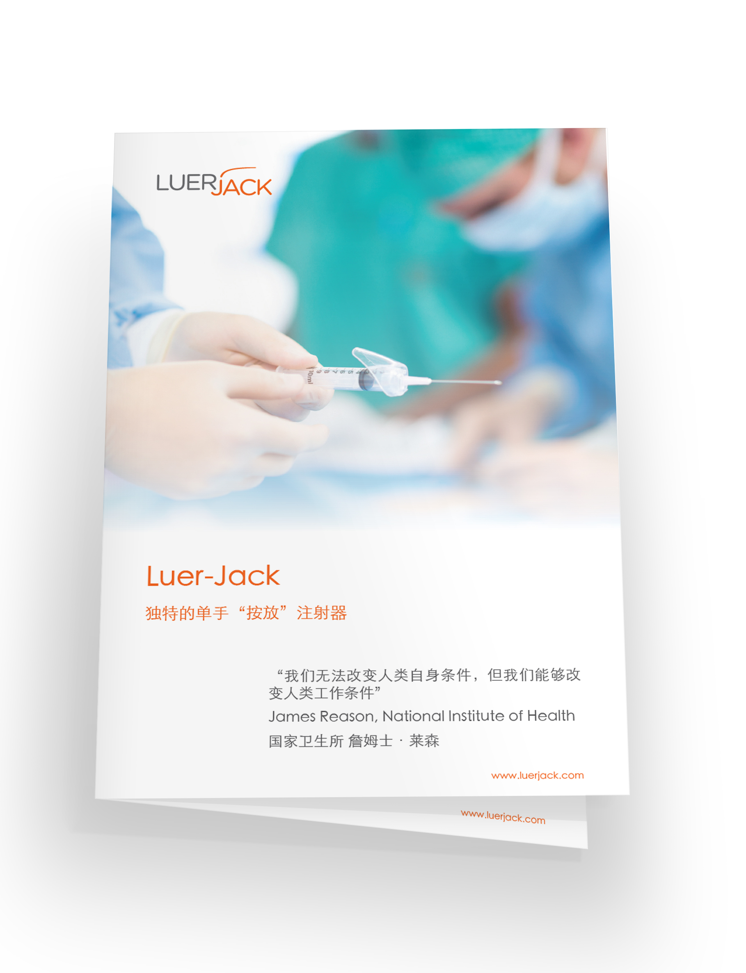
The innovative LuerJack syringe is unique through the very simple one-handed operated disconnection function. Based on the leverage effect, the ‘Click and Release’ feature performs fast, safe and more efficient one-handed disconnections from needles and any other medical luer connections, and thereby offer prevention from needlestick injuries. Using only one hand safeguards aseptic technique and could become a vital part of the on-going struggle to reduce the occurrence of healthcare acquired infections.
ConceptoMed’s strategy to protect our intellectual property rights (IPR) remains unchanged and strong. Along with other markets already protected, such as Europe, the US, Australia and Mexico, protection in Asia is now following. The LuerJack® is firmly protected by 8 patent families and > 60 patent applications (granted and pending).
Obtaining proper IPR protection in China is fundamental to our planned global journey towards new market entries.
‘ConceptoMed is serving the global market with innovative product categories and unique proprietary technology. These additional issued patent for LuerJack is another instrumental milestone for ConceptoMed. The global growth and reach of the LuerJack concept will now be a step closer to access patients and healthcare workers worldwide – also beyond Europe.’, said Christian Mide, M.D., CEO and founder of ConceptoMed.
Background
The 6% taper friction fit (luer) connection is the most common connector type used in medical settings. Tapered fittings ensure tight connections by allowing female hubs to bond with male tips by friction fit. The simple design creates a strong hold. It was invented in the 1890's and has been used predominantly in medical settings for over a century. However, both traditional luer slip and luer lock applications are disengaged using two hands for the operation - with fingers in close proximity with critical aseptic parts and sharp objects of medical procedures.

ConceptoMed AS is a ISO 13485 certified, ambitious medtech company serving the global market with innovative product categories and unique proprietary technology. We create smart medtech systems that empower healthcare professionals and improve patient care. Excellence through simplicity is our code. We are brave, curious and dedicated. We simply care.
Based in Norway, the team is continuously meeting milestones and expanding its activities for international growth.
For more information on the company and career opportunities, see www.conceptomed.com and www.luerjack.com .
Follow us on MyNewsdesk and LinkedIn.
For further info: | Christian Mide, CEO  Ann-Christine Jungmar, CCO | christian.mide@conceptomed.com  ann-christine.jungmar@conceptomed.com |  | +47 95 100 720  +46 708 71 46 76
Luer-Jack® is a registered trademark owned by ConceptoMed AS. The Luer-Jack® technology is widely patent protected throughout the world, currently with > 60 patents (granted and pending) from 8 patent families.

