Tough weekend for the Bäckman siblings in France
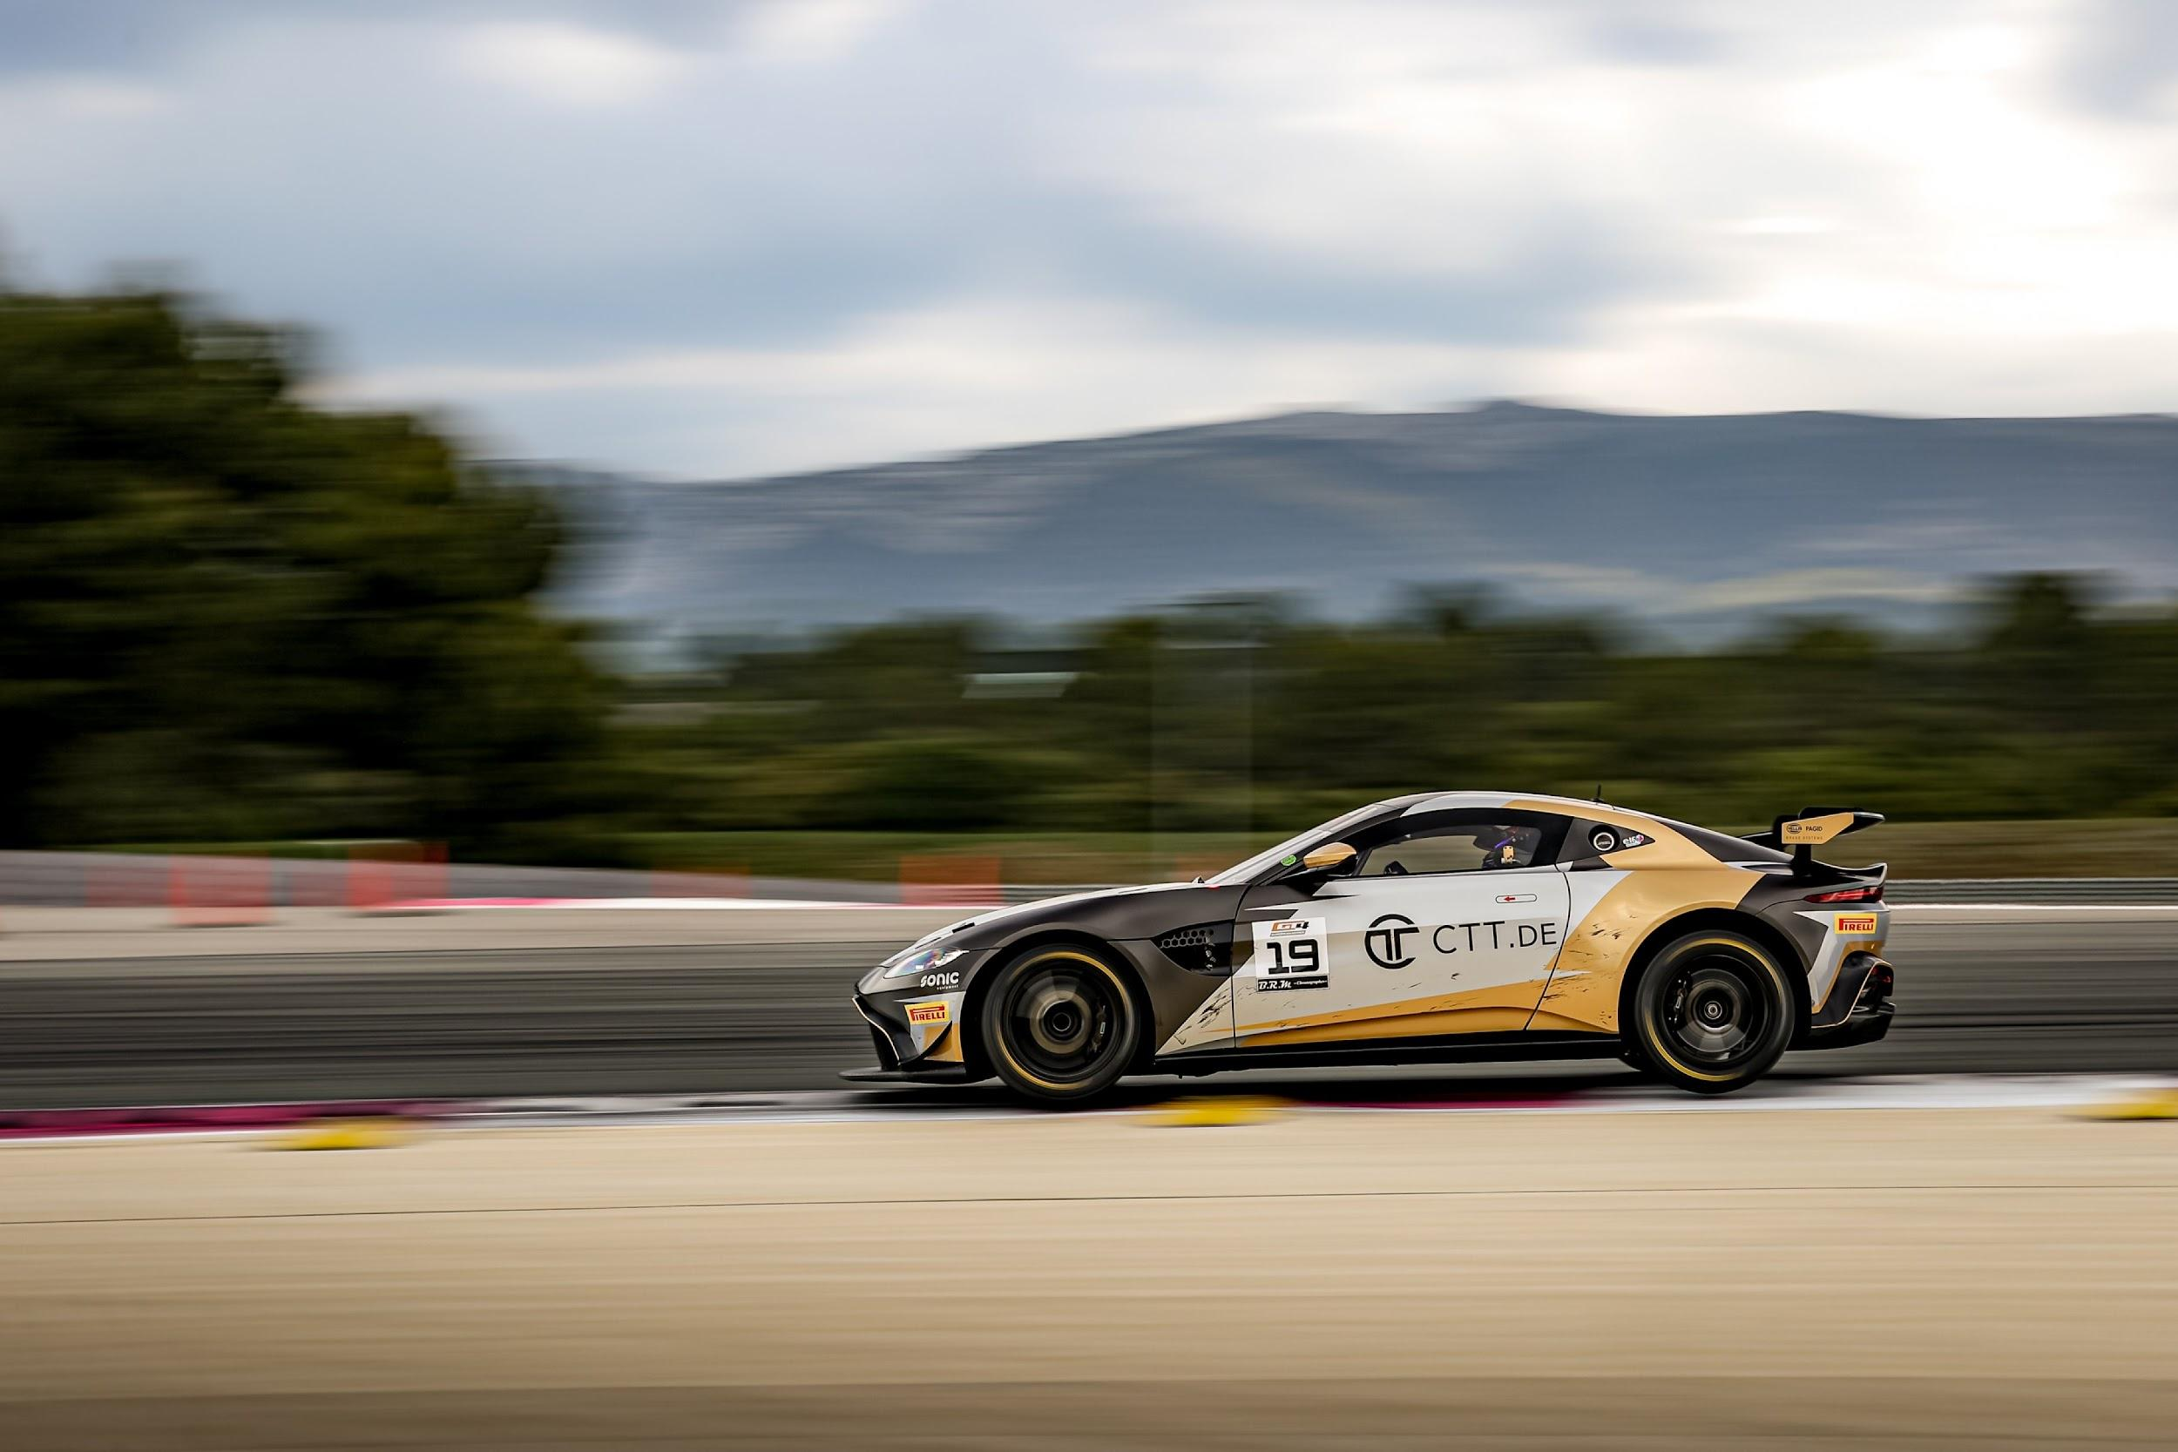
Andreas and Jessica Bäckman had a tough weekend at Circuit Paul Ricard at the second round of the European GT4 championship GT4 Europe.
Photo: GT4 Europe (Free rights to use the image)
Last weekend, June 2nd-4th, the siblings Andreas and Jessica Bäckman competed at the French Paul Ricard track at the second round of the GT4 European Series in an Aston Martin Vantage GT4 car. It was also their first race with the German team racing one, that the siblings are competing with in the European championship.
- It was a weekend that we learned a lot from, it is always a lot to learn when we come to a new team but we took big steps during the weekend. It was another weekend with messy qualifyings and races, but we will come back even stronger for the next race, Andreas Bäckman says.

Last weekend, June 2nd-4th, the Bäckman siblings competed in the GT4 European Series at the French track Circuit Paul Ricard, located near Marseille in the south of France. On the starting grid the Bäckman’s were up against 57 of the best GT4 cars/drivers in the world.
Many learnings but tough weekend for the siblings
It was an up-and-down weekend with both successes and setbacks. The siblings competed in a new team this weekend, racing one. So it was important to get to know the team, how they work and also how they set up the car. A lot of progress was made during the weekend and the speed was there at times during the weekend.
Saturday morning started with a difficult qualifying for the siblings as all of the 57 cars on the track made it difficult to get clear laps without traffic on track. Jessica qualified 42nd in the first qualifying and Andreas 13th in the second qualifying.
That meant that Jessica started the first race in 42nd position on the Saturday afternoon. There she had a good start but was involved in an incident that damaged the front of the car and thus had to retire the car from the race directly on the first lap.

The team worked on fixing the car but unfortunately the car was too damaged to be able to start the second race.
- The qualifying did not turn out as I had hoped, both traffic and track limits caused the trouble. Then we knew that the race would be tough when you are at the back, unfortunately there was an incident that damages the front of the car. It’s sad when we know we can perform much better, but there are more races coming up so we have to look forward to them, Jessica Bäckman says.
- It was a weekend that we learned a lot from, it is always a lot to learn when we come to a new team but we took big steps during the weekend. It was another weekend with messy qualifyings and races, but we will come back even stronger for the next race, Andreas Bäckman says.

Andreas and Jessica’s results:
Free Practice 1: 7th place
Free Practice 2: 45th place
Timed Qualifying 1 (Q1): 42nd place
Timed Qualifying 2 (Q2): 13th place
Race 1: DNF (Retired)
Race 2: DNS (Did not start)

TV links in case you missed last weekend’s qualifying and race:
Click here to see Qualifying 1 and 2
Click here to see Race 1

Next up for the siblings is the second round of the ADAC GT4 Germany championship in two weeks time, June 23rd-25th, at Circuit Zandvoort, located near Amsterdam in the Netherlands.

GT4 Europe Calendar 2023:
April 21st-23rd - Monza, Italy
June 2nd-4th - Paul Ricard, France
June 29th - July 2nd - Spa-Francorchamps, Belgium
July 14th-16th - Misano, Italy
September 1st-3rd - Hockenheim, Germany
September 29th - October 1st - Barcelona, Spain

Free rights to use the images.
Download press-pictures here:
http://bit.ly/jabaeckman-photos
https://www.mynewsdesk.com/se/ja-backman/images

