Mixed results for the Bäckman siblings at Spa
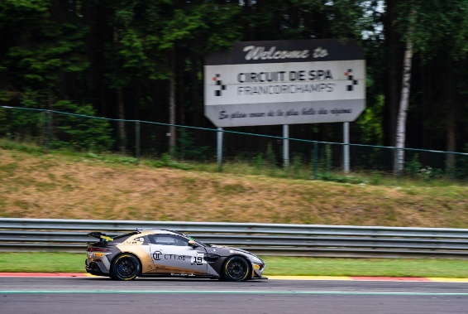
Andreas and Jessica Bäckman had a weekend of mixed results at the Circuit de Spa-Francorchamps at the third round of the GT4 European Series. Photo: racing one (Free rights to use the image)
Last weekend, June 29th - July 1st, Andreas and Jessica Bäckman competed at the Belgian Spa Francorchamps circuit at the third round of the GT4 European Series in an Aston Martin Vantage GT4 car. It was a weekend with mixed results but also some positive things to take away from the weekend.
- It was a learning weekend for us and we had good speed in qualifying, unfortunately we didn't get to show it because traffic and track limits prevented it. But in the rainy Race 2, we were one of the fastest cars and advanced up through the field, Jessica Bäckman says.

The previous weekend, June 29th - July 1st, the Bäckman siblings competed in the European GT4 Championship at the Belgian Circuit de Spa-Francorchamps, located approximately 150 km from the Belgian capital, Brussels. On the starting line, Bäckman faced 62 of the best GT4 drivers/cars in the world.
Learning weekend for the siblings
The weekend started with a training session on Tuesday. Next on Wednesday was the annual parade from the track into the town of Spa, where over 200 GT4 and GT3 cars lined up.
During Thursday, the race weekend continued with two more practice sessions. On Friday morning it was then time for the two time qualifyings. Andreas drove the first qualifying and Jessica the second qualifying.
Both Andreas and Jessica had a better feeling in the car during qualifying. Andreas qualified 15th overall for the first race, but there was potential for more.
- I was on a really good lap in qualifying, but unfortunately I lost a lot of time because cars came running out of the pits on my fast lap and didn't move out of the way. The speed was there to be able to qualify in the top 3, so it was a bit frustrating. But at the same time it was positive that the speed was there to be able to challenge for the fastest lap times, Andreas Bäckman says.
Jessica also had a good feeling in the car during qualifying and set a time that would have been enough for 12th place overall. Unfortunately, the lap time was deleted due to track limits and therefore she ended up in 34th place overall, even though she also had the potential for a much better result.
- Frustrating qualifying that started with a red flag, after that there was a restart and I knew I only had one chance while the tires were at their best to get a good lap which I managed, but unfortunately the lap was then canceled due to track limits by only a few centimeters and then I had to settle for 24th place in our class, Jessica Bäckman says.
For the first race on Saturday evening, Andreas started the race in 15th place overall. Unfortunately, the speed wasn't quite there for the first half of the race, so he dropped down the field. Then there was a messy pit stop when it was time for the driver change. But Jessica was responsible for a strong recovery after the struggle and drove herself up to 24th place in the silver class.
In Sunday's race, it was the first time this weekend that there was a lot of rain and therefore there were completely new conditions for all drivers and teams. Both siblings had a good race and showed that they had good speed in the difficult conditions. Jessica made it through the start and the first half of the race despite poor visibility and many incidents out on the track, driving up through the field. They then made a good pit stop with the driver change, which went flawlessly.
Andreas then drove up further at the end of the race and they finished in 18th place overall from 34th starting position. They had good speed throughout the race and were one of the fastest cars out on the track.

Unfortunately, the tenths were on the wrong side and the pit stop was 0.3 seconds faster than the minimum time allowed, giving them an 11 second added time and therefore they were dropping down to a final 26th place overall and 20th in class.

- It was a learning weekend for us and we had good speed in qualifying, unfortunately we didn't get to show it on the track because traffic and track limits prevented it. But in the rainy Race 2, we were one of the fastest cars and advanced up through the field, Jessica Bäckman says.

Andreas and Jessica’s results (Silver class):
Free practice 1: 20th place
Free practice 2: 3rd place
Qualifying 1 (Q1): 10th place
Qualifying 2 (Q2): 24th place
Race 1: 24th place
Race 2: 20th place

TV links in case you missed last weekend’s qualifying and races:
Click to watch Qualifying 1 & 2
Click to watch Race 1
Click to watch Race 2

Next up for the siblings is the fourth round of the GT4 European Series in two weeks, July 14-16th, at the Misano World Circuit Marco Simoncelli, located near Bologna, Italy.

GT4 Europe Calendar 2023:
April 21st-23rd - Monza, Italy
June 2nd-4th - Paul Ricard, France
June 29th - July 2nd - Spa-Francorchamps, Belgium
July 14th-16th - Misano, Italy
September 1st-3rd - Hockenheim, Germany
September 29th - October 1st - Barcelona, Spain

Free rights to use images
Download press pictures here::
http://bit.ly/jabaeckman-photos
https://www.mynewsdesk.com/se/ja-backman/images

