pressmeddelande/rapport
www.custice.se

Halvårsnomineringar till Custice Awards 2015 – Sveriges bästa fastighetsägare för företag!

2014-12-19 1 (3)
kontakt
Mikael Glännström,
informationsansvarig
mikael.glannstrom@custice.se
tel: 0704-621202
om custice
Custice är en analys-leverantör som hjälper sina kunder med att hitta rakare vägar till ökad lönsamhet.
om tjänsten ”fakta”
Databasen ”fakta” innehåller över 216 000 företag. Tjänsten erbjuds som säljstöd för att exempelvis hitta nya kunder.

Kontakta oss för frågor eller gratis demonstration av #fakta med skarpa case!
026 – 270 700

Denna release får användas om Custice nämns som källa.
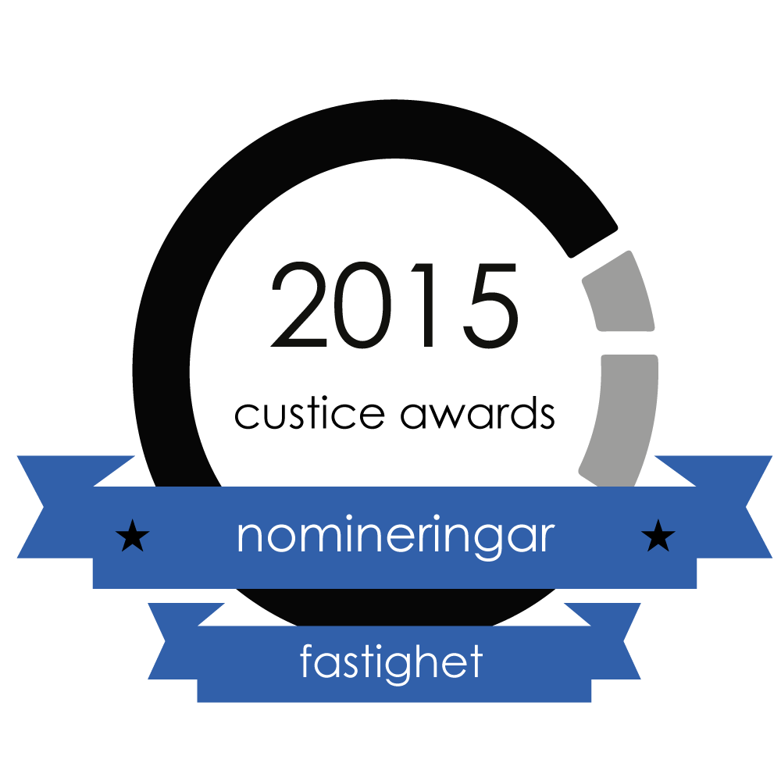
Året börjar närma sig sitt slut och det är snart dags att summera 2014 års kundnöjdhet som kommer utmynna i Custice Awards 2015 till de leverantörer som har de allra nöjdaste kunderna i Sverige! Härmed nominerar vi tre fastighetsägare i kategorin ”bästa fastighetsägare” i hela Sverige, Stockholm, Göteborg och Malmö som ligger bäst till efter det första halvåret av 2014.
Är ditt företag nominerat?
Vi kommer presentera samtliga nominerade varje måndag, onsdag och fredag fram till jul. Idag presenterar vi de fastighetsägare som ligger bäst till efter juni 2014 i kategorin ”bästa fastighetsägare” i hela Sverige, Stockholm, Göteborg och Malmö. Fastighetsägare som inte är nominerade kan fortfarande gå om och vinna en Custice Award eftersom det är jämnt i toppen.
Prestigefylld utnämning
Detta blir det andra året vi presenterar Custice Awards. Custice Awards 2014 togs väl emot av bransch och media med publiceringar i ibland annat IDG, Fastighetsnytt och Telekomidag. Undersökningen av kundnöjdhet i dessa branscher är den största i Sverige med upp till 18 500 svar i varje kategori, hämtade ur vår intervjudatabas #fakta.

pressmeddelande/rapport
www.custice.se

Halvårsnomineringar till Custice Awards 2015 – Sveriges bästa fastighetsägare för företag!

2014-12-19 2 (3)
kontakt
Mikael Glännström,
informationsansvarig
mikael.glannstrom@custice.se
tel: 0704-621202
om custice
Custice är en analys-leverantör som hjälper sina kunder med att hitta rakare vägar till ökad lönsamhet.
om tjänsten ”fakta”
Databasen ”fakta” innehåller över 216 000 företag. Tjänsten erbjuds som säljstöd för att exempelvis hitta nya kunder.

Kontakta oss för frågor eller gratis demonstration av #fakta med skarpa case!
026 – 270 700

Denna release får användas om Custice nämns som källa.

Custice Awards 2015 prisutdelning till alla vinnare startar måndagen den 16:e mars och pågår till fredagen den 27:e mars. Missa inte det!

Nominerade företag
De nominerade företagen presenteras i bokstavsordning, utan inbördes ranking. Företag som ej är nominerade kan göra ett starkt andra halvår och vinna Custice Awards, men de nominerade företagen ligger för närvarande bäst till.

Bästa fastighetsägaren i hela Sverige
Hufvudstaden
Norrporten
Platzer

Bästa fastighetsägaren i Stockholm
Diligentia
Fabege
Vasakronan

pressmeddelande/rapport
www.custice.se

Halvårsnomineringar till Custice Awards 2015 – Sveriges bästa fastighetsägare för företag!

2014-12-19 3 (3)
kontakt
Mikael Glännström,
informationsansvarig
mikael.glannstrom@custice.se
tel: 0704-621202
om custice
Custice är en analys-leverantör som hjälper sina kunder med att hitta rakare vägar till ökad lönsamhet.
om tjänsten ”fakta”
Databasen ”fakta” innehåller över 216 000 företag. Tjänsten erbjuds som säljstöd för att exempelvis hitta nya kunder.

Kontakta oss för frågor eller gratis demonstration av #fakta med skarpa case!
026 – 270 700

Denna release får användas om Custice nämns som källa.

Bästa fastighetsägaren i Göteborg
Eklandia
Platzer
Wallenstam

Bästa fastighetsägaren i Malmö
Briggen
Stena
Vasakronan

