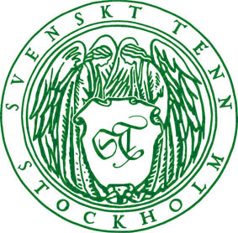

Press release
Stockholm, September 4, 2014

Svenskt Tenn celebrates 90th anniversary with an inspirational magazine
On October 25, 1924, Estrid Ericsson opened Svenskt Tenn in Stockholm, Sweden. For the upcoming 90th anniversary – that has been in the focus throughout this year in new products introductions and in exhibitions – an inspirational magazine is released.

’’We want to paint a picture of Svenskt Tenn of today and share a selection from our company history, some of which is perhaps less known. For example the fact that Svenskt Tenn is owned by a foundation, and how the contribution from Svenskt Tenn has enabled the foundation to support important causes’’ said Thommy Bindefeld, Marketing Director at Svenskt Tenn.
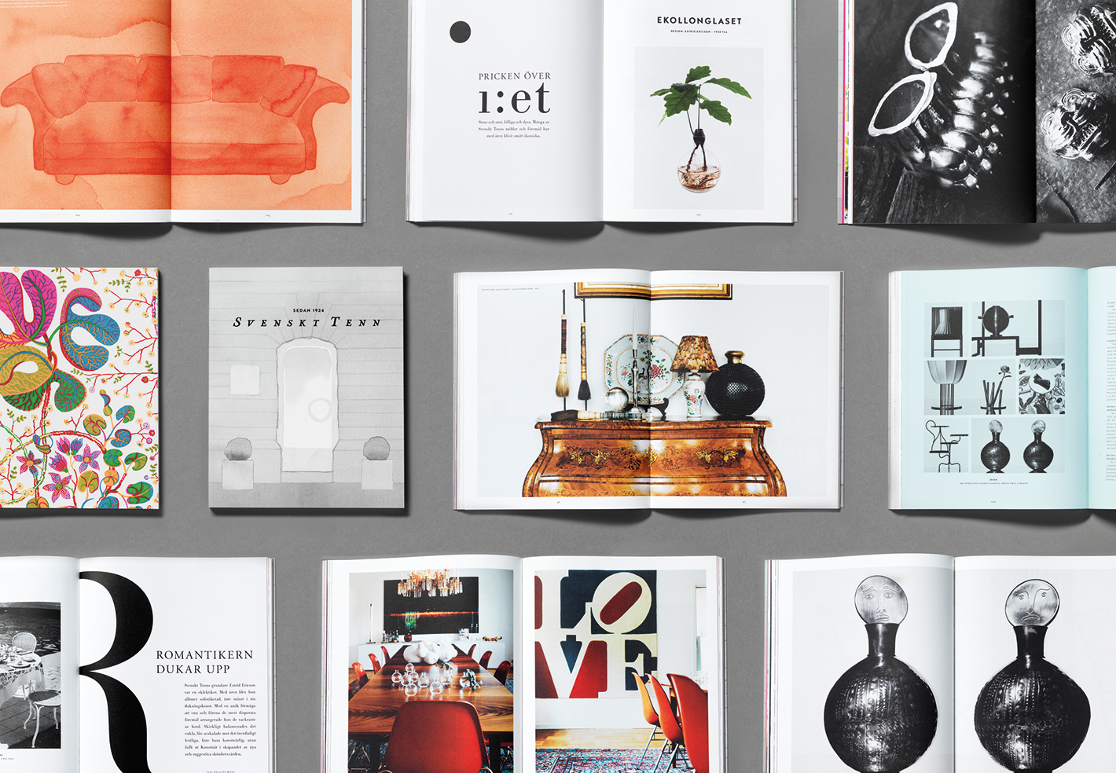
Journalist Annica Kvint has been the editor of the magazine and Planeta Design did the graphic design and art direction. Other contributors were writers Anita du Rietz, Petter Eklund and Christian Björk, stylist Mikael Beckman and decorator Karin Södergren. There are images by photographers Tobias Regell, Roland Persson, Emil Larsson, and illustrations by Mats Gustafsson.

The magazine, priced SEK 150 is available through Svenskt Tenn’s web shop or the store in Stockholm from September 5. It will also be available for online browsing at www.svenskttenn.se.

For further information, please contact:

Vicky Nordh, Marketing Assistant: +46 8-670 16 23 or vicky.nordh@svenskttenn.se

Thommy Bindefeld, Marketing Director: +46 8 670 16 02 or thommy.bindefeld@svenskttenn.se

Image bank: www.svenskttennpress.se User name: Press Password: Tenn

