

**PRESS RELEASE**

**For immediate release: Friday 22 November 2013**

**Healthcare recruiter’s ‘Pride Without Prejudice’ campaign raises funds for the Philippines**

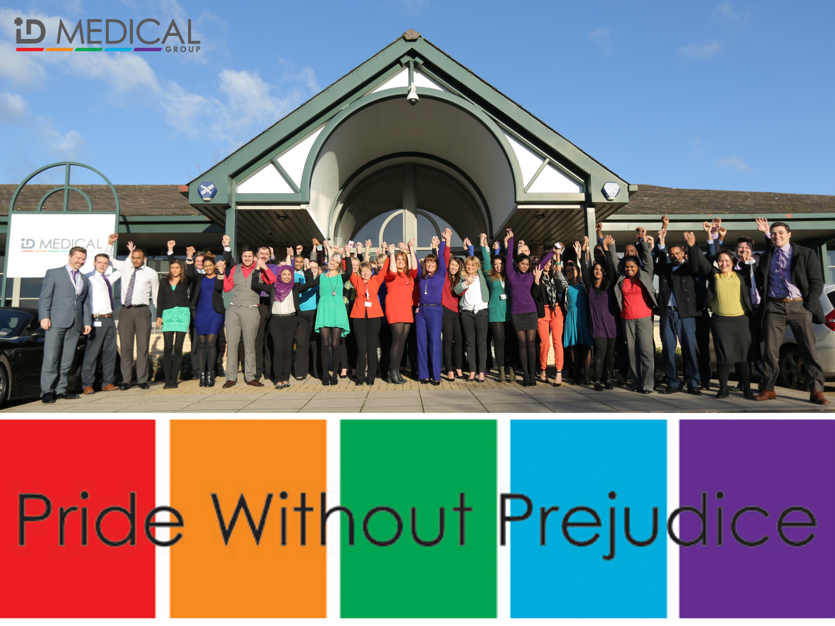

Responding to the disaster caused by Typhoon Haiyan, multi-disciplinary healthcare recruiter [ID Medical](http://www.id-medical.com/typhoon-haiyan-appeal) this week launched its [‘Pride Without Prejudice’](http://www.id-medical.com/typhoon-haiyan-appeal) nationwide fundraising campaign to help ensure the people of the Philippines receive the life-saving emergency help they urgently need.

Today (Friday 22 November), the force of almost 300 ID Medical employees came to work wearing one of the company’s five vibrant logo colours, a brand every member of staff is proud of, and will each donate a minimum £2 to the cause, with the company directors pledging to match pound-for-pound the total raised by ID Medical staff.

The philanthropic initiative, underpinned by ID Medical’s ‘Together we will make the difference’ philosophy, also invites the recruiter’s valued customers to join its employees in raising funds for the Disasters Emergency Committee ([DEC](http://www.dec.org.uk/)) - the organisation which coordinates responses to major disasters overseas, enabling the British public to donate to British aid agencies in times of crisis.

Caryn Cooper, ID Medical’s head of marketing and CSR ambassador commented, “With many of ID Medical’s candidates originating from the Philippines, we really wanted to involve everyone in our fundraising campaign; employees, candidates and clients. It’s about everyone uniting, coming together to make the difference and giving all we can to support the people of the Philippines following their catastrophic ordeal.”

One nurse from the Philippines working through ID Medical responded to the fundraising campaign: **“**Thank you ID Medical group. This means a lot to all of us Filipino people. From the bottom of my heart, thank you!”

ID Medical has set up a JustGiving page for donations to the DEC and will be sharing the fundraising campaign’s progress via its social networks.

[www.justgiving.com/idmedical](http://www.justgiving.com/idmedical)

<https://twitter.com/IDMedical>

<https://www.facebook.com/IDMedical>

**ENDS**

**About ID Medical**

Award-winning, multi-discipline healthcare recruiter ID Medical was formed in 2002 and is a superior quality supplier of locum doctors, nurses, allied health professionals and clerical staff to over 90% of NHS hospitals and private medical sector organisations.

From its headquarters in Milton Keynes as well as its central London office, ID Medical provides practical, cost-effective and innovative workforce solutions, supplying more than 3 million hours to the NHS per annum. Crown Commercial Service (CCS), HealthTrust Europe (HTE) and London Procurement Partnership (LPP) framework approved, ID Medical supplies medical staff into over 38,000 available shifts per month in hospitals nationwide.

Within each of its professional divisions, the workforce solutions provider has dedicated client and candidate teams covering the multitude of medical specialties and roles to ensure every valued customer receives its premier level service, ultimately ensuring patients are always put first. Further to this, ID Medical School was launched in 2014 to offer candidates Continuing Professional Development accredited courses and workshops to enhance their medical careers.

Since its foundation, the company has earned itself industry-wide accreditation and success with an amounting collection of accolades. These include the Recruiter FAST 50, Real Business Hot 100, Recruitment International Top 250 and The Sunday Times Virgin Fast Track 100. Most notably, through an abiding focus on employee satisfaction, ID Medical was crowned Recruitment International’s ‘Best Recruitment Company to Work for 2013’ and made its debut in The Sunday Times Best Companies to Work for 2014 at list position 33. ID Medical is delighted that for the second year running it features in The Sunday Times Best Companies to Work for 2015.

For more information please visit our website at [www.id-medical.com](http://www.id-medical.com/), view our[Facebook](https://www.facebook.com/IDMedical) page or follow us on Twitter [@IDMedical](https://twitter.com/IDMedical).

For further information on ID Medical please contact:

**Caryn Cooper**

head of marketing

Description: markdes

ID MEDICAL - ID House - 1 Mill Square - Wolverton Mill South - Milton Keynes - MK12 5ZD

**t:** +44 (0) 1908 555 498 **f:** +44 (0)1908 552 825

**w:** id-medical.com   **e:** [caryn.cooper@id-medical.com](mailto:caryn.cooper@id-medical.com)

[Description: FaceBook-icon.png](http://www.facebook.com/IDMedical)  [Description: Twitter-icon.png](http://www.twitter.com/idmedical)  [Description: g-plus-icon-48x48.png](https://plus.google.com/104338735298043774830/posts)  [Description: Youtube-icon.png](http://www.youtube.com/user/IDMedical2012/videos)