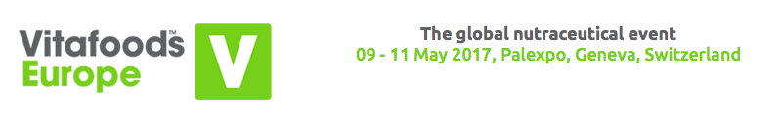

**Innovation Bonanza: 95% of nutrition companies**

**planning product launches**

**For immediate release:** Thursday 27 April 2017

The vast majority of nutrition and nutraceutical companies are planning to launch new products this year, research has shown.

The organisers of Vitafoods Europe (9-11 May, Palexpo, Geneva) surveyed 192 of their exhibitors and visitors.* More than nine in ten (95%) said they would launch at least one new product over the next 12 months, an increase on last year’s figure of 92%.

The figures paint a picture of innovation across the industry, with Vitafoods exhibitors and visitors alike planning new offerings. Almost half (46%) said they would launch between one and four new products, with 25% planning five to nine. An impressive 20% said they would launch ten or more.

Year on year, businesses use Vitafoods Europe as a platform for launches, with hundreds of new ingredients being exhibited and demonstrated at this year’s event. In the New Products Zone, visitors will be able to see and experience 120 products launched over the past year, while the New Ingredients Zone will showcase 66 new ingredients.

Chris Lee, Managing Director, Global Health and Nutrition Network, Europe, Informa Exhibitions, said: “The global nutrition industry is looking particularly dynamic at the moment. The fact that the vast majority of companies are planning new launches is testimony to their commitment to innovation. We’ve worked hard to ensure that Vitafoods Europe reflects that, and supports companies with new launches as much as possible.”

The event offers a wealth of advice for visitors planning to bring new products to market. At the new Vitafoods Innovation Centre, they will be able to book a free consultation with analyze & realize GmbH, who are offering their expertise and creativity to help companies deliver tailor-made innovation solutions.

# When asked which three health benefit areas were most important for their companies, one in three (33%) respondents listed general health and well-being. Three in ten (31%) listed cardiovascular health and healthy ageing, and 29% listed weight management and bone and joint health.

**\*Notes to editors**

Survey of 192 Vitafoods Europe visitors and exhibitors carried out between between 6 December 2016 and 3 February 2017.

**About Vitafoods Europe**

Vitafoods Europe is the global nutraceutical event, featuring exhibitors from all over the world in four key market areas: ingredients & raw materials; branded finished products; contract manufacturing & private label; and services & equipment. The event offers a range of visitor attractions, including an industry-leading education programme.

Vitafoods Europe is part of Informa Exhibitions’ Global Health & Nutrition Network (GHNN), which brings together a portfolio of events, digital media and publishing for marketers, manufacturers and formulators of nutrition and dietary supplements, healthy foods/beverages and personal care products. GHNN’s events include Vitafoods Europe, Vitafoods Asia, SupplySide West and SupplySide East.

Natural Products INSIDER is the global media brand covering healthy ingredients and finished applications. Vitafoods Insights offers online content and a series of topic-specific digital magazines that bring highlights of the Vitafoods events to a global audience. For more information, visit [www.informaglobalhealth.com](http://www.informaglobalhealth.com/). [SupplySide West & Vitafoods Global Storefronts](http://storefronts.supplysideshow.com/) offers a new online environment where ingredient buyers and product developers can find and connect with the suppliers and solutions they need, all year long.