Kongsberg Digital launches remote, simulation-based DP training, accredited by The Nautical Institute

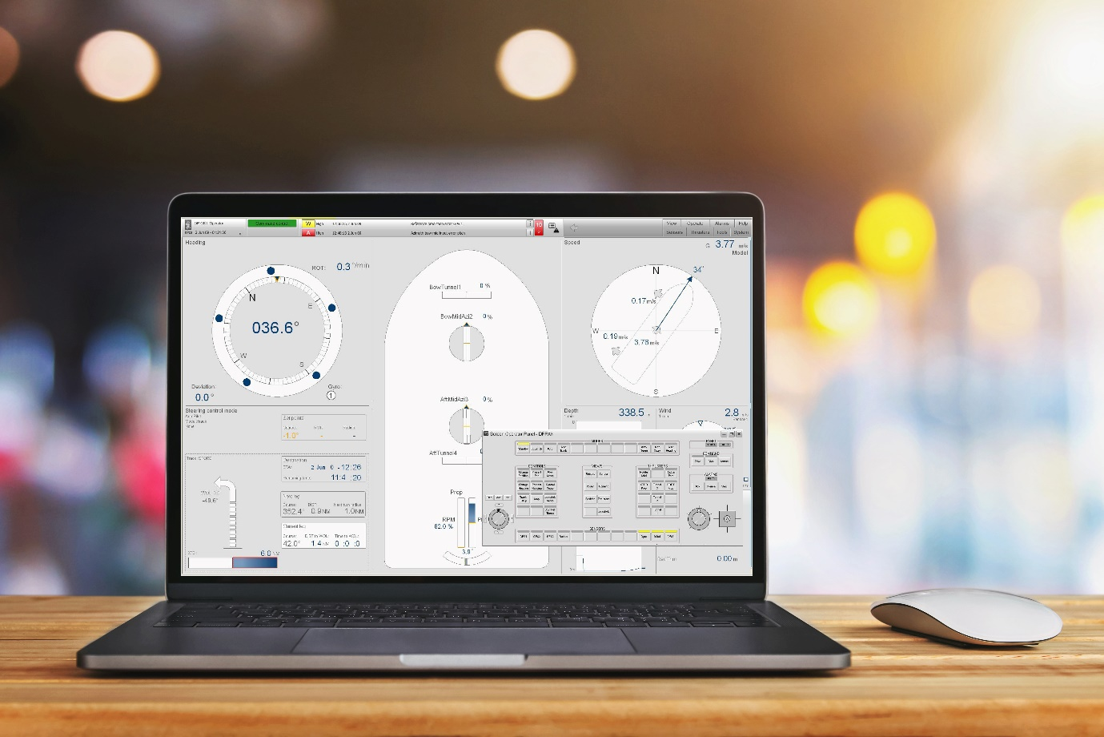
Kongsberg Digital’s cloud-based solutions give students access to advanced simulations from their own PCs
Kongsberg, Norway, February 1st, 2021 – Kongsberg Digital (KDI) and The Nautical Institute are pleased to announce an approved remote simulation solution for Dynamic Positioning (DP) Induction Courses. This has been developed by KDI to support training centers worldwide during the COVID-19 pandemic lockdowns, and has now been approved by The Nautical Institute.
Since the start of the pandemic, KONGSBERG has been ramping up the delivery of cloud-based eLearning and remote training solutions to support education and training institutes and meet the challenges imposed by the impossibility of carrying out tuition in a physical classroom situation. The latest addition to its cloud-based simulation training solutions is a remote DP simulation application, which enables instructors to continue providing their students with mandatory DP simulation-based education through remote access to KONGSBERG’s cutting-edge K-Sim DP technology.
As a response to the COVID-19 situation, the NI has reviewed and approved the use of KONGSBERG’s cloud-based remote DP simulators, equivalent with the NI Class C DP simulators required for the DP Induction courses. By temporarily approving remote simulation training, The Nautical Institute is helping the industry to maintain mandatory DP skills through the pandemic crisis. The remote training solution is valid until April 1st, 2021, with the option to further extend approval depending on the coronavirus situation.
Over the last 10 months, cloud-based simulation has proved indispensable in enabling training centers to deliver essential courses. KDI’s eLearning modules and remote training solutions provide online access to many of the company’s high-fidelity simulators via the K-Sim Connect portal, enabling distance learning and permitting students to continue to take courses and acquire basic skills outside the training center.
“It’s encouraging to know that our latest remote simulation technologies are helping students to attain DP skills even in these difficult times,” says Andreas Jagtøyen, Executive Vice-President, Digital Ocean, Kongsberg Digital. “I strongly believe that the new cloud-based simulation solutions we are now providing represent the future of maritime training and will continue to act as cost-effective teaching aids when COVID-19 has been consigned to history.”
“The functionality of Kongsberg Digital’s remote DP solution has been demonstrated and found fit for purpose. It has therefore been temporarily approved for remote DP Induction Courses until the end of the COVID-19 period. It is of course subject to continual review as its usefulness for instructors and trainees alike is unquestionable,” adds Qasim Masood, Accreditation Manager, Dynamic Positioning Department, The Nautical Institute. “We’re pleased to give our approval to this solution, which is of great help in training the next generation of DP operators, particularly when more traditional training delivery arrangements are not viable.”
Ends

For further information, please contact:

Anne Voith
Communications & Marketing Manager,
Maritime Simulation
Kongsberg Digital
Tel: +47 4567 8255
anne.voith@kdi.kongsberg.com

David Pugh
Saltwater Stone
Tel: +44 (0)1202 669244
d.pugh@saltwater-stone.com

About Kongsberg Digital
Kongsberg Digital is a provider of next-generation software and digital solutions to customers within maritime, oil and gas, and renewables and utilities. The company consists of more than 500 software experts with leading competence within the internet of things, smart data, artificial intelligence, maritime simulation, automation and autonomous operations.
Kongsberg Digital is subsidiary of KONGSBERG (OSE-ticker: KOG), an international, knowledge-based group delivering high-technology systems and solutions to clients within the oil and gas industry, subsea, merchant marine, defense and aerospace. KONGSBERG has 11.000 employees located in more than 40 countries.
Web: Kongsberg Gruppen | Kongsberg Digital
Social media: LinkedIn | Twitter | Facebook

About The Nautical Institute
The Nautical Institute (NI) is an international organization for maritime professionals, with membership that encompasses a broad range of experience across the maritime domain, both afloat and ashore. The expertise of the NI is recognized at the International Maritime Organization, where the NI has status as a non-governmental organization (NGO).
The Nautical Institute is the leading certification organization for DPO qualifications, which are held by over 25,000 mariners world-wide.
Web: The Nautical Institute

