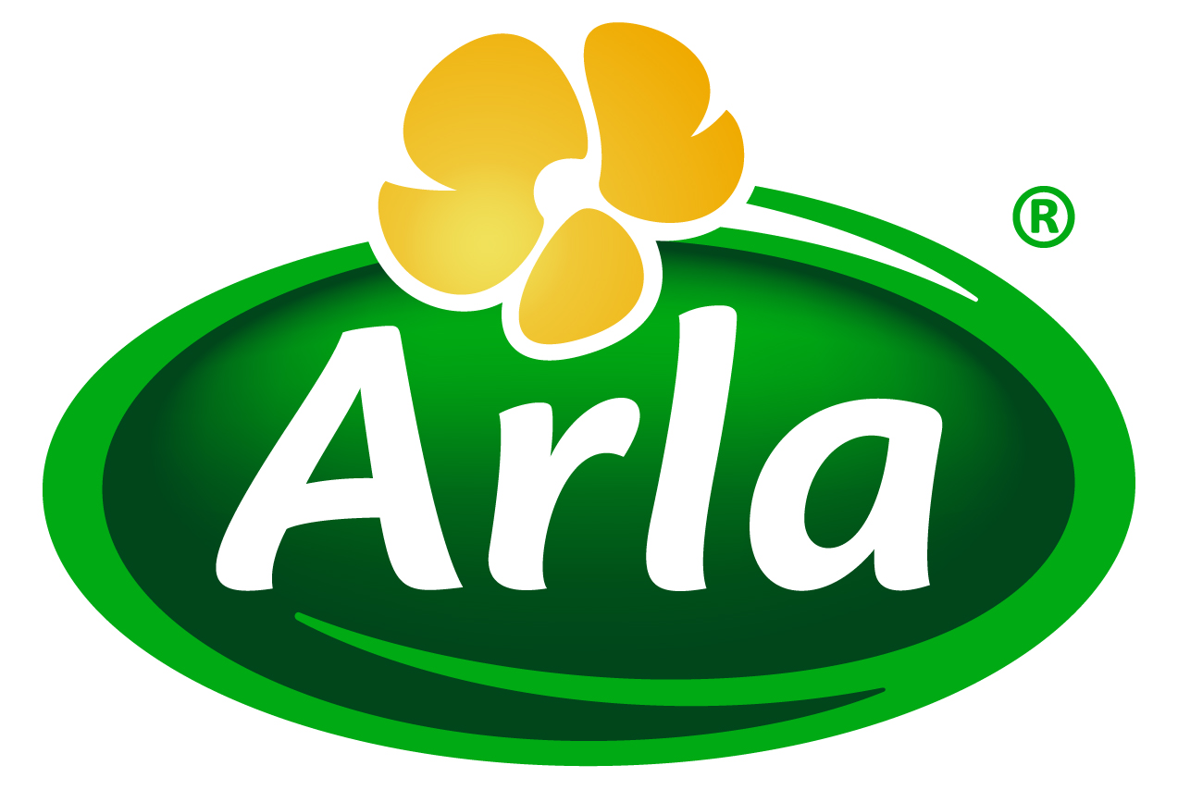
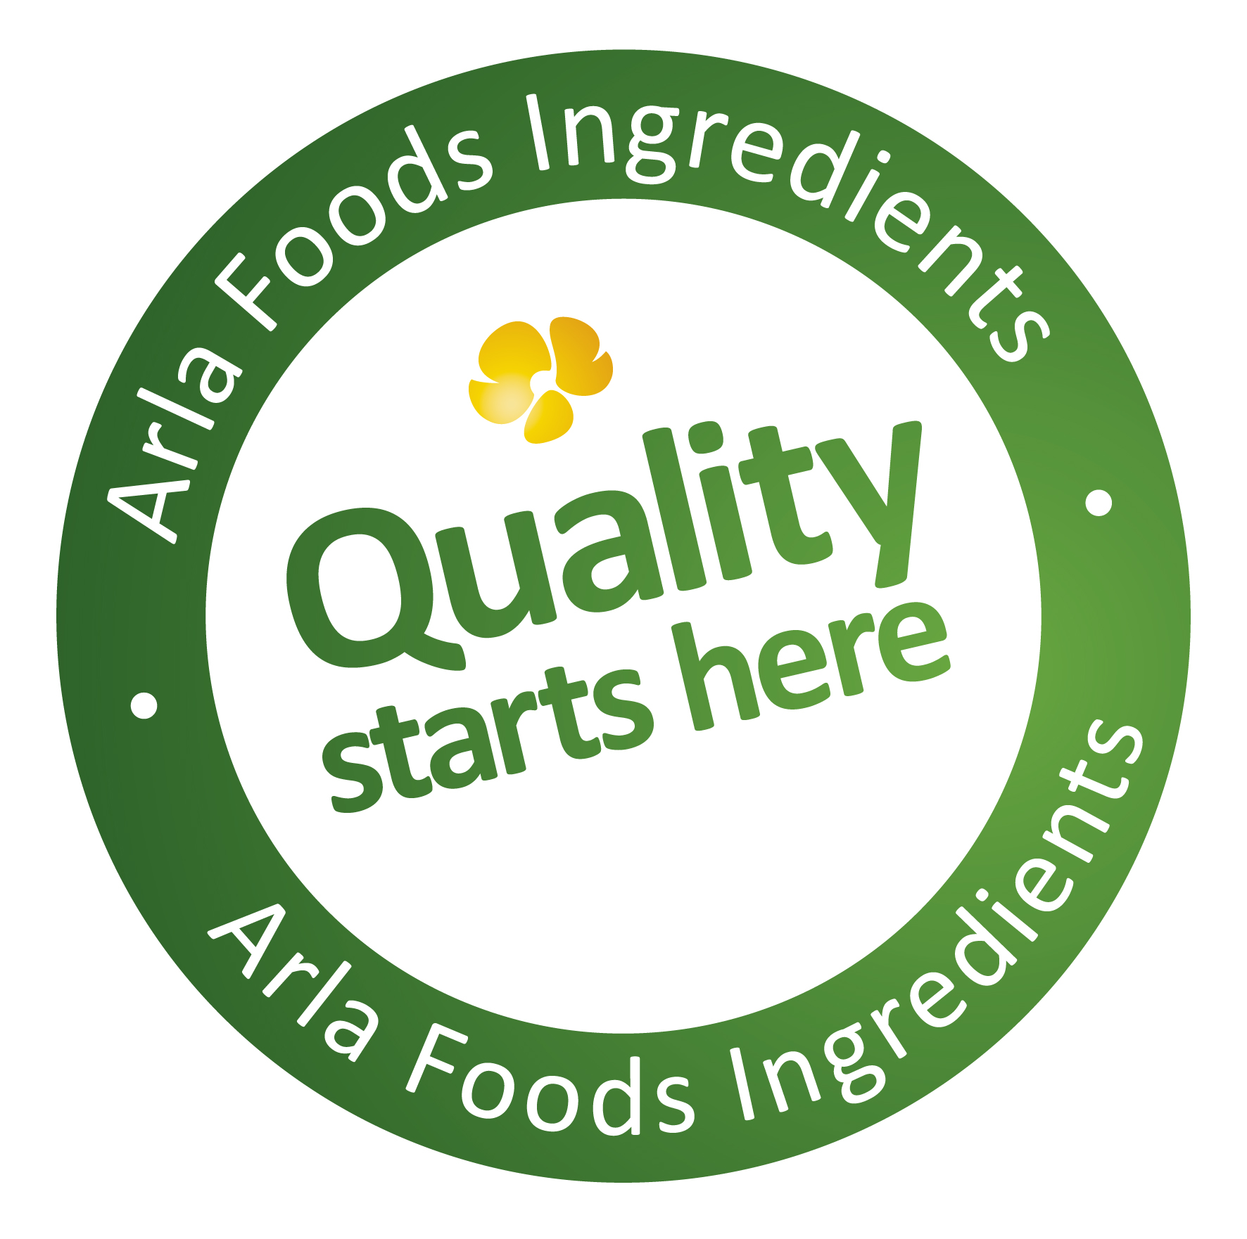

31 May 2016
PRESS RELEASE
Acid whey isn’t waste – it’s a goldmine,
says Arla Foods Ingredients

Many dairy companies are yet to realise that their acid whey is a valuable raw material that can be used to create high quality and nutritious consumer products, according to Arla Foods Ingredients.

Acid whey is a by-product of a number of popular dairy goods – most famously Greek yoghurt, but also a number of cheeses including cottage and cream cheeses. Traditionally companies have treated acid whey as waste. But when further processed – in combination with whey proteins – it offers enormous potential as the base for a range of dairy products.

Arla Foods Ingredients is promoting the possibilities presented by acid whey as part of a new campaign called Maximum Yield. The awareness drive is seeking to change perceptions of acid whey and explain how dairy companies can use it to maximise their output, increase profits and significantly cut waste.

Claus Andersen, Category & Application Manager at Arla Foods Ingredients, said: “Acid whey remains an untapped goldmine. It contains the same minerals as milk, which means it offers the same benefits to bones, teeth and general health. But it is often disposed of in waste streams or sold for little or no profit to farmers for use in animal feed. Our Maximum Yield campaign is highlighting how it can instead be converted into high value consumer products and, in turn, enable dairies to boost their efficiency by using 100% of their milk and not just a portion of it.”

Yields for some dairy products are typically only 25-50% of the milk used. In the case of Greek yoghurt, for example, only 33% of the milk ends up in the finished product: the remaining two thirds is acid whey. In addition to impacting on its efficiency and profitability, this can damage a dairy company’s sustainability credentials. Waste is among the leading consumer concerns in today’s food and beverage industry, and Euromonitor International has ranked sustainable food production among its top 10 trends for 2016.

To enable dairies to maximise their yields, Arla Foods Ingredients has developed a range of Nutrilac® whey protein solutions which, when added to acid whey, make it possible to transform it into a wide selection of high quality and nutritious dairy products.

Possible applications include cream cheese, processed cheese, dips, beverages, stirred yoghurts and desserts. As well as supplying the Nutrilac® whey proteins, Arla Foods Ingredients provides full technical support to help dairy companies use them with their acid whey.

Claus Andersen added: “If you go back 30 years, whey protein from cheese making was viewed as a by-product with little value. Now it is recognised as a high value ingredient with almost endless possibilities in multiple sectors such as dairy, bakery and sports nutrition. We are at a similar stage now with acid whey. It is an exceptional raw material, but many processors don’t know how to unlock its potential. Nutrilac® whey protein solutions are the key to achieving this and – with our expertise and technical support – we can show dairies just how easy it is.”

ENDS

For more information, please contact:
Ann Eshaw, Ingredient Communications
Tel: +44 141 280 4141 | Cell: +44 790 822 8575
Email: ann@ingredientcommunications.com
@ingredientcomms

About Arla Foods Ingredients
Quality starts here: Arla Foods Ingredients is a global leader in natural whey ingredients for products in a range of categories – from sports, clinical and infant nutrition to beverages, bakery, dairy and ice cream.

The cornerstones of our business are innovative ingredients, world-class facilities and a staff of dedicated experts. Drawing on our portfolio of functional and nutritional whey proteins, milk minerals, lactose and permeate, our expert team delivers solutions that bring new food products quickly and efficiently to market. Our application centres run hundreds of customer product trials every week. All ingredients are produced using state-of-the-art processing technology at our plant in Denmark, or by one of our joint ventures in Argentina, Germany and the UK.

Arla Foods Ingredients Group P/S is a 100% owned subsidiary of Arla Foods, a global dairy company and cooperative owned by dairy farmers in Denmark, Sweden, the UK, Germany, the Netherlands, Belgium and Luxemburg.

RSS Feed
Visit our website at http://www.mynewsdesk.com/arla-foods-ingredients and sign up to our News RSS feed for all the latest developments – updated regularly.

Twitter
Follow us on twitter for all the latest updates @ArlaIngredients

LinkedIn
http://www.linkedin.com/company/arla-foods-ingredients

10 global consumer trends for the next five years, Euromonitor (2012) http://www.euromonitor.com/10-global-consumer-trends-for-the-next-five-years/report

