THE JEWEL IN THE L.I.M CROWN

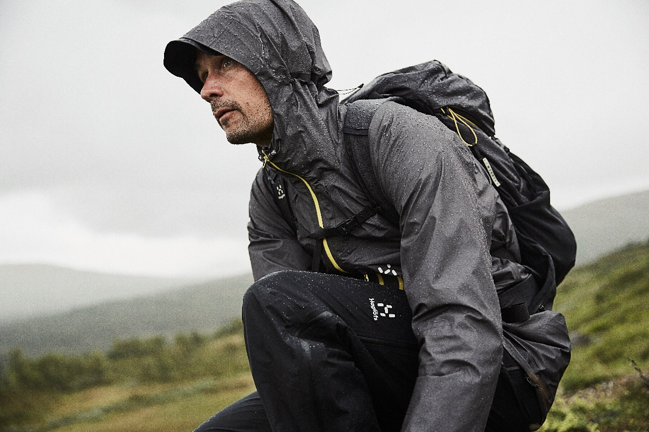

Innovation, cutting-edge design and a real understanding of the rigors of outdoor activity combined. This season, the L.I.M range is more comprehensive than ever before. Every garment in it is as light and as protective as possible. But one of the SS20 collection’s outstanding pieces - the L.I.M Crown Jacket - proves the concept like never before.

“Everything that bears the L.I.M tag is designed to be as light as we can go. Each piece needs to strike a perfect balance between low weight and high performance, making it perfect for fast, grueling outdoor activity in challenging conditions. But as well as letting the person wearing it perform to the highest standard, the gear itself has to perform - and that’s what we focused on most with the L.I.M Crown Jacket,” says Robert Olsson, Senior Designer Clothing at Haglöfs.

The jacket offers incredible breathability, comfort and protection. This is possible thanks to Haglöfs’ innovative PROOF™ material technology, which is used here to create what Robert calls “the most breathable, lightweight and waterproof 3-layer fabric available” - a state-of-the-art performance fabric that’s almost three times as breathable as the industry standard, trapping almost no moisture inside it at all, as well as being water/weatherproof enough to keep the wearer protected in even the harshest conditions. In combination with the jacket’s low weight (200g) the way it performs means it can be worn for days on end, no matter how often the weather and conditions change.

Thanks to the way it performs and protects, the jacket is perfect for fast trekking and intense outdoor activity. Since it’s designed for adventure, it’s equipped with a searchable RECCO® reflector for safety and peace of mind. It’s also been tailored for quick, easy adjustments at the hem, cuffs and hood, to let the wearer fix the fit while on the move.

As Robert Olsson puts it: “Even if something is already great, we have to see if there’s a way we can make it better – as long as we don’t sacrifice performance while we do so. Our L.I.M range is already known for being one of the most premium, protective and reliable low-weight collections out there: but with the L.I.M Crown Jacket we wanted to take it one step further.”

The L.I.M Concept – ‘Less is More’
The basic concept is simple. Remove everything unnecessary but keep what is needed. It might sound easy, but it’s a long process. Every garment is tried out, compared, evaluated, tested and reworked – over and over again. What material weighs as little as possible without sacrificing durability, flexibility, waterproofing and packability? How thin can you make a membrane without compromising its other qualities? There's always a smarter way of constructing something, but it’s never obvious. Having perfected the L.I.M Concept for 20 years, at this point Haglöfs understands this better than anyone, this is as light as it gets.

Haglöfs’ L.I.M Crown jacket will be available from Spring 2020, in Haglöfs’ own stores and online, as well as through selected retailers worldwide.

For more information, please contact:
Lisa Grübb
Global PR & Sponsorship Specialist
Lisa.grubb@haglofs.se

Haglöfs’ L.I.M Crown jacket – Product sheet:

Fabrics: PROOF™ 3-layer 100% Polyamide: this state-of-the-art laminate, combines a super light 6D, semi dull, soft, ripstop face fabric, laminated to an extremely breathable membrane and a super light jersey backer. It is the lightest, most breathable and most progressive PROOF™ laminate ever, 47 g/m² Hydrostatic head: >20,000 mm; Moisture Permeability (inverted cup): >60,000 g/m²/24h

Key Features: Breathable and ultra-lightweight jacket in 3-layer PROOF™ fabric for full wind- and waterproofing Fluorocarbon-free DWR-treated surfaces help repel water and dirt 3-way adjustable snug fitted hood RECCO® reflector in brim for searchability Drawcord-adjustable bottom hem Velcro-adjustable cuffs Two zippered pockets Centre back length 83 cm (men's size L)

Weight: 200g (Size L)

RRP:

Available in size range:
Women: XS-XXL
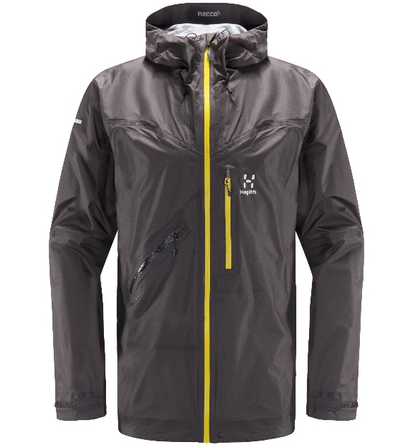
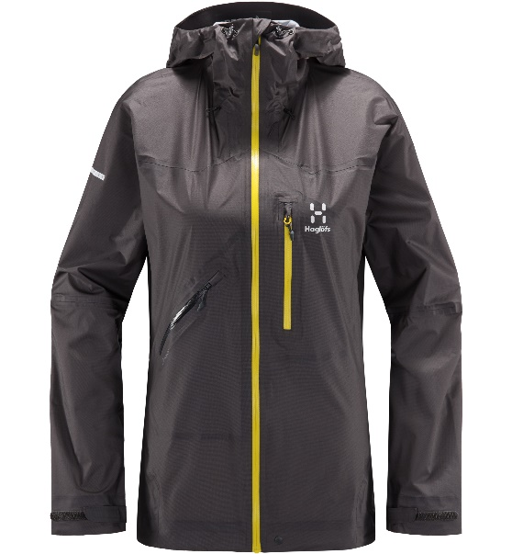
Men: S-XXL

