Press release   
  
IDKA won the 2017 Bully Award  
**Stockholm, 9 June - Idka winner of Bully Award 2017 in Barcelona**

[The Bully Awards](http://whitebull.com/award/2017-bully-awards) is all about bringing top European entrepreneurs from all stages of business, for their potential in market opportunity, competitiveness, innovation in business model and execution as well as their management team with global investors and big brands.

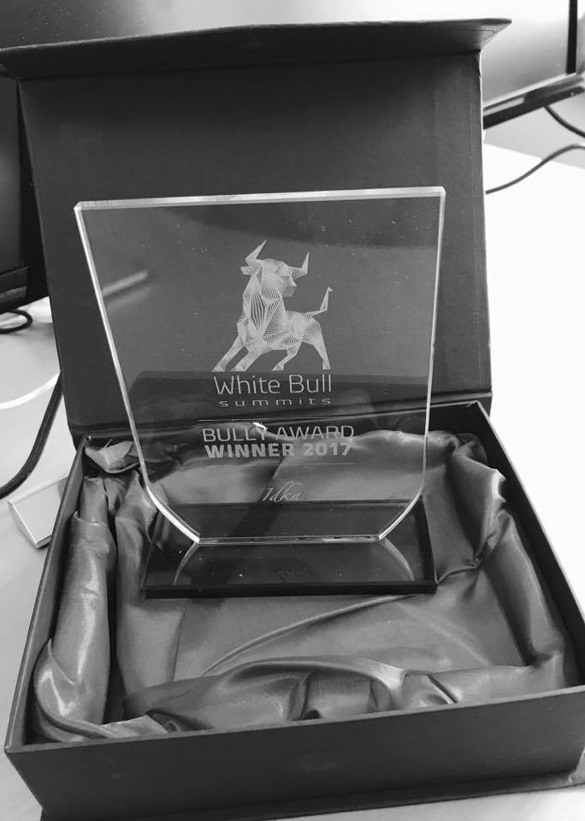Withe Bull announced that Idka AB is a Bully Award 2017 winner, recognizing the strong growth potential in reinventing collaboration and social interaction tools based on integrity, security and privacy, combined with a best-in class cloud storage and user experience.

* We are very proud of being one of the winners of the 2017 Bully Awards. This is also a great recognition for our unique business concept, says Göran Wågström, CEO, Idka. This award will be much appreciated by the team and give us further inspiration.

**For more information, please contact:**  
Mina Billing, CMO, Idka  
E-mail: [mina.billing@idka.com](mailto:mina.billing@idka.com)

**About Idka**Idka means productivity and simplicity. Idka is a clean, uncluttered, noise free and easy-to-implement, yet very functional collaboration tool. On Idka you can communicate, share and work undisturbed with colleges and friends. There is no advertising, nothing irrelevant and no-one can see, share or access your data. Communicate freely on a platform where you own your content.

Idka provides functionality that is otherwise spread across several services, all integrated in a super simple and effective user experience. When there are no disturbances, focus can be on what is important to you. Both businesses and private persons can open accounts, all with the same functionality: effective, secure, simple and add-free. Idka is not like other collaboration tools or social media. ­­

Idka is focusing on the protection of your privacy and integrity, combined with simplicity and productivity. Idka is like a newly polished floor. For more information please visit [www.idka.com](http://www.idka.com)

**White Bull**White Bull Summits (sponsored by Qualcomm Ventures) are Europe's most exclusive, and uniquely intimate gatherings in Tech, where entrepreneurs meet with global investors, big brands, and industry peers, to make meaningful and lasting connections that will accelerate their success and change the course of their lives. Several hundred start-ups took part in this year’s Bully Awards on which 60 was chosen to present their business ideas to a distinguished panel of advisors in Barcelona from 5th to 8th of June 2017. Idka was awarded the first price in the category of yearling/start-ups. For more information, visit: <http://whitebull.com>