**Shouaa Company Co. an exclusive distributor for PPO-Elektroniikka Oy in the GCC countries**

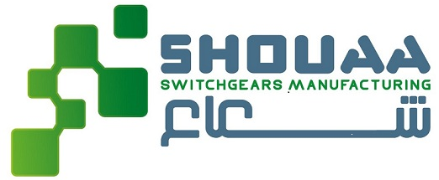PPO-Elektroniikka Oy has signed a cooperation agreement with the Saudi Arabian Shouaa Company Co.

Shouaa Company Co. exclusively represents our hospital technology in the Gulf Cooperation Council (GCC) countries of Saudi Arabia, Kuwait, the United Arab Emirates, Bahrain, Oman and Qatar.

We launched the export of the MEV-8 insulation level monitoring system in 2019. We developed a fifth-generation system for export according to international standards and also listening to the needs and wishes of the international target group.

Shouaa Company Co. is a manufacturer of low-voltage electrical panels. The company’s customers are mainly hospitals. The company was looking for a suitable partner to supply insulation level monitoring systems based on the requirements of the international IEC standard. The MEV-8 solution meets all international standards as well as the requirements of the GCC countries.

“We are very honoured to start cooperation. With Shouaa Company Co.’s strong expertise and solutions, we can provide the best possible electrical safety for hospitals in the GCC countries. We look forward long and successful cooperation with our new distributor,” says Timo Ohtonen, CEO of PPO-Elektroniikka Oy.

The MEV-8 Insulation Monitoring System monitors the safety of electrical equipment in operating rooms where defective electrical equipment can cause serious incidents. Our system has been saving lives and protecting valuable equipment in all Finnish hospitals for the last 39 years.   
  
It is a matter of safety, efficiency and cost savings. The MEV insulation level monitoring system

• protect patients and staff from electric shocks

• prevents fires and burn injuries

• ensures that unnecessary downtime can be avoided

• ensures that the service life of surgical equipment is extended.

The abbreviation MEV comes from the Finnish words "earth insulation level control".

**More information:**

Mr Timo Ohtonen, CEO, PPO-Elektroniikka Oy, timo.ohtonen@ppo-elektroniikka.fi, tel: +358 9 566 09 210

Mr Saud Al Saidan, Chairman, TECHSEN Technical Support, Industrial Services & Trading  
Shouaa Company Co, Electrical industries development  
Member of the Saudi-Irish Business Council  
Tel: + 966- (0) 13 340 3262 / (0) 13 341 1182, Mobile: +966505389800