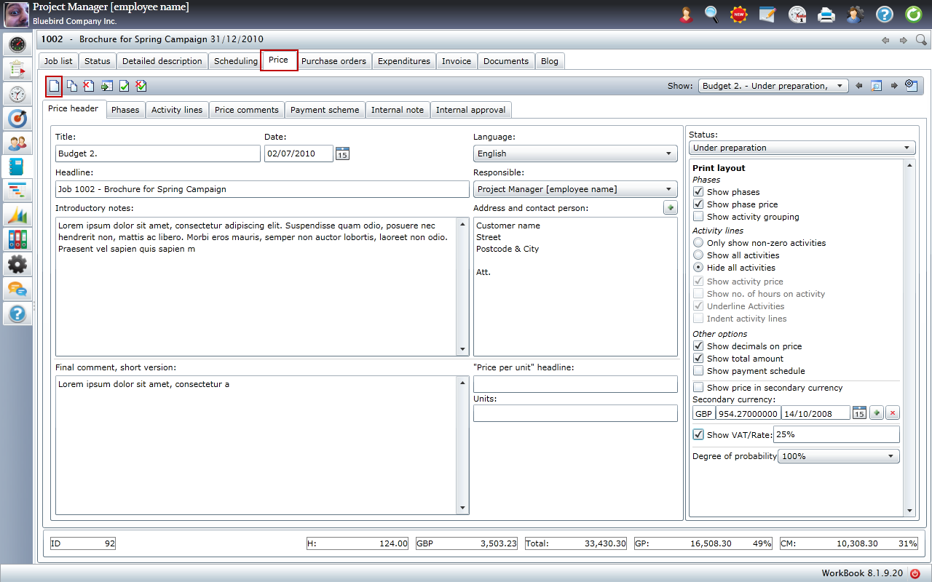

**WorkBook** is an integrated, adaptable business management system that helps you and your employees make better business decisions based on knowledge about projects and finances. WorkBook cooperates and works together with Microsoft Dynamics software, automating and streamlining business processes that help you drive your business to success.

The **‘Price estimate’** section is where you will create and send a price estimate to your customer once your new job has been created. Within the ‘Price’ tab, you then have many sub-tabs:

* ‘Price header’ – all price estimate settings including the ‘Print layout’ settings
* ‘Phases’ - divide many activities into just a few phases to make it more simple for the customer
* ‘Activity lines’ – this is where you create each individual activity with an estimate of how many hours needed to complete each activity with an hourly rate for each activity

Creating a price estimate and creating an invoice in WorkBook are carried out in very similar ways and this is no coincidence.

The ‘Price estimate’ section also presents these advantages:

* Print layout settings so you can choose exactly what information to include in the price estimate to your customer
* If you have a previous price estimate that you have already made, you have the option to copy this into your current price estimate to save you time
* Add any extra comments at the start or end of the price estimate to be included when you send it

<http://www.youtube.com/watch?v=E7e7rlhp0z8&hd=1>

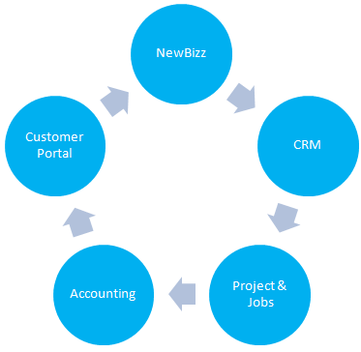

WorkBook can be used in the Professional Services industry with a vertical focus primarily on these sectors:

* Consultancy
* Advertising & Design
* Communication & PR
* Architects
* Digital Agencies

**Key Benefits + System Advantages**

* Easily and highly scalable
* Advanced technology supports your growing business
* Supports connectivity with customers, vendors, business partners and employees
* Robust, comprehensive functionality, all-in-one system
* Supports entities across countries, sites, languages and currencies
* Customisable, Adaptable and Modular ERP system
* World leading Project Management Tools
* Always up to date with the latest Microsoft Technology

WorkBook provides a first-class web-based business system for project and resource planning. We create a fantastic day-to-day overview and ensure optimised utilisation of resources.

We know our users and we are here for our users!

Our software contains all the tools necessary for project management aimed at project driven businesses.

WorkBook is extraordinarily user friendly which makes the system highly adaptable for end users.

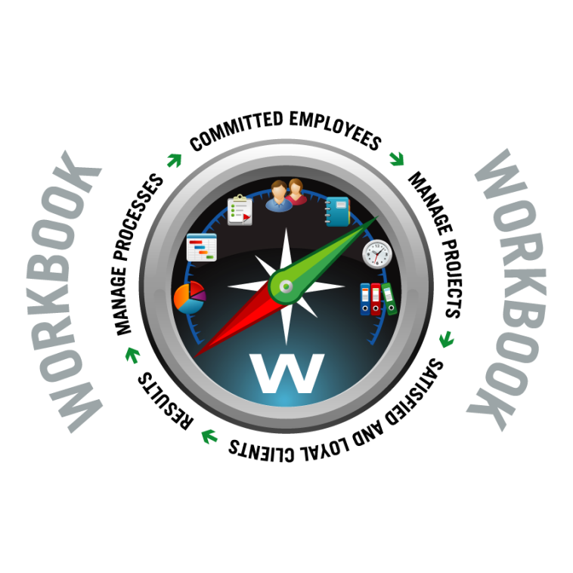

**About WorkBook Software A/S**

WorkBook is a specialist in developing systems for project driven organisations with tight integration to business systems like Microsoft Dynamics and other Microsoft platforms. Our system handle all working related processes - from CRM and new businesses, project and resource handling, mileage allowance, expenses, time registration, document handling, invoicing, accounting and management reports.

**Headquarters Address:**

WorkBook Software A/S

Teglværksgade 37

2100 Copenhagen  
Tel. +45 70 20 33 18

[www.workbook.net](http://www.workbook.net)

[info@workbook.net](mailto:info@workbook.net)

