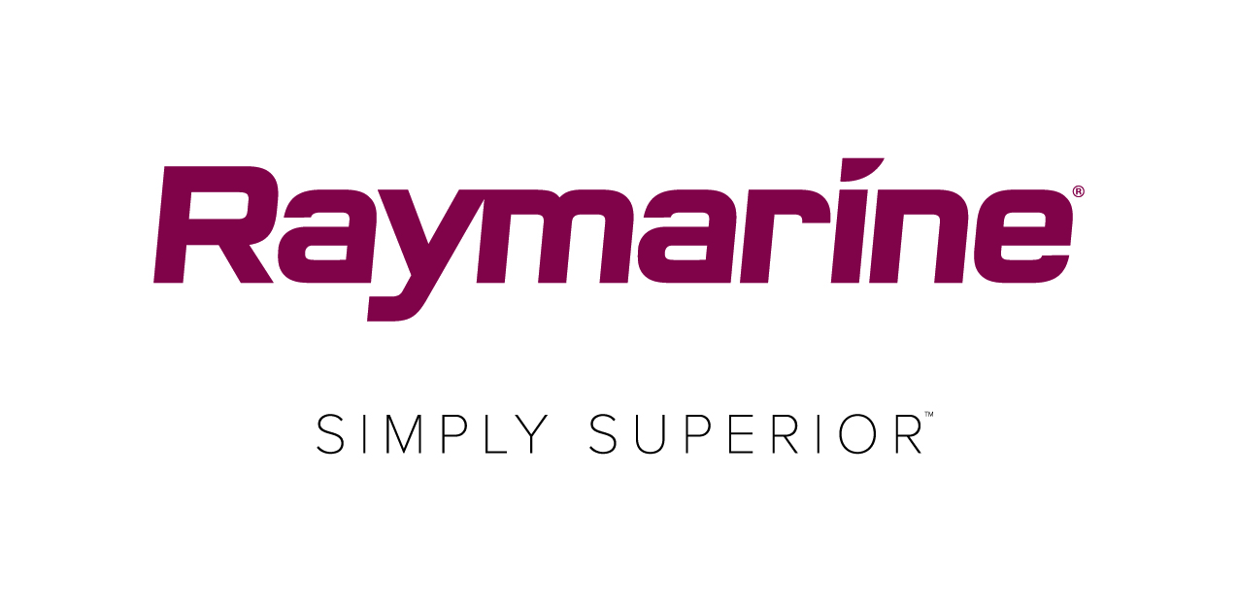
Pre-Race Tips from Raymarine’s Will Sayer
Get Ready for the Round the Island Race in association with Cloudy Bay

The excitement is building for competitors taking part in Round the Island Race, in association with Cloudy Bay. As the countdown progresses, it’s worth thinking about what preparations need to be made. Marine electronics can play an important part in achieving success at such a high-profile sailing competition, so we asked Will Sayer, Global Product Manager for Raymarine’s Axiom product line Winner of the 2016 SORC Round the Rock, for some tips on how to get the best out of your electronics and some other pointers for getting your boat race-ready.
Check your electronics
Make sure your depth sounder, electronic compass and speed indicator are all giving sensible readings. Verify your VHF is working properly with a radio check, and a pre-race shake down run is always a good idea to verify navigation, autopilot, and radar are operating correctly. Visually inspect all your electronics interconnect cables and most importantly check to make sure your DC batteries and charging system are operating correctly. Also, remind yourself how your depth transducer is calibrated – waterline or keel – as this could save you from running aground if you decide to cut any corners.

Prepare your course
Take time to study the course and tides so that you can input the route and its waypoints into your chartplotter in advance. When doing this, check the likely tidal height at each close-quarter location so you can predict roughly what clearance to expect. Some decisions, such as whether to risk the gap between the Needles and the wreck of the SS Varvassi, or how close to go inshore on the final legs, will be determined by the wind and sea state but last-minute waypoint changes can easily be made on the day.

Know the weather
To ensure you have a thorough understanding of predicted conditions, be sure to register to attend Raymarine’s pre-race briefing at Cowes Yacht Haven’s Event Centre in association with leading marine meteorologist Simon Rowell. Sign up here.

Get tracking
As official Tracking Partner, Raymarine is encouraging competitors to sign up to the race’s live GPS tracker using a mobile phone or AIS transceiver as part of this year’s #ItsYourRace campaign. In addition to the safety benefits for both crew and organisers, who will be able to monitor competing vessels, the tracker will help crews to keep an eye on the speed of their adversaries and allow them to see how friends among the fleet are faring. To register your phone or AIS for the tracker, click here. A downloadable tracker app will be available after 23rd June. Although AIS is not compulsory this year it is likely to be next year so take advantage of a limited 2018 race offer. Raymarine is offering competitors a cashback incentive of £150 on purchases of its new AIS700. The offer ends on 31st July. More information can be found here.

A thorough brief
The day before the event it’s also a good idea to have a thorough crew briefing, running over the course and potential hazards along the route, so everyone is prepared and aware of areas such as St Catherine’s Point where conditions often get rough. This is also a good time to make sure they understand how to work safety and electronic equipment, particularly the VHF radio.

Eat well
And don’t forget – if you want a happy crew – make sure there’s a plentiful supply of good food and drink aboard!

A final point to remember; never rely on one source of data. Always confirm the information from other sources too and always pay more attention to what you can see, rather than spend all your time looking at charts, LCD displays and computer screens – the eyeball is the best sanity check ever invented!

Raymarine is the official Technical and Tracking partner for Round the Island Race in association with Cloudy Bay. Information about their extensive marine electronics range can be found at www.raymarine.co.uk

###

About FLIR Systems
Founded in 1978 and headquartered in Wilsonville, Oregon, FLIR Systems is a world-leading maker of sensor systems that enhance perception and heighten awareness, helping to save lives, improve productivity, and protect the environment. Through its nearly 3,500 employees, FLIR's vision is to be "The World's Sixth Sense" by leveraging thermal imaging and adjacent technologies to provide innovative, intelligent solutions for security and surveillance, environmental and condition monitoring, outdoor recreation, machine vision, navigation, and advanced threat detection. For more information, please visit www.flir.com and follow @flir.

About Raymarine:
Raymarine, a world leader in marine electronics, develops and manufactures the most comprehensive range of electronic equipment for the recreational boating and light commercial marine markets. Designed for high performance and ease of use, the award-winning products are available through a global network of dealers and distributors. The Raymarine-branded product lines include radar, autopilots, GPS, instruments, fishfinders, communications, and integrated systems. Raymarine is a brand of FLIR Systems, a world leader in thermal imaging. For more information about Raymarine please go to www.raymarine.com.

Media contact:
Karen Bartlett
Saltwater Stone
+44 (0) 1202 669 244
k.bartlett@saltwater-stone.com

