Andreas Bäckman third in the 12 hours of Hockenheim
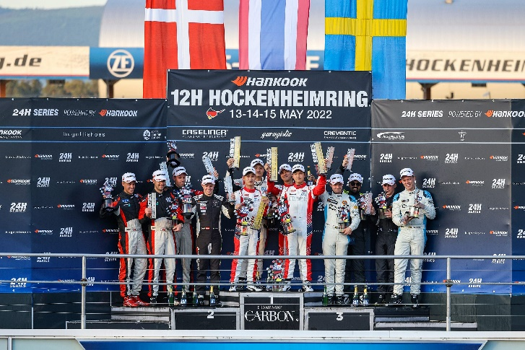
Andreas Bäckman together with his teammates in Lestrup Racing Team on the podium after clinching the third place in the Hankook 12h Hockenheimring race.
Photo: 24H SERIES (Free rights to use the images)
This weekend Andreas Bäckman finished in third place in the 12-hour race Hankook 12h Hockenheimring in Germany together with Lestrup Racing Team in the team's brand-new Audi RS 3 LMS TCR car.
- Fun to start the season with a podium and also extra fun in my first race for the team. It was also a good preparation for the upcoming STCC season, says Andreas Bäckman.
Last weekend, May 13th-15th, the Hankook 12h Hockenheimring race of the 24H Series was held in Germany. The 24H Series is a series of seven endurance races around the world, where the Hankook 12h Hockenheimring was the fourth race on this year's calendar and took place on the classic Formula 1 track Hockenheimring in Germany. Andreas Bäckman, together with three other drivers, drove car #120 for Lestrup Racing Team in the TCR class.
In 2022, Andreas will make a comeback in STCC (Scandinavian Touring Car Championship), after three years of international racing, in the brand-new Audi RS 3 LMS TCR car for Lestrup Racing Team.
Last weekend, the team Lestrup Racing Team entered the 12-hour race Hankook 12h Hockenheimring as a preparation before the STCC season. The 12-hour race gave both the team and the drivers the opportunity to get to know the new car before the STCC season starts at Ljungbyhed, Sweden at June 3rd-4th.
Andreas, together with Oliver Söderström, Emil Sällberg and Marcus Fluch, drove Lestrup Racing Team's Audi RS 3 LMS TCR car in the TCR class.
Hankook 12h Hockenheimring was both the team's first competition in the new car and also Andreas' first-ever endurance race in a TCR car.

On Friday, the weekend started with free practice and later in the evening, the timed qualifying was held, where the team managed to drive the fastest of all in the TCR class and take the pole-position for Saturday's race-start. The 12-hour race was divided into two parts, where the first six hours of the race were run on Saturday night and then the remaining six hours were run on Sunday night.
The team was at the top during the beginning of the race on Saturday, but some technical issues along the way meant that they lost 20 minutes of repairs in the pits and were for a while down in 6th place. But the team fought back to a final 3rd place finish in both the TCR and TCE classes. It was the team's first podium of the year and also Andreas' first podium in the new team.
- This was a rewarding start to the season and a very valuable preparation for our 2022 STCC title push. We had some hiccups along the way this weekend, but that is to expect with a brand-new car. But our drivers performed really well and we got really good race data that’s hard to recreate during regular pre-season test sessions, Fredrik Lestrup, co-founder of Lestrup Racing Team, says.
- I’m really glad to be a part of this result in my first-ever race weekend with the team. It was a really valuable weekend for me to get to know the car with plenty of kilometres. Everything didn’t go our way during the race, but this was a proper rehearsal of what is to come this year in the STCC, Andreas Bäckman says.

Next up for Andreas is the season start of STCC, June 3rd-4th, in Ljungbyhed, Sweden.

Results from the weekend:
Free Practice: 3rd place
Qualifying: 1st place
Race 1 (12 hours): 3rd place

Free rights to use the images.

Download press-photos here:
http://bit.ly/jabaeckman-photos
https://www.mynewsdesk.com/se/ja-backman/images

