Atos reveals design for optimized space control of solar panels

Team walks away with international award ‘Best Design for Additive Manufacturing 2016’
Bezons, Madrid, 4 May 2016 – Atos, an international leader in digital services, reveals a conceptual design to optimize solar panels control. The revolutionary solution includes a self-adjusting ball joint to orientate the solar panels of a satellite. It offers an optimized and customizable support for space that can rotate in the three axes for orientation purposes. It can be manufactured in just one part with additive manufacturing.

Starting from different concepts and real space requirements, Atos focused on creating the mechanism in only one part to reduce weight. This means that the design includes an inner sphere as a ball-joint inside a structural support, which is totally new. It adds movement to what currently is just a hinge. It can only be created with additive techniques and its small size is feasible to be produced in most industrial Additive Manufacturing machines.

According to David Wong, Head of Additive Manufacturing Innovation Centre, Nanyang Polytechnic of Singapore: “As member of the jury, I was compelled by the depth of design optimisation, embedded functionalities and weight & parts reduction exploited by the ATOS designers in realizing this functional design”

Elvira León, Head of R&D and leader of the track Additive Manufacturing in the Scientific Community at Atos explains: “Innovation lies at the core of Atos business strategy and we’re proud with this revolutionary design. Orientation of solar panels is vital for energy capture, and current solutions only deploy the panels to a fixed position. We looked for a holistic approach addressing structural integrity, functionality, material, energy consumption and assembly simplicity to a viable solution.

Javier Buhigas, Business Development manager at Atos: “We’re proud with this design that can orientate each panel to capture the most sun light and hence play a vital role in the future of satellite power systems whilst contributing to the economics of satellite launching. The next revolution in aerospace is already happening and is using Additive Manufacturing solutions”.

The achievements of this design are:
- Integration of parts for assembly reduction: a mechanism printed in one step, reducing installation time and tolerances issues.
- Reduced weight and therefore costs, as weight is critical in space.
- New functionalities: added movement to a satellite support.
- Universal solution: can be used as inspiration for applications in various sectors.
- Auto-fitted bearing concept that solves precision and tolerances issues in metal printing.
- Room for customization, like including an electric inductive engine inside the inner sphere for self-rotating.

International Design Award won
Atos has been awarded the Best Design for Additive Manufacturing 2016 earlier this year. From a group of 47 contestants, both professionals and students, three finalists were selected per category; the award was presented by Additive World at its annual conference. According to the jury, the design highlights the benefits of additive manufacturing in the design of complex solutions, simplifying the manufacturing process by reducing the number of component elements. The design was presented by INPRO, a department of Atos in Spain Advanced Product Engineering, is the result of different concepts that the engineers of this department have evolved, aimed at reducing the assembly of a mechanism, manufacturing it in one piece, without joints. The revolutionary solution includes a self-adjusting ball joint to orient the solar panels of a satellite.

Scientific Community
Innovation lies at the core of Atos’ business strategy and the company has organized itself to think one step ahead to help its clients to reinvent their growth models. The Scientific Community has over 100 members from all geographies where Atos operates, representing a rich mix of skills and backgrounds. Its aim is to help Atos anticipate and craft its vision of upcoming technology disruptions and the future business challenges that will be faced by the markets it serves. As part of this, Atos is creating new designs with exhaustive analysis, like thermal, fatigue and non-linear analysis. This is the needed approach to introduce parts created by 3D printing into demanding sectors, like aerospace or automotive.

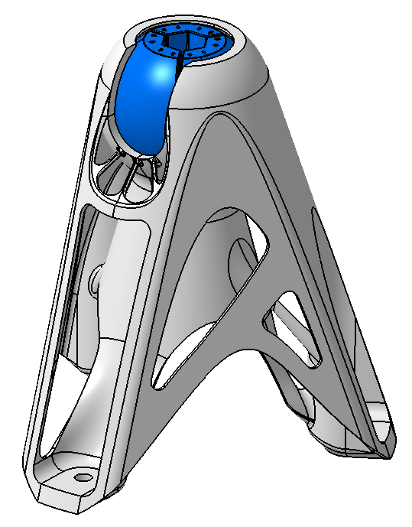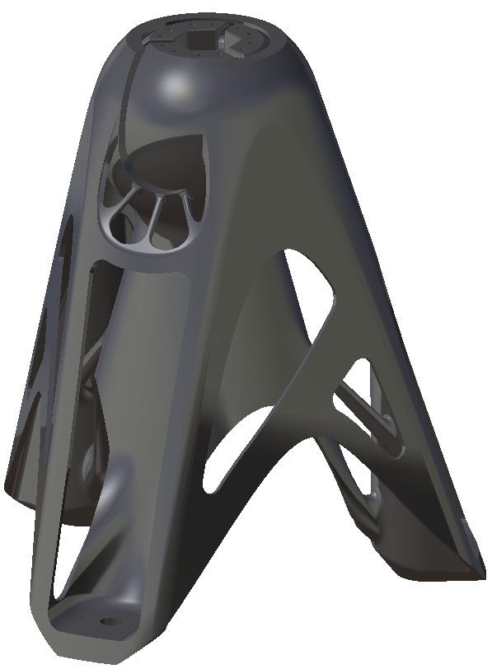

About Atos
Atos SE (Societas Europaea) is a leader in digital services with pro forma annual revenue of circa EUR 12 billion and 100,000 employees in 72 countries. Serving a global client base, the Group provides Consulting & Systems Integration services, Managed Services & BPO, Cloud operations, Big Data & Cyber-security solutions, as well as transactional services through Worldline, the European leader in the payments and transactional services industry. With its deep technology expertise and industry knowledge, the Group works with clients across different business sectors: Defense, Financial Services, Health, Manufacturing, Media, Utilities, Public sector, Retail, Telecommunications, and Transportation. Atos is focused on business technology that powers progress and helps organizations to create their firm of the future. The Group is the Worldwide Information Technology Partner for the Olympic & Paralympic Games and is listed on the Euronext Paris market. Atos operates under the brands Atos, Atos Consulting, Atos Worldgrid, Bull, Canopy, Unify and Worldline.

For more information, please contact:
Rhoda Dinesen
+65 67308524
Rhoda.dinesen@atos.net

