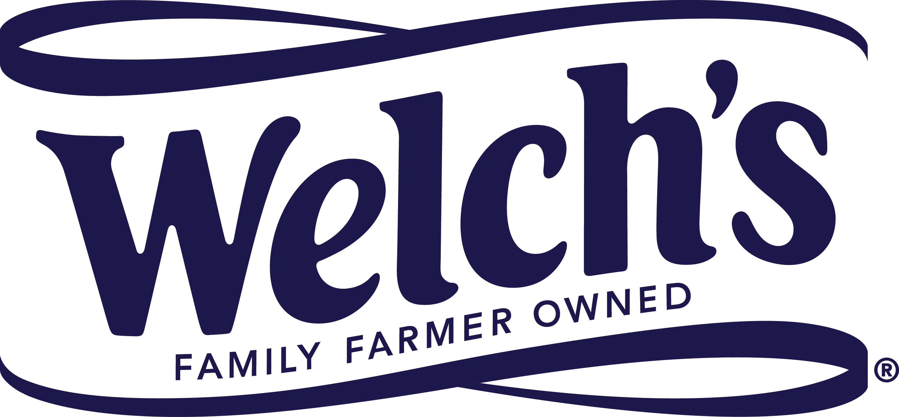

27 July 2017
SUPPLYSIDE WEST EXPO 2017
Taste, nutrition and value: Welch’s showcases
triple benefits of Concord grape ingredients
Innovative applications for Concord grape ingredients in the nutrition category will be the key focus for Welch’s Global Ingredients Group at SupplySide West Expo (Las Vegas, 27-28 September 2017).

Among the main attractions on the company’s booth (#R169) will be FruitWorx real fruit pieces. These delicious and wholesome Concord grape bites are perfect ingredients for healthy snack bars, baked goods and cereals. And, they also make a tasty, nutritious and convenient delivery system for functional ingredients with specific health and wellness benefits.

Also appearing on the Welch’s Global Ingredients Group stand will be FruitWorx Concord grape juice powder and Concord grape superfruit juices and purées.

Native to North America, the Concord grape delivers a distinctively delicious flavor and polyphenols – natural, health promoting plant nutrients– making it a perfect fit for snack foods and beverages in the wellness category. Furthermore, compared with many other leading superfruit juices, Concord grape juice is an affordable ingredient, helping manufacturers and brands to keep their costs down and retail price-points competitive.

Wayne Lutomski, Vice President International & Welch’s Global Ingredients Group, said: “Great taste, nutrition and value – our Concord grape ingredients really do provide a trio of compelling benefits that’s hard to find in other superfruits. For companies that are looking to differentiate their products, we have a wide range of solutions that check all three of these boxes, and they will be available to see and taste at our booth at this year’s SupplySide West Expo.”

After its highly successful debut at the recent IFT17 Expo, Welch’s Global Ingredients Group’s popular chef station will be making another appearance at this year’s SupplySide West Expo. Tempting the tastebuds will be an array of naturally functional beverages and clean-label snack solutions made by an expert culinologist using Concord grape ingredients.

As well as exhibiting at the Expo, Welch’s Global Ingredients Group has been named as SupplySide West’s official 2017 antioxidant sponsor.

The Concord grape is a distinctive dark purple variety that’s singularly delicious and naturally sweet. It is quite different from standard table grapes with a thick skin and crunchy seeds, where the polyphenols are to be found that hold the key to the grape’s goodness.

Visit Welch’s Global Ingredients Group on Booth #R169
at SupplySide West Expo 2017 to find out more.

ENDS

For more information, please contact:
Steve Harman, Ingredient Communications
Tel: +44 1293 886291 (office) / +44 7494 307911 (cellphone)
Email: richard@ingredientcommunications.com

About Welch’s Global Ingredients Group
Established in 2014 as a division of Welch Foods, Inc. (Welch’s), Welch’s Global Ingredients Group offers grape juice expertise and solutions to companies across the globe. Our primary ingredients include Concord and Niagara grape single-strength juices, juice concentrates and purées made in the USA, as well as a range of powders and fruit bites. Our sales territories are North, Central and South America; Asia, with special emphasis in Japan, Korea and China; and EMEA. In EMEA and China we operate through our distribution partner, WILD.

Welch’s is the processing and marketing subsidiary of the National Grape Cooperative. Located across America and in Ontario, Canada, the cooperative’s approximately 900 family farmers own the company and grow the delicious and inherently healthy Concord Grape used in Welch’s juices and other grape-based products. Welch’s is committed to research and development that will meet the growing demand for products that address consumers’ health and nutrition needs. Welch’s products are sold throughout the United States and in approximately 40 countries around the globe. Welch’s is an Equal Opportunity Employer – Minorities/Female/Disabled/Veterans. For more information, visit www.welchs.com.

