Epson launches its new Direct to Garment printer, the SureColor F2130
Users can print and dispatch completed garments in as fast as 27 seconds

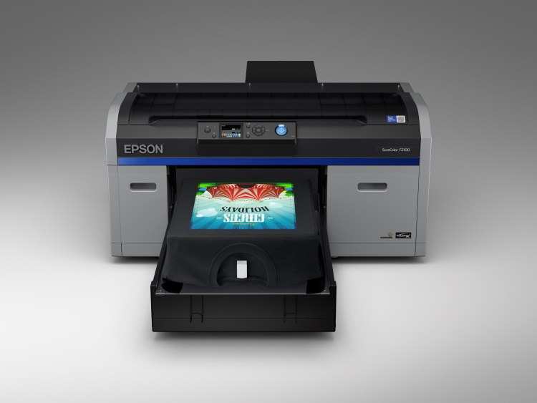
Epson’s SC-F2130 DTG printer

Kuala Lumpur, Malaysia, June 7, 2018 –

Epson, a leader in professional printing, has announced the launch of the new SureColor F2130 Direct-to-Garment (DTG) printer that has an enhanced design and improved usability, enabling faster turnaround time for print jobs and better productivity for the business. The SC-F2130 printer will replace the existing SC-F2000 model and will help to lower costs with improved speeds and reliability.

The SC-F2130 is suited for small to medium businesses who want to add direct-to-garment printing to their services, such as production t-shirt printers, online t-shirt retailers, high and low-volume print companies, as well as corporates who want to produce their own branded workwear or promotional items.

The new SC-F2130 DTG printer is driven by Epson’s proprietary PrecisionCore Thin Film Piezo printhead delivering fast production speeds at outstanding clarity and sharpness on textiles, at resolutions of up to 1,440 x 1,440 dpi, and is one of the fastest direct-to-garment printers in its class. Users can print and dispatch completed garments in as fast as 27 seconds.
The revamped printer has improved image reproducibility with its new multi-dot print mode that delivers a wider colour gamut than the previous model. The Epson Ultrachrome DG ink technology developed specially for Direct-to-Garment applications brings outstanding colours and robust garment durability to textile prints and is certified by Eco Passport for sustainable textile production.
The DTG printer has been re-designed with a new automated maintenance design that includes a cleaning cartridge configured to automatically clean the printhead cap, enabling continuous operations and reducing manual maintenance efforts. Its new white ink filter system improves ink flow, further preventing ink build-up for improved reliability and performance.

Significantly, the new SC-F2130 comes with a new ink circulation algorithm that shortens waiting time before start of next print job, improving turnaround time.

The Epson Garment Creator software has also been re-designed with usability and intuitiveness as key, to enhance the workflow of the printing process. Users can save predefined colour management and layout control presets for ease of use. Designed for convenience in calculations of costings, users can get cost estimates before a job is sent to print.

The control panel has an improved interface that provides overview of settings and consumable levels to monitor ink usage, showing information on thumbnail preview, fabric wiper level, platen size, t-shirt colour for printing and more.

The printer’s physical structure has also been enhanced for productivity. The platen gap has been refined to 0.5mm, enabling finer height adjustments for better and finer print out. It comes with a new platen grip pad that does not require a frame the secure the garment in place, cutting down on the printing processes. It also has improved serviceability with improvements to the mechanical design – with fewer parts to remove to access the rear.

“Through our research and development, we have revamped the SC-F2130 to meet the needs of businesses, with productivity and ease of use in mind. We have consulted with our customers and taken their feedback into consideration to deliver an enhanced DTG printer that can bring direct-to-garment printing to new productivity levels at exceptional print quality,” said Daisuke Hori, Managing Director of Epson Malaysia

***

About Epson
Epson is a global technology leader dedicated to connecting people, things and information with its original efficient, compact and precision technologies. With a lineup that ranges from inkjet printers and digital printing systems to 3LCD projectors, smart glasses, sensing systems and industrial robots, the company is focused on driving innovations and exceeding customer expectations in inkjet, visual communications, wearables and robotics.
Led by the Japan-based Seiko Epson Corporation, the Epson Group comprises more than 80,000 employees in 86 companies around the world, and is proud of its contributions to the communities in which it operates and its ongoing efforts to reduce environmental impacts.
http://global.epson.com/

About Epson Singapore
Since 1982, Epson has developed a strong presence across major markets in Southeast Asia and South Asia. Led by the regional headquarters Epson Singapore, Epson’s business in Southeast Asia spans an extensive network of 11 countries with a comprehensive infrastructure of close to 500 service outlets, 7 Epson solution centres and 7 manufacturing facilities.
http://www.epson.com.sg

About Epson Malaysia
Epson Malaysia Sdn Bhd was established in Malaysia in 1991 as Epson Trading (M) Sdn Bhd, a sales company of the Seiko Epson Corporation, Japan. The company has exclusive rights to market, distribute and support a complete range of leading-edge Epson consumer and business digital imaging products in Malaysia and Brunei. Today, Epson Malaysia has 84 employees and an extensive network of 59 authorised service outlets nationwide. For more info, please visit www.epson.com.my or connect with us at www.facebook.com.my/EpsonMalaysia

Media Enquiries:
Epson Malaysia Sdn Bhd  Chua Li Tinn  Manager – Marketing Communications  Tel: (03) 5628 8288 Ext 274  Email: ltchua@emsb.epson.com.my | SWOT Communications Sdn Bhd  Vino Nair  Tel: 016 365 6268  Email: vino@swotcommunications.com

Based on default of Production (4pass) Color Mode. Refer to printhead firing time when using dual color mode, image size 10 x 8” landscape. Applicable for white t-shirts only.
Epson’s printed garments achieved scores of 4.0 or higher on industry standard AATCC wash test.
An international safety standard in the textile industry, and is certified to be safe for adults and children, including babies.

