**Scandinavia’s leading online career fair**

**- where you can meet employer’s from the comfort of your own home**

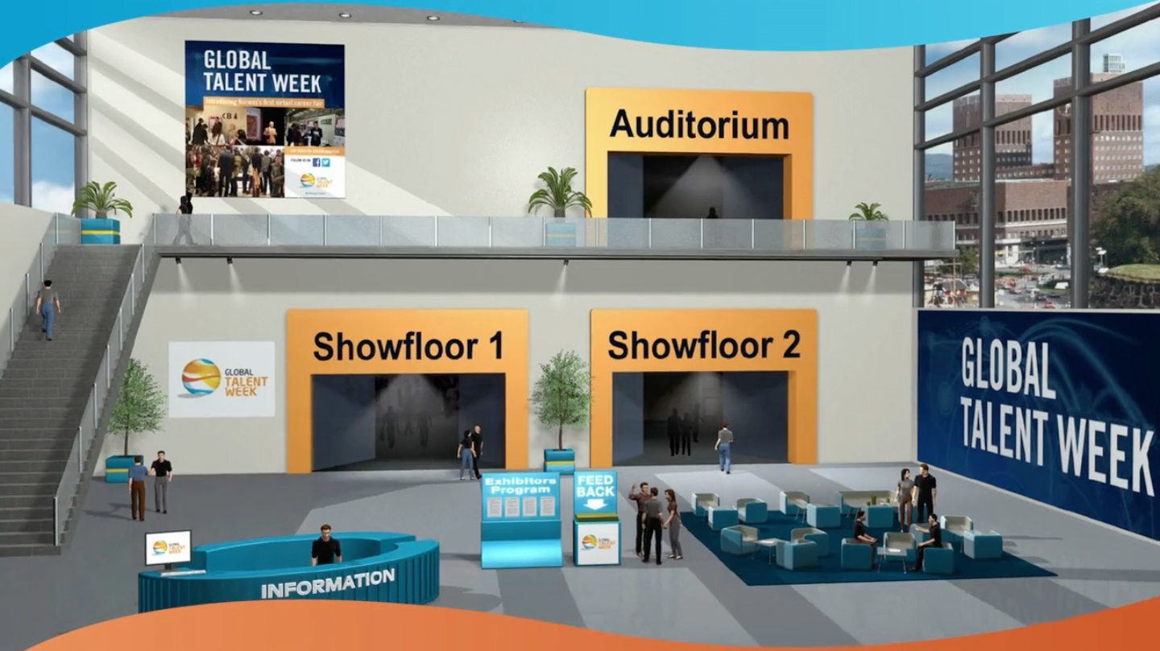

**After a successful pilot in 2015, Global Talent Week is back with an even better version of Scandinavia’s leading online career fair. Here people from around the world can meet some of the region’s most attractive employers, including Tesla Motors and PWC – without having to move from the comfort of their own home.**

“An online career fair is the best way for employers and employees to meet in today’s digital world” says managing director Bjørn Christian Nørbech of Global Forums, the startup behind the online career fair.

“It is much easier for candidates to attend an online career fair”, says Christian Scheen, Head of Recruitment at Skanska Norway. “Last time we met a highly qualified candidate who spoke to us from a beach in Indonesia. It allows professionals to keep their anonymity and prevents them from running into a colleague or even worse their boss at a physical career fair”.

This year’s fair features major employers like Tesla Motors, PWC, IBM, DNV GL, Tieto, Statoil, Jotun, Opera Software and Statkraft. 2 500 talents are expected to attend this year, and they have all been carefully selected and invited by leading talent organizations like NOVA, AIESEC, IAESTE and ESN.

For more information, please contact: adne@globaltalentweek.com



Managing director Bjørn Christian Nørbech of Global Forums