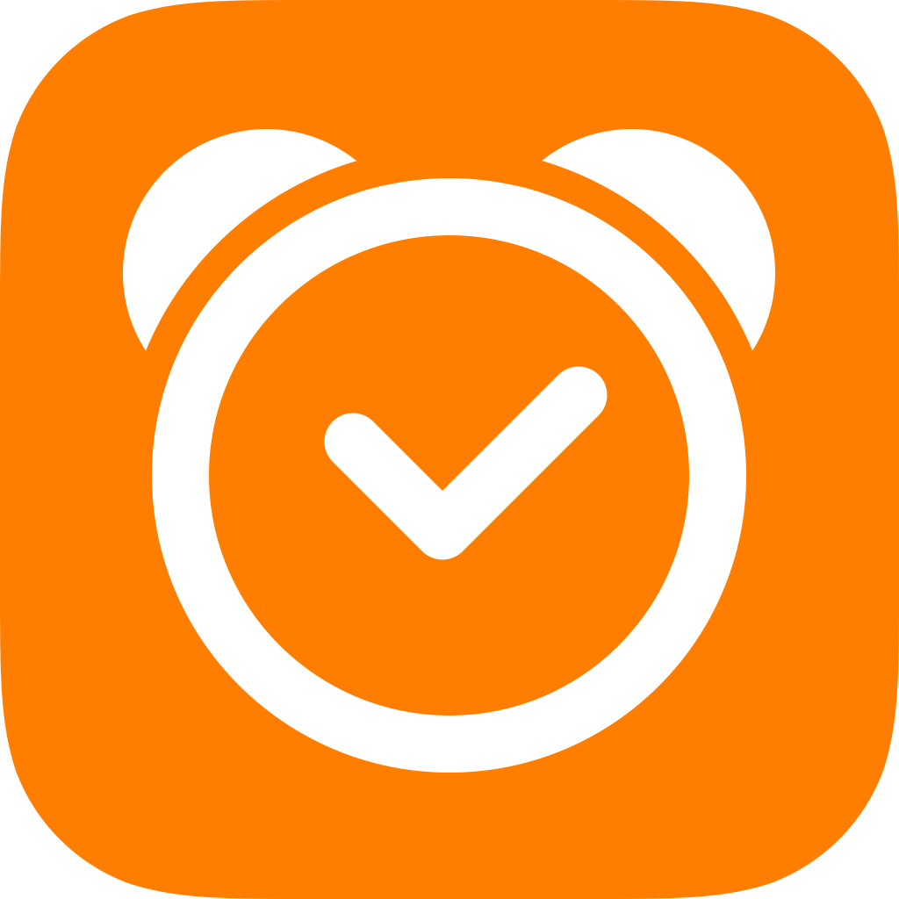
Sleep Cycle

Sleep Cycle alarm clock
- Now integrated with Apples new Health app

15 October, 2014 – The release of Sleep Cycle alarm clock 4.6 was announced today, featuring full support for the Apple Health app.

Sleep Cycle alarm clock 4.6 introduces full support for iOS 8 and Apples new Health app, including adaptive layouts for both iPhone 6 and iPhone 6 Plus. The newest version enables all Sleep Cycle users to automatically synchronize their current and historic sleep data with the Apple Health app. The data uploaded from Sleep Cycle will include bedtime, wake up, sleep quantity, sleep quality, and heart rate.

Sleep Cycle alarm clock wakes users up in the lightest sleep phase. Sleep Cycle utilizes the accelerometer in the phone to track movement patterns and determine which sleep phase users are in. Waking up during the lightest sleep feels like waking up without an alarm clock – a natural wake up where you feel rested and relaxed. It’s waking up made easy.

Download Sleep Cycle alarm clock 4.6
Preview video
Download images

Northcube
Northcube is a leading Swedish game and app development studio founded in 2008 by industry veterans, with its head quarters in Gothenburg, Sweden. Engaging some of the most talented programmers and designers in Europe, Northcube promotes a passionate company culture where play and business is equally important.

Media contact
Malin Eriksson
Director Public Relations
Northcube
+971 55 285 8644
malin@northcube.com
www.northcube.com

Sleep Cycle

Sleep Cycle alarm clock
- Nu med full support för Apples nya Health app

15 oktober, 2014 – Sleep Cycle alarm clock har nu släppt en ny version med full support för iOS 8 och Apples Health app.

Sleep Cycle alarm clock 4.6 introducerar integration med Apples Health app och iOS 8, inklusive full support för både iPhone och iPhone 6 Plus. Sleep Cycle kommer automatiskt synkronisera all sömndata med Apples nya Health app, inklusive sömnkvalitet, sömnlängd och morgonpuls.

Sleep Cycle alarm clock mäter av dina rörelsemönster medan du sover genom att använda telefonens accelerationsmätare för att sedan väcka dig när du befinner dig i din lättaste sömnfas. Att vakna när man befinner sig i sin lättaste sömnfas känns som att vakna utsövd och pigg utan alarm.

Ladda ner Sleep Cycle alarm clock 4.6
Se förhandstitt av video
Ladda ner bilder

Northcube AB
Svenska Northcube grundades 2008 av specialister inom spel- och hälsoapp-utveckling. Teamet består av några av Europas mest talangfulla programmerare och designers och har sitt huvudkontor i Göteborg.
Media contact
Malin Eriksson
Director Public Relations
Northcube
+971 55 285 8644
malin@northcube.com
www.northcube.com

