New KONGSBERG-designed freezer trawler is ready
to commence service in Arctic fishing grounds
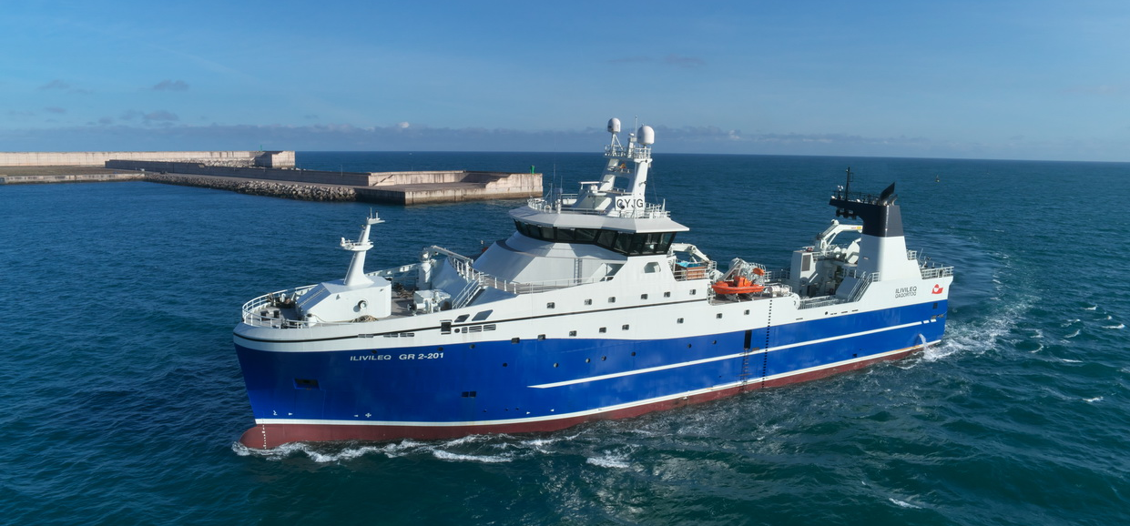
The KONGSBERG-designed NVC 375 WP freezer trawler Ilivileq combines safety, efficiency and sustainability
Kongsberg, Norway, 18th May 2020 – The latest vessel of Kongsberg Maritime design to enter service, an 81.80m NVC 375 WP freezer trawler named Ilivileq, has just been delivered to its working domain in Arctic waters.
Ilivileq typifies the principles upon which the NVC range was conceived, combining an economical and environmentally beneficial foundation of low emissions and fuel-efficient operation with a freeboard of optimal height to ensure crew safety, teamed with modern, responsible fish-handling solutions. The low-resistance, wave-piercing hull maximises the vessel’s speed, comfort and seakeeping qualities, while Ilivileq’s design flexibility will enable its crews to undertake both pelagic and bottom trawling. These assets lead to outstanding hourly catch capacity and quality, allied with minimal environmental impact.
In tandem with the hull, Ilivileq’s hybrid propulsion system makes for a substantial reduction in fuel usage and operational noise (both on board and into the water) by allowing crews to engage either mechanical or diesel/electric drive modes. The trawler’s green credentials are further enhanced with the integration of the most cutting-edge nitrogen oxide reduction technology.
Kongsberg Maritime’s corporate emphasis on system integration is reflected in Ilivileq’s full complement of system packages. In addition to equipping the vessel with hybrid propulsion and electrical power generation technology, the company has also supplied a manoeuvring system (steering gear, flap rudder, tunnel bow thruster and Helicon X3 remote control); an ACON automation system incorporating modules for energy and power management, pump and valve control, and alarm and monitoring capabilities; plus key items of deck machinery including an electrical winch system.
“The delivery of Ilivileq represents yet another successful waypoint in our continuous commitment towards helping crews of all kinds to operate sustainably and conscientiously in the world’s oceans while simultaneously increasing crew safety and boosting productivity,” adds Bård Bjørløw, EVP Global Sales and Marketing, Kongsberg Maritime. “Given the fragility of today’s marine ecosystems and the pressures of commerce, these considerations obviously have to go hand-in-hand if any positive changes are to be made; and it’s highly encouraging to know that our vessel designs and integrated technologies are driving such a constructive evolution in the maritime industries.”
Ends

For further information, please contact:
Gunvor Hatling Midtbø, VP Communication
Kongsberg Maritime
Tel: +47 9921 4209
gunvor.hatling.midtbo@km.kongsberg.com
David Pugh
Saltwater Stone
Tel: +44 (0)1202 669244
d.pugh@saltwater-stone.com

About Kongsberg Maritime
Kongsberg Maritime is a global marine technology company providing innovative and reliable ‘Full Picture’ technology solutions for all marine industry sectors including merchant, offshore, cruise, subsea and naval. Headquartered in Kongsberg, Norway, Kongsberg Maritime has manufacturing, sales and service facilities in 34 countries.
Kongsberg Maritime solutions cover all aspects of marine automation, safety, manoeuvring, navigation, and dynamic positioning as well as energy management, deck handling and propulsion systems, and ship design services. Subsea solutions include single and multibeam echo sounders, sonars, AUV and USV, underwater navigation and communication systems.
Training courses at locations globally, LNG solutions, information management, position reference systems and technology for seismic and drilling operations are also part of the company’s diverse technology portfolio. Additionally, Kongsberg Maritime provides services within EIT (Electro, Instrument & Telecom) engineering and system integration, on an EPC (Engineering, Procurement & Construction) basis.
Kongsberg Maritime is part of Kongsberg Gruppen (KONGSBERG), an international, knowledge-based group that celebrated 200 years in business during 2014. KONGSBERG supplies high-technology systems and solutions to customers in the oil and gas industry, the merchant marine, and the defence and aerospace industries.
Web: Kongsberg Gruppen | Kongsberg Maritime
Social media: LinkedIn | Twitter | Facebook

