FONTAINES D.C. ANNOUNCE UK & EUROPEAN ARENA TOUR
20 DATES ACROSS 14 COUNTRIES, OCTOBER & NOVEMBER 2026
INCLUDING LONDON'S O2 ARENA ON FRIDAY 27TH NOVEMBER
THE BAND’S FIFTH STUDIO ALBUM DOPAMINE CHAMBER
OUT 16TH OCTOBER VIA XL RECORDINGS
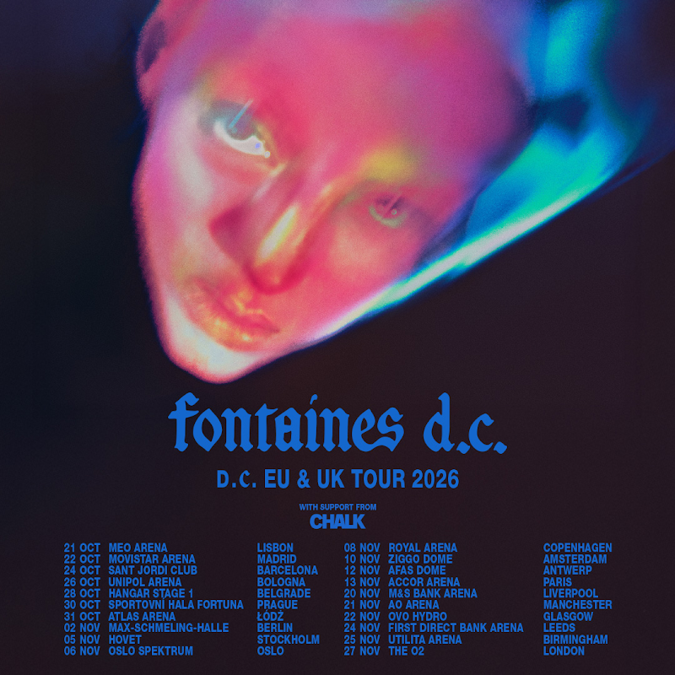
Fontaines D.C. today announce their biggest headline tour to date, taking in twenty arena shows across Europe and the UK this autumn. The tour opens in Lisbon on 21st October - five days after the release of their fifth album Dopamine Chamber - and ends at London's O2 Arena on 27th November. The announcement comes ahead of a run of festival headline appearances this weekend - Reading Festival (tonight), Leeds Festival (Saturday) and Electric Picnic (Sunday).
The run will see the band perform in Madrid, Barcelona, Bologna, Belgrade, Prague, Łódź, Berlin, Stockholm, Oslo, Copenhagen, Amsterdam, Antwerp and Paris, before a six-date UK leg through Liverpool, Manchester, Glasgow, Leeds, Birmingham and London. Fans in Ireland should stay tuned for live news soon.
Tickets go on general sale at 10 am BST / 11am CEST on Thursday 3rd September, from https://fontainesdc.com/pages/live. Pre-sale begins at 10 am BST / 11am CEST on Tuesday 1st September. Fans who have pre-ordered Dopamine Chamber from the official store by 6pm BST Monday 31st August gain access to UK pre-sale. For pre-sale access to EU dates, sign up here by 6pm BST Monday 31st August.
Fontaines D.C. - Grian Chatten, Carlos O’Connell, Conor Curley, Conor Deegan and Tom Coll - will release their fifth album Dopamine Chamber on 16th October via XL Recordings. Produced by James Ford, it's the follow-up to 2024's UK platinum-certified Romance – and the sound of a band moving decisively away from the guitar language of their early records and into their most seductive music yet. Preceded by lead single "Marianne", the album arrives like a constellation behind undulating sighs of smog: potent balladry, anthemic melodies glinting through the murk. In a world tipping towards collapse, it asks how pleasure mutates amid peril—and what our pursuit of it reveals about us. The album itself is a dopamine chamber,” says Chatten. “You step inside and we test these different mind- or mood-altering pieces of music on you.”
Fontaines D.C. have spent five albums refusing to repeat themselves – from Dogrel (2019) through A Hero’s Death (2020), the UK and Ireland No. 1 Skinty Fia (2022) and the anarchic, kaleidoscopic Romance (2024). Dopamine Chamber is their most radical turn yet: It was made with Ford between London, the English countryside and Palermo, where Chatten recorded vocals in a makeshift booth built from mattresses and cushions. “There’s a poignant sense of us being on the brink of some other kind of form of humanity, or non-humanity,” says Chatten. For their fifth album, Fontaines D.C. have built the chamber. What happens to the listener inside it will be the experiment.
“Marianne” is out now. Dopamine Chamber is released on 16th October via XL Recordings and available on LP, deluxe LP, CD, cassette and digital. Pre-order here.

FONTAINES D.C. LIVE – OCTOBER & NOVEMBER 2026
Wednesday 21st October - Lisbon, Portugal - MEO Arena
Thursday 22nd October - Madrid, Spain - Movistar Arena
Saturday 24th October - Barcelona, Spain - Sant Jordi Club
Monday 26th October - Bologna, Italy - Unipol Arena
Wednesday 28th October - Belgrade, Serbia - Hangar Stage 1
Friday 30th October - Prague, Czech Republic - Sportovní hala Fortuna
Saturday 31st October - Łódź, Poland - Atlas Arena
Monday 2nd November - Berlin, Germany - Max-Schmeling-Halle
Thursday 5th November - Stockholm, Sweden - Hovet
Friday 6th November - Oslo, Norway - Oslo Spektrum
Sunday 8th November - Copenhagen, Denmark - Royal Arena
Tuesday 10th November - Amsterdam, Netherlands - Ziggo Dome
Thursday 12th November - Antwerp, Belgium - AFAS Dome
Friday 13th November - Paris, France - Accor Arena
Friday 20th November - Liverpool, UK - M&S Bank Arena
Saturday 21st November - Manchester, UK - AO Arena
Sunday 22nd November - Glasgow, UK - OVO Hydro
Tuesday 24th November - Leeds, UK - First Direct Arena
Wednesday 25th November - Birmingham, UK - Utilita Arena
Friday 27th November - London, UK - The O2 Arena

