PRESS RELEASE

Raise your beer mugs and say “Prost” to Oktoberfest 2019 at Poolside Patio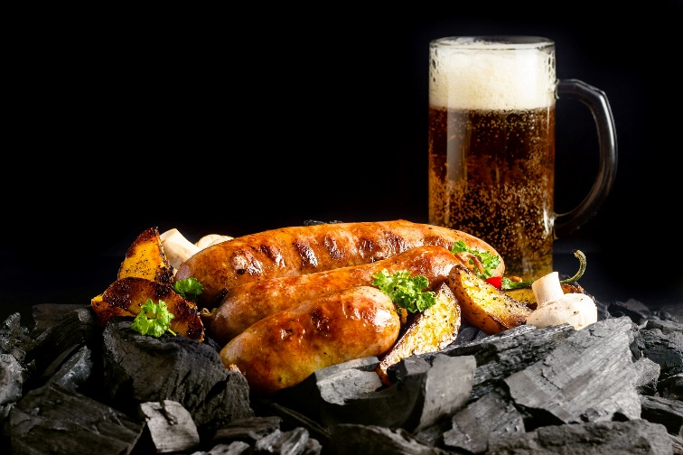

Singapore, 04 September 2019– Welcome to Oktoberfest 2019 at Pan Pacific Singapore’s Poolside Patio, where guests can embrace this annual tradition and celebrate a rousing festival at our alfresco dining venue.

From 20 September to 26 October, every Friday and Saturday evening, indulge in our Poolside Oktoberfest BBQ offering hearty delights of unlimited hot plate dishes specially created by our culinary team. From 16 September onwards daily, guests can quench their thirst with quintessential German beers from Erdinger’s wide selection.

Start off with a selection of house baked breads ranging from Dark Rye, Sour Dough, and Light Rye Caraway Seed accompanied by Butter and Sea Salt condiments and appetisers including cold cuts, salad, ham and sausages, German classics of Black Forest, Virginia Ham, Milano Salami, Bierschinken, Liver Würstl and German Potato Salad.

Turn the heat up thereafter with unlimited servings of traditional German hot plates including highlights such as Schweinebraten (Roast Pork), Schnitzel (Crumbed Chicken), Assorted Würstl with Sauerkraut (Veal Bratwurst/Nurnberger/Bockwurst), Räucherforelle (Smoked Trout with Almond Butter) or classic BBQ staples such as Char Grilled Worcestershire & Mustard Marinated Beef Flank Steak and Tiger Prawns.

There’s always room for a sweet finale so indulge in our unlimited servings of Semolina Pudding with Cherry Compote, Black Forest Cake, Sacher Torte, Apple Strudel with Crème Anglaise or the refreshing Sliced Tropical Fruit Platter.
For a limited time period, enjoy our German beers at special prices and unwind with the trendiest Oktoberfest songs for this annual celebration at our Poolside Patio.

Venue: Poolside Patio, Level 4, Pan Pacific Singapore (excludes swimming pool access)
Availability: Fridays and Saturdays, 6:30pm to 9:30pm (last order is at 9:00pm)

Oktoberfest BBQ Promotion Poolside
20th September to 26th October 2019 (Friday and Saturday only)
SGD78 per adult* (food menu only), SGD39 per child (six to 12 years old)

Erdinger Promotion Poolside
16th September onwards, daily.
SGD12 per glass (Erdinger Weissbier, Erdinger Dunkel)
SGD40 Combo Package (up to 4 glasses, 4pm to 8pm only)
SGD80 Tower Package (up to 8 glasses)

For dining reservations or enquiries, please call 6826 8240 or email dining.ppsin@panpacific.com.

High-resolution image can be downloaded here.

All prices are subject to 10% service charge and prevailing Goods and Services Tax. Child prices are for children between the ages of 6 to 12.

ENDS

Media Contact
Mr Luo Junjia
Marketing Communications
DID: (65) 6826 8058
E-mail: luo.junjia@panpacific.com

Ms Gillian Teo
Assistant Director of Marketing Communications
DID: (65) 6826 8095
E-mail: gillian.teo@panpacific.com

About Pan Pacific Singapore
Located in the heart of Marina Bay and with easy access to world-class shopping, Suntec Singapore International Convention and Exhibition Centre and the Central Business District, Pan Pacific Singapore offers 790 contemporary rooms and suites that are ideal for business or leisure. Savour epicurean delights at our award-winning restaurants and bars or rejuvenate at our swimming pool and spa. Pan Pacific Singapore is proud to be named Asia’s Leading Business Hotel by the World Travel Awards from 2006 to 2012, World’s Leading Business Hotel by the World Travel Awards from 2007 to 2010 and 2012, and World’s Leading City Hotel by the World Travel Awards in 2011. The hotel was also recently named a “Four-Star Hotel” by Forbes Travel Guide 2019 and Top 25 Hotels in Singapore in Tripadvisor’s 2019 Traveller’s Choice Awards.

About Pan Pacific Hotels and Resorts
With hotels, resorts and serviced suites across Asia, Oceania and North America, Pan Pacific provides a safe harbour in an ever-changing world. Places with less worry about because, when you stay with us, rest assured that all will be taken care of. For this is where you will find your balance.

About Pan Pacific Hotels Group
Pan Pacific Hotels Group is a wholly-owned hotel subsidiary of Singapore-listed UOL Group Limited, one of Asia’s most established hotel and property companies with an outstanding portfolio of investment and development properties.

Based in Singapore, Pan Pacific Hotels Group owns and/or manages more than 40 hotels, resorts and serviced suites including those under development across 24 cities in Asia, Oceania, North America and Europe.

Voted “Best Regional Hotel Chain” by readers in Asia in 2017 and 2018, Pan Pacific Hotels Group comprises two acclaimed brands: its signature brand, Pan Pacific and its deluxe brand, PARKROYAL.

Sincerity is the hallmark of Pan Pacific Hotels Group. The Group is known to its guests, partners, associates and owners for its sincerity in people and the sense of confidence which alleviates the stresses of today’s complex world.

About Poolside Bar
Set amidst lush greenery, this urban tropical bar offers icy cold beverages, delicious cuisines and mouth-watering desserts. Bask in the relaxing poolside ambience sipping refreshing cocktails, bubblies or fresh juices, while enjoying the comfort of luxurious cabanas and sun loungers.

