*New collaborative project:* **World famous ceramic designer Lisa Larson makes new Astrid Lindgren figures**

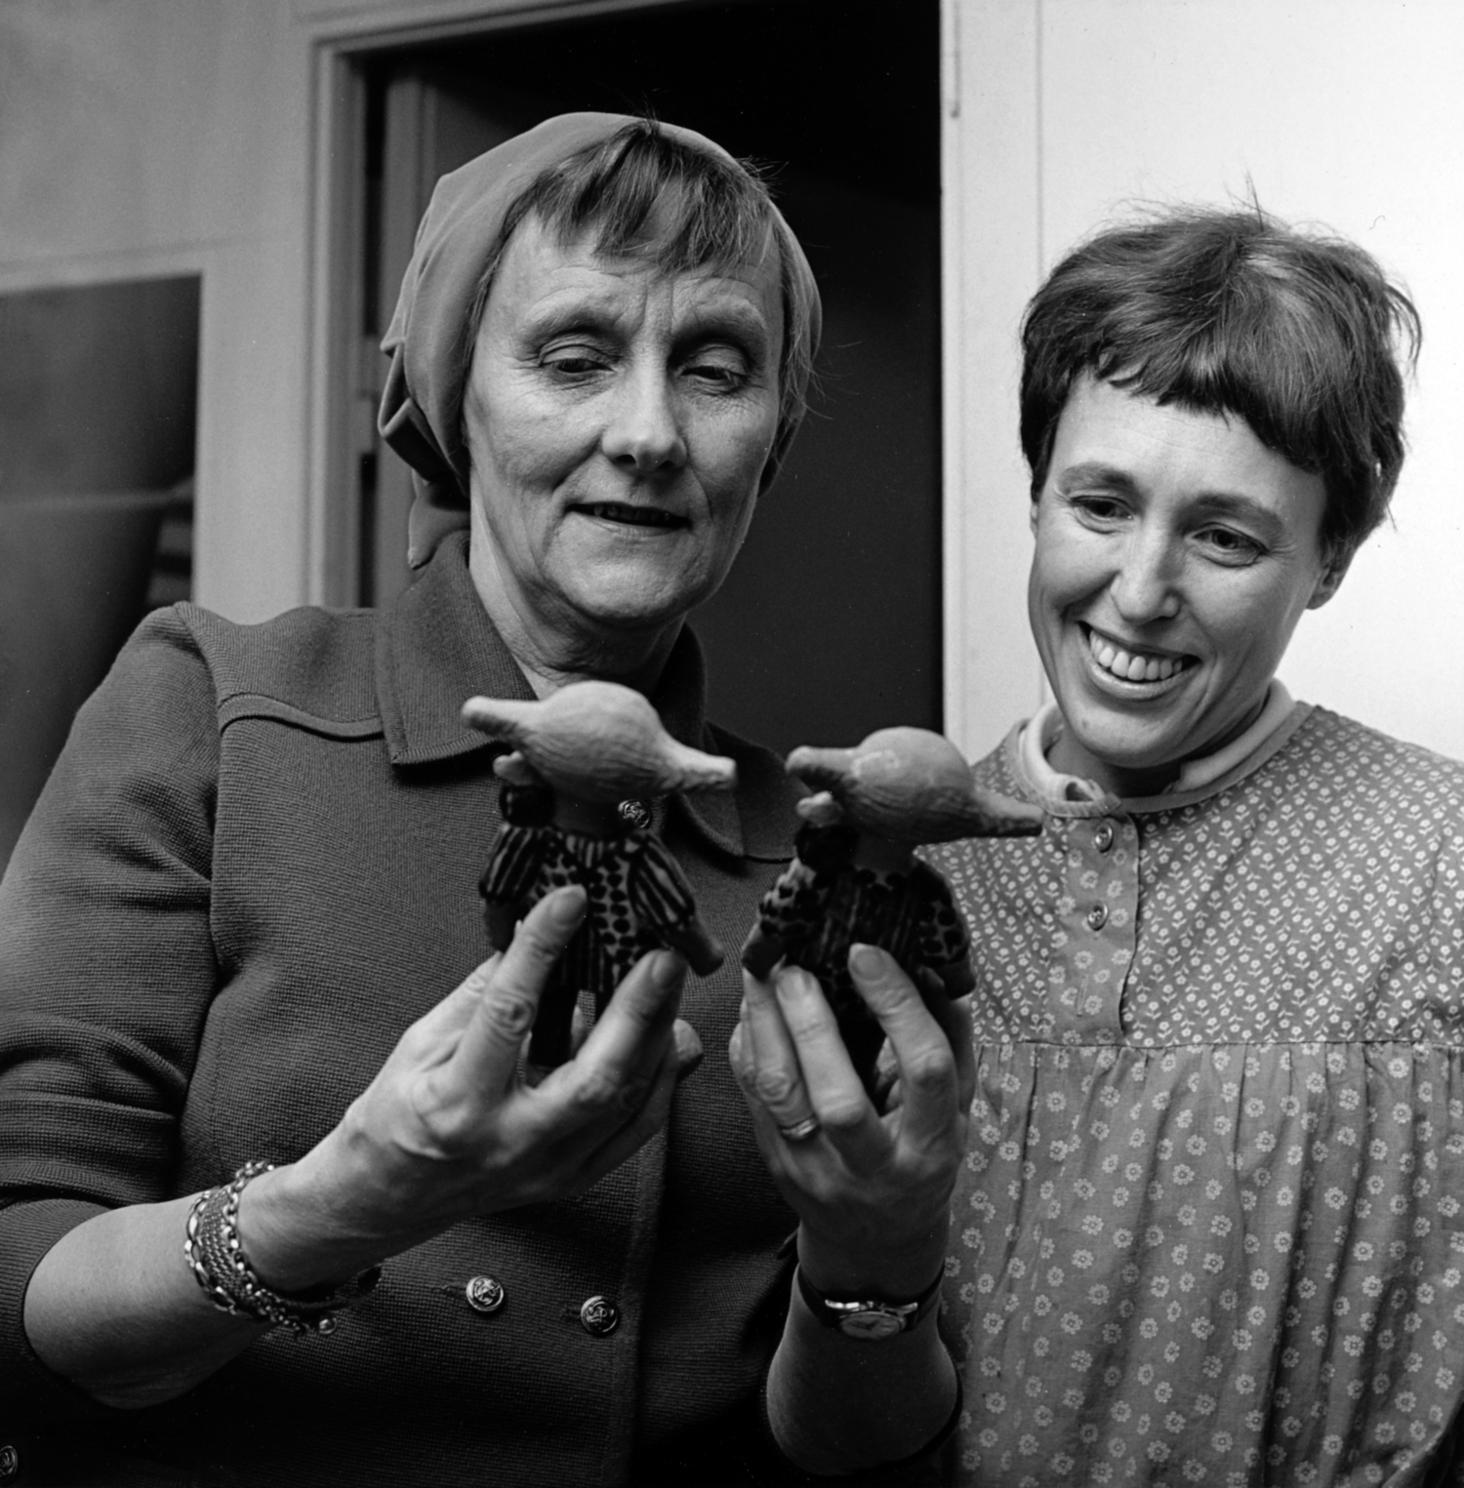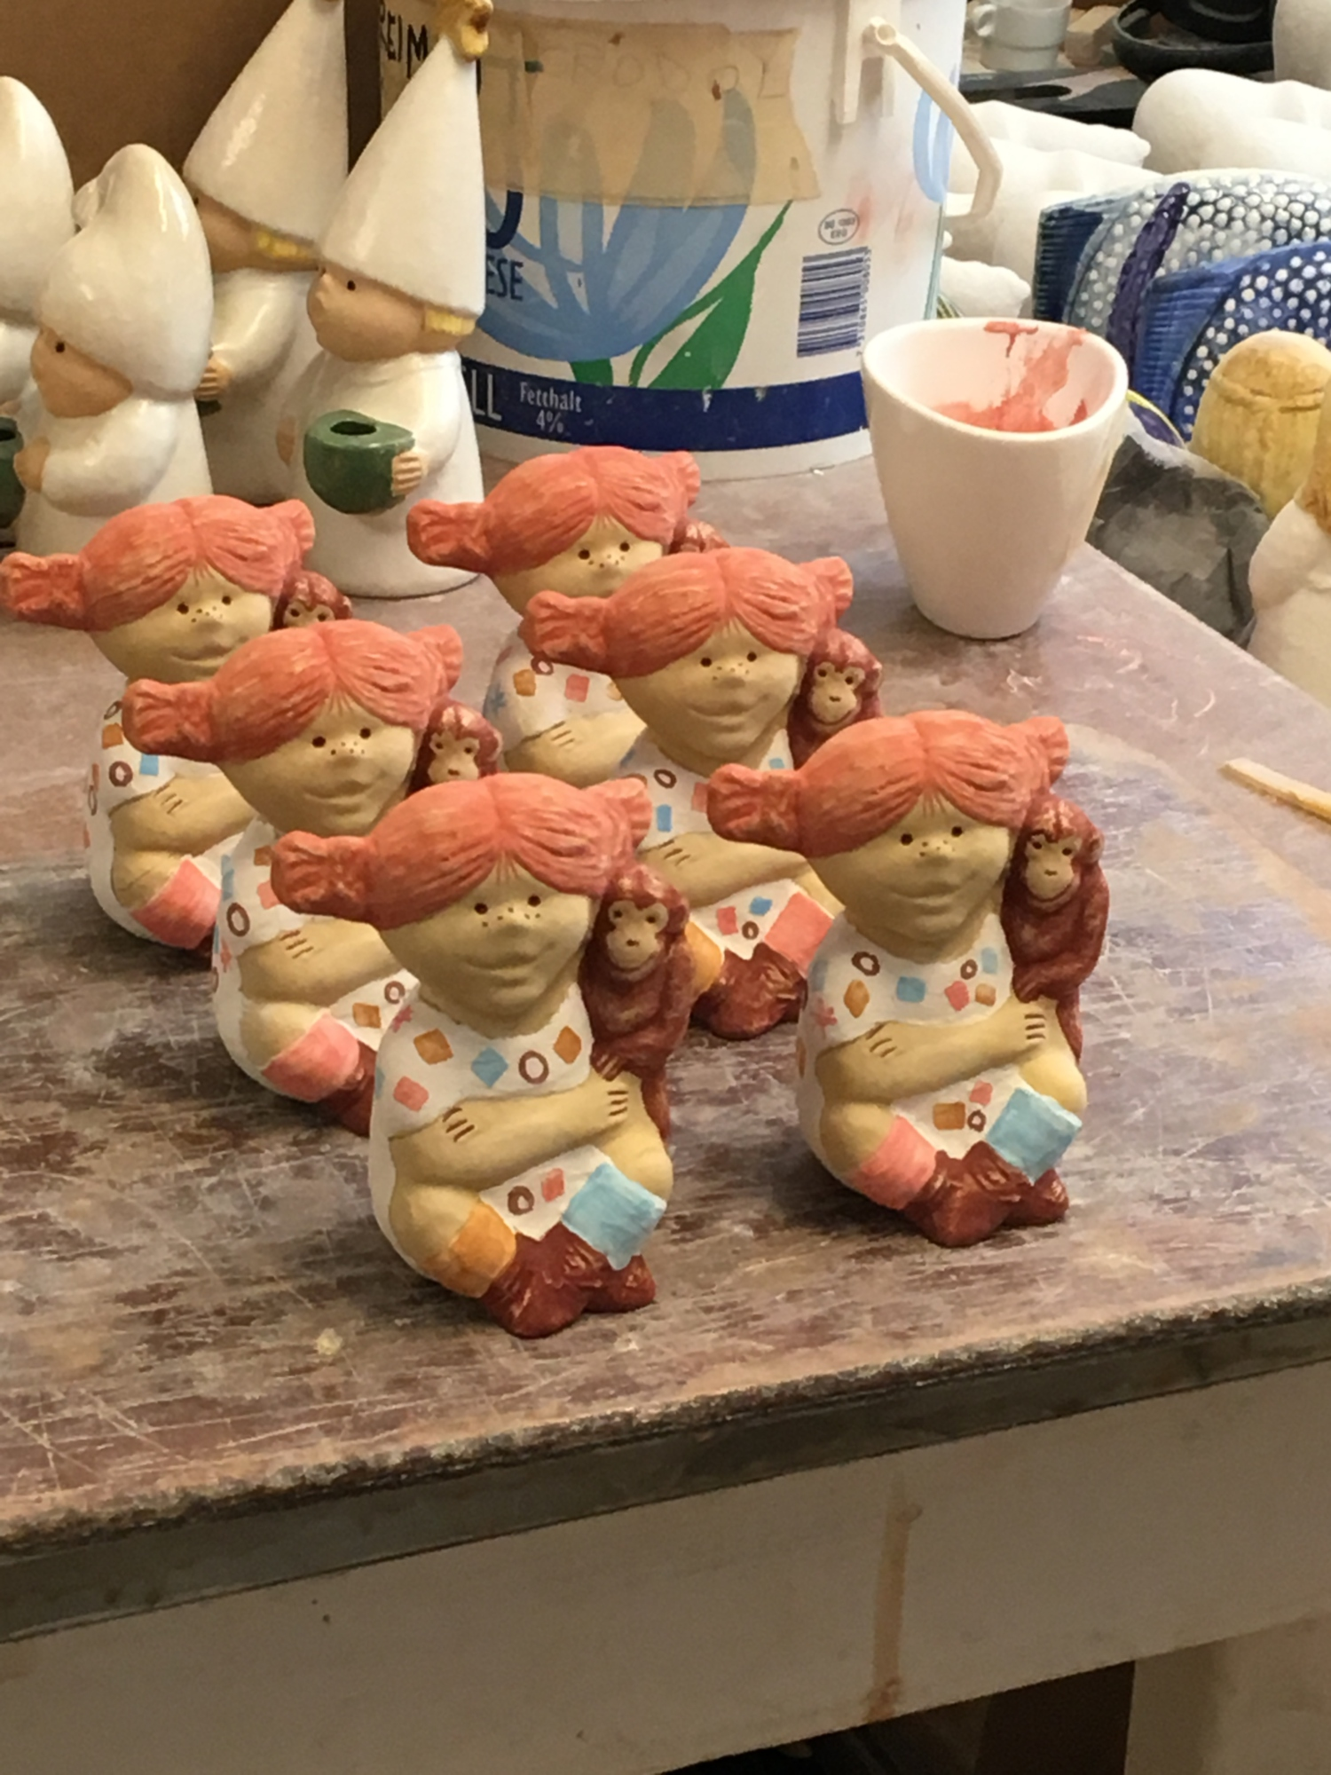

**Lisa Larson and Saltkråkan – the Astrid Lindgren Company - have embarked upon a new collaboration; the creation of a series of figurines based on Astrid Lindgren's characters, commencing with a new Pippi Longstocking. Lisa Larson's and Astrid Lindgren's collaboration began in the late 1960’s, when Lisa Larson created a classic, and, now much sought after, ceramic figure of Pippi Longstocking.**

When the first Pippi was about to be produced, Astrid Lindgren visited the factory in Gustavsberg outside Stockholm, in order to give her approval. She was so delighted by it, she suggested that Lisa should also recreate the character Emil in Lönneberga.

Lisa recalls Astrid telling her she was writing a new book about a young boy called Emil, and how Lisa should make him as well. “That was forty-five years ago, and it still hasn't materialized. However,” Lisa continues, “when I was requested to make new Astrid Lindgren figures, I became so inspired I started working on several of them at the same time.”

Lisa Larson, Sweden's most beloved ceramic designer, is, among other things, known for her stoneware figures. Many of them have become international design classics, treasured by collectors and antique dealers around the world.

Lisa Larson and Saltkråkan have now embarked upon a collaboration and agreed on producing a series of Astrid Lindgren’s characters. The first item to be launched is Pippi Longstocking.

“To continue the legacy, to make ceramic history, and, at the same time, contribute to what Astrid Lindgren always wanted, feels incredible” says Tobias Mannheimer, Head of Licensing at Saltkråkan. “The whole process has been delightful, the project is a joy to be involved with. Lisa's dedication is contagious. I look forward, very much, to the future.”

The Pippi figure is 10 cm high, moulded in stoneware, and fired at 1220-1230 degrees Celcius, by Keramikstudion in Gustavsberg. The decor is hand-painted and the figures will all differ slightly from each other.

“We are honoured to produce the new Pippi Longstocking. It's an exciting challenge for us. I remember working at the factory in Gustavsberg where they produced the old Pippi figure”, says Franco Nicolosi, founder of Keramikstudion.

To celebrate this event, the very first new Pippi figure, signed ‘Nr 1.’ by Lisa Larson, is being auctioned at Swedish online auctioneer Tradera (http://www.tradera.com/item/302283/259982830/unik-pippifigur-av-lisa-larson-till-forman-for-sos-barnbyar-). All monies raised will go to SOS Children's Villages, and the new village “Bullerbyn” in Atakpame, Togo.

“It gives us great pleasure, as Astrid Lindgren's family, to bring together the past and the present, and to contribute to the new Children's Village currently under construction”, says Olle Nyman, CEO at Saltkråkan, and Astrid Lindgren’s grandchild.

The new Pippi Longstocking figure can be purchased this summer at Astrid Lindgren's Näs, and Astrid Lindgren's World, in Astrid Lindgren’s native village, Vimmerby, Sweden.

It will also be available from Lisa Larson Shop, (http:// https://lisalarson.myshopify.com/)

**For more information, please contact:**

**Cilla Nergårdh**, Marketing and PR Manager at Saltkråkan, cilla.nergardh@saltkrakan.se, +46 709-38 46 52

**Tobias Mannheimer**, Head of Licensing Saltkråkan AB, tobias.mannheimer@saltkrakan.se, + 46 703-15 15 91

**Andreas Ribbung**, Lisa Larson Design AB, info@lisalarsonsweden.com

**Franco Nicolosi**, Keramikstudion, keramikstudion.gbg@telia.com, +46-8-570 305 86