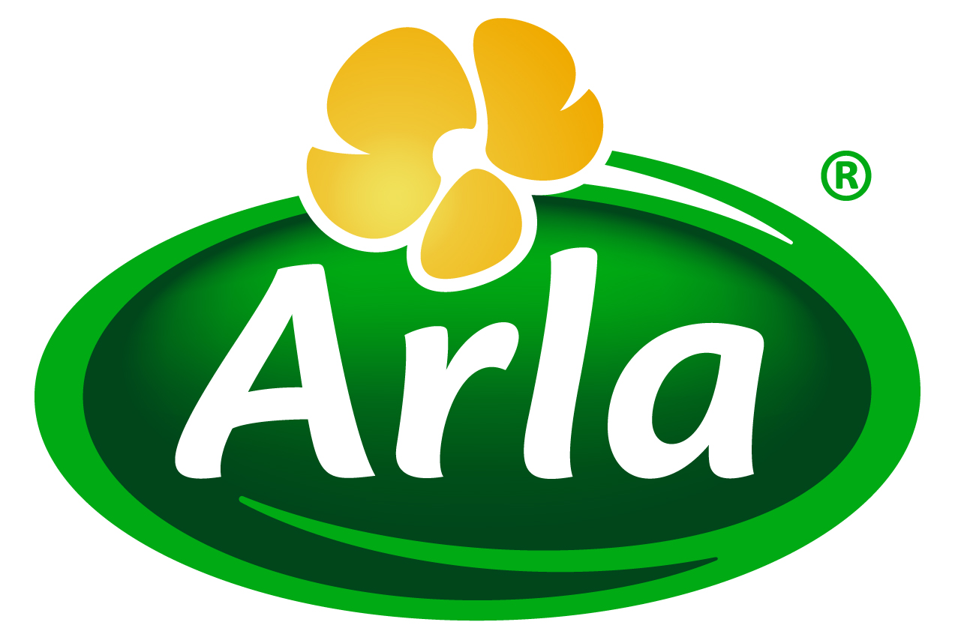
24 September 2013

PRESS RELEASE – FIE 2013 PREVIEW

Arla Foods Ingredients to showcase
new ‘Protein Water’ concept
Food Ingredients Europe, Messe Frankfurt, 19-21 November 2013 – Stand 8C01

Arla Foods Ingredients is set to unveil a new Protein Water beverage concept at Food Ingredients Europe 2013.

Protein Water is a prototype product created by Arla Foods Ingredients to demonstrate to soft drinks companies the potential for incorporating high quality whey protein isolate into a great-tasting beverage with wide consumer appeal.

Each 500ml bottle of Protein Water contains 25% of the RDA of protein – sufficient to make a nutrition claim on the label. Protein Water can be enhanced with vitamins and minerals to capture the opportunity to develop an all-round nutritious drink that fits into the lifestyles of busy consumers looking for healthier beverage choices.

The concept beverage has been designed to appeal to shoppers with an interest in maintaining a healthy diet and weight, particularly female consumers, but also anyone wishing to lead a healthier lifestyle.

Peter Schouw Andersen, Business Development Manager for Health & Performance at Arla Foods Ingredients, said: “The attraction of protein as an ingredient has broadened among consumers. Once the domain of hardcore sports and workout enthusiasts, dairy protein is now seen as a wholesome and nutritious ingredient sought out by mainstream consumers – something the success of Greek yoghurt has testified to. Our Protein Water concept has been created to show soft drinks companies how they can tap into this market and reap the rewards.”

Exhibiting on Stand 8C01, Arla Foods Ingredients’ friendly and knowledgeable representatives will be on hand to discuss with visitors how dairy proteins can enhance their products and processes and give them a significant edge on their competitors.

ENDS

For more information, images or to arrange an interview with an Arla Foods Ingredients representative on this subject, please contact:

Miranda Mills, Ingredient Communications
Tel: +44 207 193 4167
Email: Miranda.mills@ingredientcommunications.com

About Arla Foods Ingredients
Arla Foods Ingredients is a leading developer and supplier of nutritional and functional milk-based ingredients to the global food industry. The company operates production facilities in Denmark, Sweden, Argentina and Germany, application centres in Denmark and Argentina, and a worldwide network of sales offices. Arla Foods Ingredients is a subsidiary of Arla Foods, one of Europe’s principal dairy groups.

RSS Feed
Visit our website at www.arlafoodsingredients.com/news and sign up to our News RSS feed for all the latest developments – updated regularly.

Twitter
Follow us on twitter for all the latest updates @ArlaIngredients

