VisiConsult X-ray Systems & Solutions GmbH
Brandenbrooker Weg 2-4
23617 Stockelsdorf

Stockelsdorf, 25/11/2019

Press Release

Sauter Elektonik buys XRHCount during productronica 2019
VCcount, the new electronics division of VisiConsult participated at productronica 2019 and sold to a brand-new customer one of their systems.

It’s been a successful event for VCcount. Many visitors stopped by and demonstrated interest. The team presented two new features, the Worry-free Counting package as a new payment model, and they sold one system to the company Sauter Elektronik.
CEO of Sauter, Harry Sauter, “During the last 8 years we used a solution that counted the perforation of the SMD reels, but that takes much too long. So, we investigated several possibilities and I was impressed how fast the XRHCount is! There is no need for the operator to pre-set something. He loads four reels into the drawer, pushes one button and after ten seconds we have accurate quantities. Beside the fast counting, I’m glad to provide my operator an ergonomic solution due to the sophisticated drawer design.”

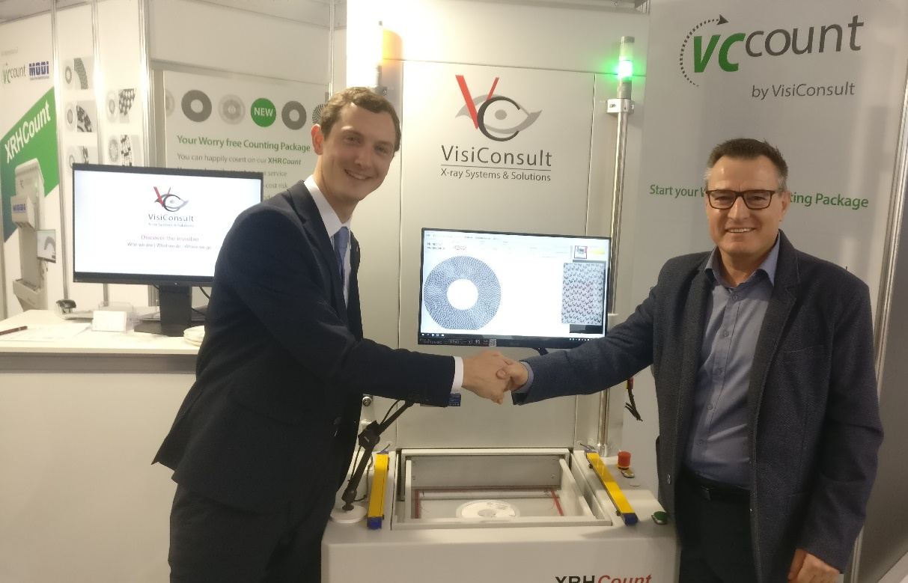

Nico Federsel and Harry Sauter sealed the deal with a handshake during productronica 2019.

Sauter Elektronik is a strongly expanding manufacturing service within the EMS branch, and has been a force in the market for over 30 years. Equipped with top equipment and committed staff, investigations into solutions with long-term benefits are logical.
Their newest acquisition will be integrated into the production line and brings additional benefits:

- Counting Cloud
- Data Base Connection
- Barcode Reader

Nico Federsel, Head of VCcount, explains, “The system that we sold to Sauter Elektronik is a system that includes the Quad Count Pro, so they will also benefit by a time-saving of 75%. I am curious to see how this will accelerate Sauter Elektroniks success.”

