Stena Line to add extra North Sea freight capacity on Rotterdam to Harwich route
21 July 2017 - In response to demand on the route from Rotterdam (Europoort) to Harwich, Stena Line is to increase capacity by changing to larger ships.

The current RoRo ships the Capucine and Severine which operate twice daily from Europoort in the Netherlands and Harwich in the UK will be replaced by larger ships, the RoRo ships MV Misada and MV Misina, when their present charter contracts expire in January 2018. As a result, the overall freight capacity of the route will increase by approximately 20%.

The change coincides with the expected completion of a second berth in Europoort, part of a significant investment program in the port to ensure it develops into a strong multipurpose freight transport hub. The capacity expansion is also linked to Europoort developing as an important rail freight connection point to and from the UK.

Annika Hult, Trade Director at Stena Line North Sea said: “I am very pleased to announce that we will now take the next step in the strategic development of our Rotterdam (Europoort) - Harwich route. We have seen a strong growth in the transport market to the UK over the past several years and we are currently trading at very high utilisation on this route. This has been further fuelled by freight volumes arriving to Europoort by train. The current rail connections between Poznan, Poland and Europoort, which changed ownership earlier this year, are running very well. We believe that this combination of rail and RoRo transportation will only increase in the future.”

“We have seen strong growth in the transport market to the UK over the past several years and we intend to maintain our strong position on the Continent – UK market. We want to be in the best place to care for the business needs of our most important relations, our customers. With this tonnage change and capacity increase we clearly demonstrate that we will keep on providing a reliable service where we can meet future demands. Europoort continues to develop as a key freight hub for Stena Line and we are confident our customers will react positively to our further expansion.”

“The new vessels will be chartered on a time-charter contract and will consequently be fully manned. Unfortunately, this will impact our onboard staff. As a company, we want to avoid as many redundancies from happening as reasonably possible and we will be looking at all available options including redeployment to other vessels within Stena Line,” she concluded.

# # #

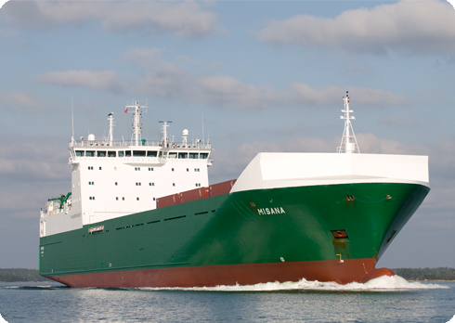
Facts MV Misada and MV Misina
Type of ship: RoRo
Year of construction: 2007
Length: 165.75 m
Width: 23.4 m
Service speed: ∼19 kn
Passengers: 12
Lane meters: 2,155

For more information, please visit www.stenalinefreight.com

~ ends ~

Notes to editors:
Stena Line is one of Europe’s largest ferry operators with 35 ferries and 20 routes in northern Europe. Stena Line is an important part of the European logistics network and it is developing new intermodal freight solutions by combining transport by rail, road and sea. With its extensive passenger operations, Stena Line also plays an important role for tourism in Europe. The company is family-owned, was founded in 1962 and its head office in Gothenburg. Stena Line is part of the Stena Sphere, which has around 19 000 employees and a turnover of approximately SEK 51 000 million.
Stena Line North Sea’s social media updates are available at @StenaLineUK and www.facebook.com/StenaLineUKtoHolland

For further press information please contact:

Fiona Brown, Duffy Rafferty Communications
Tel: +44 28 9073 0880 / email: fiona@duffyrafferty.com

