Contact:
Ovelin ltd.
+358407764954
media@ovelin.com

FOR IMMEDIATE RELEASE:

GUITARBOTS RELEASES MR. FASTFINGER
CHALLENGE FOR ADVANCED GUITARISTS

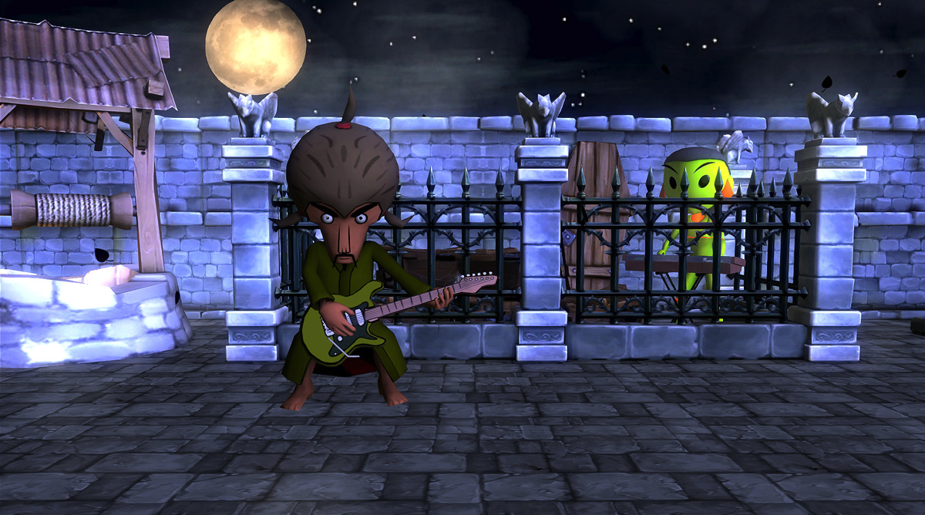
GUITARBOTS JOINS FORCES WITH MR.FASTFINGER AND RELEASES A PACKAGE OF ADVANCED GAMIFIED GUITAR LEARNING CONTENT

New Mr.FastFinger song and exercise package available globally 14 May 2013.

SAN FRANCISCO – (14 May, 2013) – Ovelin ltd. announced today the release of a new “Mr. Fastfinger challenge” song package for GuitarBots (www.guitarbots.com), the social guitar game played with a real guitar. The new song package release introduces new, challenging levels for more advanced guitarists. With the release, Ovelin ltd. hints of oncoming, exciting content releases and features in GuitarBots for more serious guitar gamers.
The released Mr. Fastfinger challenge features six new levels with advanced rhythm and lead guitar exercises. The released song levels feature new, original songs tailored for GuitarBots by “Mr. Fastfinger” (sensei), the hugely popular animated character from the guitar instructional site GuitarShredShow.com (with millions of visitors), produced and composed by JamTrackCentral.com featured guitarist Mika Tyyskä. The Mr. Fastfinger song package release in GuitarBots also acts as a teaser to the oncoming release of "Stringweaver" EP, featuring full versions of the tracks presented in the GuitarBots Mr.Fastfinger song package (Awaki-Waki, Practice Heart, Nightvisions ) and an extra track “Sandwashing”.
The release of the Mr. Fastfinger challenge paves the way for more serious guitar gaming, controlled with a real guitar, also for advanced guitarists. "I'm not usually spending time with computer games, but then I was introduced to something special by the creators of GuitarBots” said Mika Tyyskä. “The game detects your guitar playing, the pitch and timing incredibly well - I tested some of the already exciting game levels and realized the potential of the game. I was very much inspired of this opportunity"
The release of Mr. FastFinger challenge also introduces a novel, interactive means of releasing music. The gamified setting introduces a deeper level of interaction with song content, and opens an array of new possibilities for fan engagement. “You can get so much deeper with the music when you’re playing it yourself. Once I had started working on the music, I realised the material would also make a nice stand alone music release”, commented Mika Tyyskä.
In addition to the game levels, another layer of instruction is provided by a simultaneous release of tutorial videos for the released game levels. ”Learning to play advanced levels such as the Mr. Fastfinger challenge can be quite technical – when you combine technique videos with the engaging, real-life gameplay of GuitarBots, you have a very powerful, fully featured learning package that makes technical practice more interesting”, explained Mikko Kaipainen, the COO and co-founder of Ovelin ltd., the developer of GuitarBots.
Mr. Fastfinger song package is available online 14th May 2013 for Pc and Mac computers, at www.guitarbots.com.
The “Stringweaver” EP will be available 21th March from All major digital download stores, including tracks:
1. Awaki-Waki
2. Practice Heart
3. Nightvisions
4. Sandwashing (*EP only, not included in the GuitarBots game package)

For more information about GuitarBots visit : www.guitarbots.com
For inquiries, contact: Mika Jalonen, media@ovelin.com (+358 40 7764954)

More information about Ovelin at: www.ovelin.com
Ovelin youtube channel : www.youtube.com/ovelinbird

About GuitarBots
GuitarBots is an innovative online guitar learning game played with any real guitar features, making it more motivating and fun to develop real life guitar skills.
Starting with GuitarBots is simple – you can play the game directly on your web browser. The game is played with a real guitar (acoustic or electric), using the computer’s microphone to “listen” to the chords and notes played.
GuitarBots is suitable for all ages and skill levels, featuring step-by-step tutorials, a built-in tuner and a variety of songs with both beginner and advanced difficulty levels.

About Ovelin ltd.
Ovelin is changing the way people learn to play musical instruments. Headquartered in Finland, the company is known as the creator of the popular guitar learning game WildChords for iPad. WildChords, played cord-free with a real guitar, has been the number 1 music app in 34 countries, featured in the Sunday Times ’World’s Best Apps 2012’ list, WIRED magazine and TechCrunch. It has also won several awards, the Best European Learning Game in 2011, and winner of SXSW 2012 and MIDEM 2012.

About Mr. Fastfinger

In 2005 Mr. Fastfinger shook the guitar world when GuitarShredShow.com, animated instructional guitar game site was launched. Cartoon sensei's charisma revealed to be quite appealing not only to Mika but also to the wide world of guitarists. Guitar Shred Show was highly popular with several million visitors.

The carton sensei then became a live act, Mika Tyyskä and the cartoon character on screen has been performing in Europe and Japan. Mika and Mr. Fastfinger has been doing cooperation with companies such as Hughes & Kettner and TC Electronic. Mika has shared the stage or recorded together with such artists as Jordan Rudess (Dream Theater), Mattias IA Eklundh, Thomas Blug and Christophe Godin. Mr. Fastfinger's two albums "The Way of The Exploding Guitar" (2009) and "in Motion" (2012) have been well received by the global guitar scene.

In 2012 joined the high class of guitar players at JamTrackCentral.com. Mika is featured along side with some of the most respected and successful guitarist such as Gutherie Govan, Andy James, Marco Sfogli. So far Mika has created two educational jam packages for Jam Track Central, more to come.

