MEDIA RELEASE

“A Course for a Cause”
Pan Pacific Hotels Group Marks World Food Day
By Raising Funds for Those with Special Needs

19 July 2018, Singapore – Diners who enjoy good food will be delighted to know that a portion of their bill will be donated towards a good cause as Pan Pacific Hotels Group marks World Food Day with its annual fund-raising campaign to support the needy.

Aptly titled “A Course for a Cause” this year, the four hotels operated by Pan Pacific Hotels Group in Singapore have pledged part of their food and beverage revenue towards purchasing grocery vouchers for individuals with special needs from six Day Activity Centres from now until 15 August 2018.

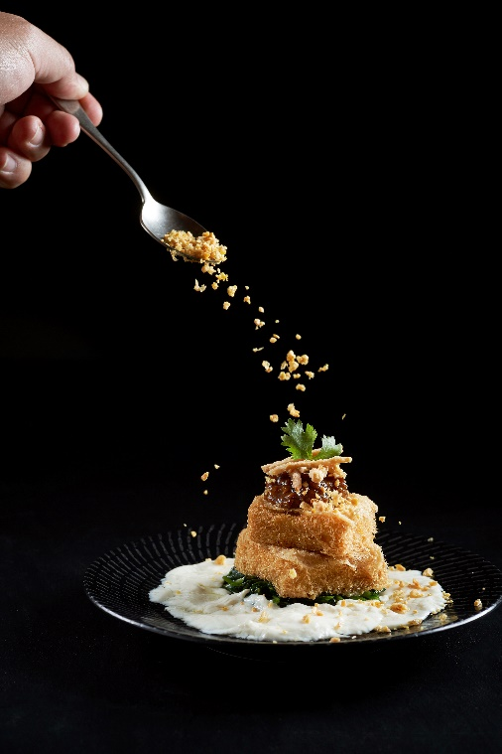
Pan Pacific Singapore, PARKROYAL on Pickering, PARKROYAL on Beach Road and PARKROYAL on Kitchener Road will donate 1 per cent of total revenue from their all-day dining restaurants during the campaign period.

In addition, four specialty restaurants within the hotels — Keyaki Japanese Restaurant and Hai Tien Lo Chinese Restaurant at Pan Pacific Singapore, as well as Si Chuan Dou Hua Restaurants at PARKROYAL on Beach Road and PARKROYAL on Kitchener Road— will donate 20 per cent of sale proceeds from their mouth-watering signature dishes: Wok-fried Diced Beef Tenderloin with Mushrooms in Black Pepper Sauce by Hai Tien Lo Chinese Restaurant and Five Varieties of Seasonal Sashimi from Keyaki Japanese Restaurant, both at Pan Pacific Singapore, Beancurd Medley dish PARKROYAL on Kitchener Road, and Chong Qing Diced Chicken with Dried Chilli dish from PARKROYAL on Beach Road (dish descriptions in Annex A).
Beancurd Medley from
Si Chuan Dou Hua Restaurant at PARKROYAL on Kitchener Road
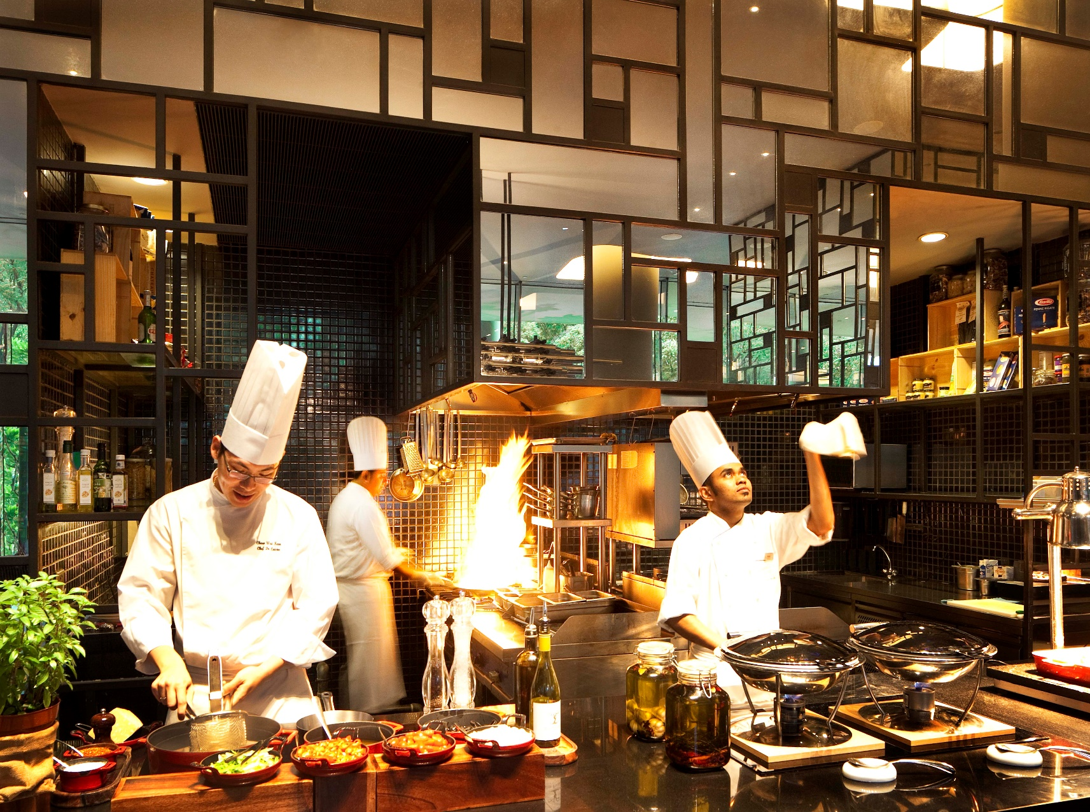
Lime, PARKROYAL on Pickering

Pan Pacific Hotels Group is also proud to announce a new partnership with Mastercard® this year. In a strong bid of support for “A Course for a Cause”, Mastercard® has pledged a $10 grocery voucher for every transaction charged to a Mastercard® at the eight participating restaurants (Annex B). With all vouchers going to the beneficiaries, diners can be assured that they are tucking in for a good cause, whether they opt to dine in at the all-day dining restaurants— Edge at Pan Pacific Singapore, Lime at PARKROYAL on Pickering, Ginger at PARKROYAL on Beach Road, and Spice Brasserie at PARKROYAL on Kitchener Road— or to tuck into the signature dishes at the speciality restaurants.

Says Ms Wee Wei Ling, Executive Director, Lifestyle & Asset Management, who is also Pan Pacific Hotels Group’s Head of CSR, “Pan Pacific Hotels Group is committed to building a more inclusive society. We actively champion disability inclusion and through our annual fundraising campaign this year, we hope to once again bring awareness to the cause and help alleviate the daily stresses of individuals with special needs who need more support in their lives. We’re very encouraged by the response from our diners and partners such as Mastercard®, whose support will double the impact of our efforts.”

Named Asia’s “Best Regional Hotel Chain”, Pan Pacific Hotels Group is passionate about being a socially responsible corporate citizen and has in place several initiatives which give back to the community. In Singapore, the Group has also partnered seven charity homes for the elderly, women, and those with mental disabilities to promote eating well by cooking meals for the residents and imparting healthy and tasty recipes to their resident cooks throughout the year.

END

Visit panpacific.com for more information about us.
For media queries, please contact:
Cuili Ng
Brand & Corporate Communications Manager
Pan Pacific Hotels Group
DID: +65 6808 1269
M: +65 9634 4425
E: ng.cuili@pphg.com

Pan Pacific Hotels Group
Pan Pacific Hotels Group is a wholly-owned hotel subsidiary of Singapore-listed UOL Group Limited, one of Asia’s most established hotel and property companies with an outstanding portfolio of investment and development properties.
Based in Singapore, Pan Pacific Hotels Group owns and/or manages 40 hotels, resorts and serviced suites with more than 12,000 rooms including those under development in Asia, Oceania, North America and Europe.
Voted “Best Regional Hotel Chain” by readers in Asia in 2017, Pan Pacific Hotels Group comprises two acclaimed brands: its signature brand, Pan Pacific and its deluxe brand, PARKROYAL.
Sincerity is the hallmark of Pan Pacific Hotels Group. The Group is known to its guests, partners, associates and owners for its sincerity in people and the sense of confidence which alleviates the stresses of today’s complex world.

Pan Pacific Hotels and Resorts
With hotels, resorts and serviced suites across Asia, Oceania and North America, Pan Pacific Hotels and Resorts is your safe harbour in an ever-changing world. Places with less to worry about because, when you stay with us, rest assured that all will be taken care of. For this is where you will find your balance.

PARKROYAL Hotels & Resorts
A big city or cosy enclave – where there is a PARKROYAL hotel, resort or serviced suite, there is a celebration of people. Our passion for creating real connections and joyous moments can be felt when you enter any of our properties across Asia and Australia. After all, this is the place to bring out the best of you, by us.

Annex A
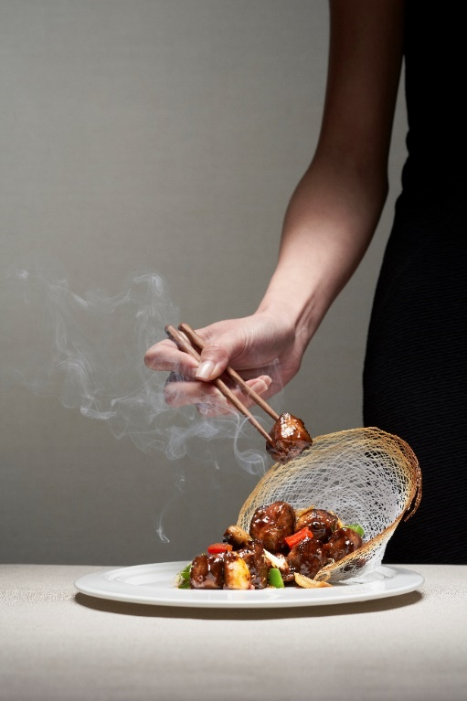
Hai Tien Lo Chinese Restaurant, Pan Pacific Singapore

One of Hai Tien Lo’s best-sellers is the melt-in-your-mouth succulent Wok-fried Diced Beef Tenderloin with Mushrooms in Black Pepper Sauce. A classic Cantonese dish, the finest grade of beef tenderloin is marinated in Chef’s special sauce and wok-fried in black pepper sauce with onions, bell pepper and mushrooms to bring out the bold flavours of this Chinese favourite. Best served with a bowl of steamed rice and paired with Hai Tien Lo’s No. 1 tea.

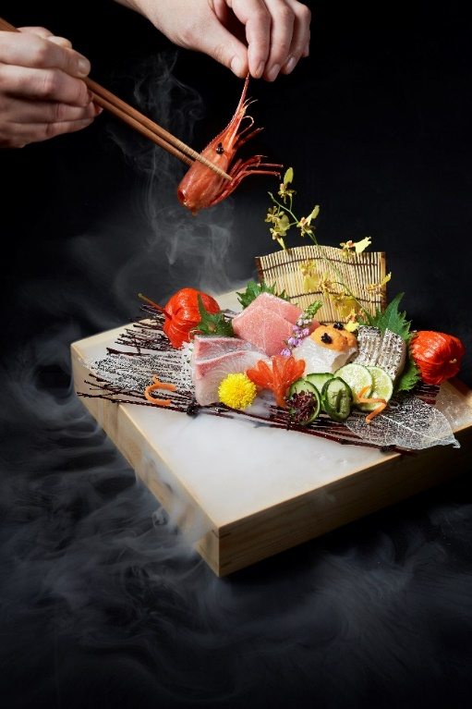
Keyaki Japanese Restaurant, Pan Pacific Singapore

Renowned for the mastery of their Chefs and for the use of seasonal delicacies air-flown from Japan, one of Keyaki’s signature dishes is the Five Varieties of Seasonal Sashimi that is immaculately presented featuring Executive Chef Shinichi Nakatake’s recommendation of five different varieties of freshly sourced premium seasonal ingredients.

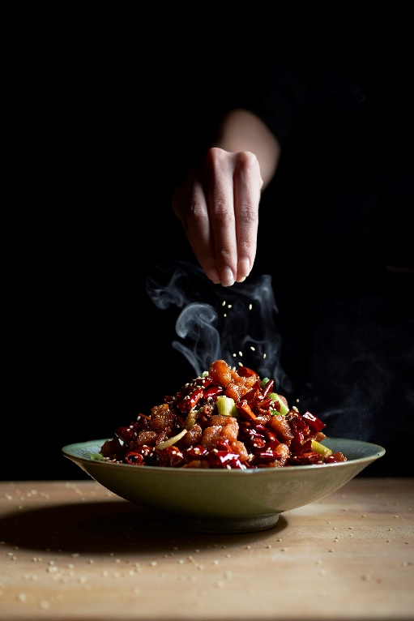
Si Chuan Dou Hua Restaurant, PARKROYAL on Beach Road

One of Si Chuan Dou Hua Restaurant’s most popular signature dishes, the Chong Qing Diced Chicken with Dried Chilli is a classic Sichuan dish. Diced chicken bits are deep-fried to be crispy on the outside, while tender within. Unapologetically fiery and tongue-numbing, it is served on a plate smothered in dried chilli and peppercorn.

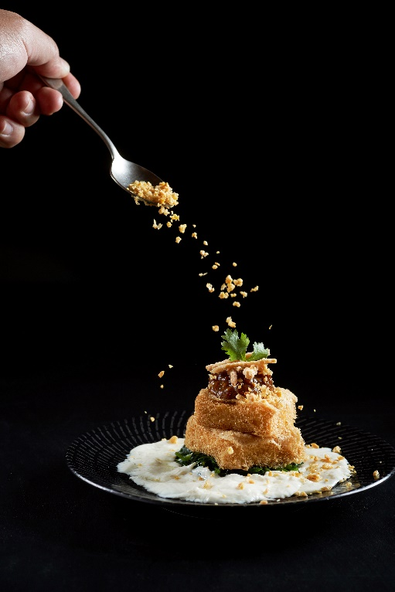
Si Chuan Dou Hua Restaurant, PARKROYAL on Kitchener Road

Executive Cantonese Chef Leung Wing transformed the everyday bean curd into a work of art. The Beancurd Medley signature dish is made with the perfect combination of bean curd, bean curd skin and soy bean crumbs fried until golden brown, placed atop a bed of homemade bean curd along with vegetables and minced meat.
Annex B

 | Name of restaurant/hotel | Signature dish | Contribution amount  (15 Jul – 15 Aug 2018)
1 | Edge, Pan Pacific Singapore |  | 1% of revenue from restaurant including buffets and ala carte dishes
2 | Lime, PARKROYAL on Pickering
3 | Ginger, PARKROYAL on Beach Road
4 | Spice Brasserie, PARKROYAL on Kitchener Road
5 | Hai Tien Lo Chinese Restaurant, Pan Pacific Singapore | Wok-fried Diced Beef Tenderloin with Mushrooms in Black Pepper Sauce | 20% of revenue from signature dish
6 | Keyaki Japanese Restaurant,  Pan Pacific Singapore | Five Varieties of Seasonal Sashimi
7 | Si Chuan Dou Hua Restaurant, PARKROYAL on Beach Road | Chong Qing Diced Chicken with Dried Chilli
8 | Si Chuan Dou Hua Restaurant, PARKROYAL on Kitchener Road | Bean Curd Medley

NTUC Fairprice vouchers
These Day Activity Centres are operated by Autism Association Singapore, Cerebral Palsy Alliance Singapore, Metta Welfare Association, and St Andrew’s Autism Centre. Many adults with moderate to severe disabilities are unable to join the workforce as they require higher support to lead independent lives. Day Activity Centres equip them with daily living skills and community living skills to maximise their independence, and also provide respite to their caregivers.

