Press release
Düsseldorf, 13/02/2024
Valuation of assets in the manufacturing industry:
challenges and solutions according to EBA/GL/2020/06
The guidelines EBA/GL/2020/06 for lending and monitoring, published by the European Bank Authority (EBA) on 29 May 2020, represent a comprehensive framework for data management, lending standards, and customer relations within the European banking sector. These guidelines aim to address identified deficiencies in existing lending processes, thereby significantly contributing to the strengthening of the EU banking system's stability.
However, national implementation is not yet complete everywhere. As of the last update of the Guidelines Compliance Table in mid-2023, only 15 out of 27 member states had completed all their homework.
Risk minimisation through precise valuation: section 7 of EBA/GL/2020/06
Section 7 of EBA/GL/2020/06 addresses the correct valuation of real estate and movable assets serving as collateral, such as aircraft, ships, machinery, and equipment. Precise valuation is crucial in the lending process as it minimises risk for both borrowers and lenders.
According to the new guidelines, banks must establish internal procedures that consider both advanced statistical models and traditional valuation methods. Therefore, for valuation based on statistical models, institutions should have appropriate IT procedures and competencies as well as sufficient and accurate data.
Valuation by expertise: the role of qualified experts
Qualified experts are also allowed according to Section 7 of EBA/GL/2020/06 for the valuation of collateral in the lending process. Experts must not only possess the necessary professional competencies but also be capable of unbiased, transparent, and objective valuations. The final valuation must be documented in a detailed report that transparently lays out all relevant aspects and parameters. Moreover, each bank must create a list of all internal and external approved appraisers.
The requirements for experts are thus high. For example, a medium-sized automotive supplier wants to invest in expanding its production capacities. Its specialised and high-quality machines and equipment serve as security. The production line includes CNC machines, robotic arms for assembly, and specialised welding and painting plants. Particularly, the valuation of complex mobile assets like entire production lines poses a challenge for the bank, which external appraisers can effectively resolve.
Incorporating external experts into the valuation process
The challenge of finding suitable experts, especially in specific areas like machine valuation, often leads banks to external partners like Valuplex. As part of Surplex, a leading European online auction house for trading used machines, Valuplex provides independent, professional valuations. Companies like Valuplex can play a crucial role in implementing EBA/GL/2020/06 as they offer several advantages:
- Increased quality and objectivity: External experts introduce an objective perspective into the valuation process, free from internal conflicts of interest and independent from bank processes. Valuplex operates independently of potential follow-up orders and possible cooperations, ensuring unbiased valuations. To always comply with current legal requirements, Valuplex commits to continuous requalification. Moreover, Valuplex adheres to high professional standards and is certified according to relevant quality norms.
- Specialisation and expertise: Expertise is particularly indispensable for complex or unusual assets, which internal teams may not have the necessary expertise for. Valuplex is distinguished by its specialised knowledge in areas like value trend analysis – specifically in the valuation of machines, plants, and entire production sites. This expertise is reinforced through continuous technical and professional training. The use of comprehensive databases and current market information allows Valuplex to determine the value of goods based on real market trends and sales figures.
- Time and resource savings: Collaborating with external appraisers like Valuplex can relieve internal resources and allow banks to focus on their core competencies.
Valuplex and Surplex: a partnership for precise valuations
Valuplex benefits from access to extensive disposal results and market information from Surplex, leading to well-founded and market-appropriate valuations. Since nearly 25 years, up to 55,000 items per year have been auctioned off via the Surplex.com auction platform. Simultaneously, independence is guaranteed as Valuplex operates unaffected by potential follow-up orders or cooperations.
Valuplex has established itself as a reliable partner for over 125,000 customers, assisting them in decision-making processes for succession arrangements, M&A processes, sale-and-lease-back procedures, and investor searches. With an interdisciplinary team of 20 experts at 16 European locations, Valuplex delivers over 2,500 data and experience-based valuations annually. This comprehensive expertise, combined with Surplex’s rich database on used machines and industrial goods, enables Valuplex to provide precise and market-appropriate comparative value reports – of immense value to banks and other financial institutions in implementing EBA/GL/2020/06.

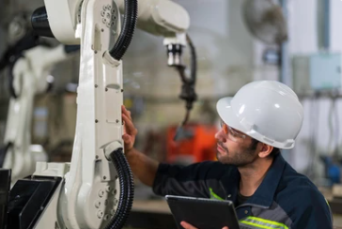 | Photo 1  The principle that “things are worth only what someone is willing to pay for them” is a fundamental concept in economics, playing a crucial role in the valuation of goods and assets.  (© Chatchawal Phumkaew / Shutterstock.com).
Photo 2
Alexander Peitz has been the new head of Valuplex since the beginning of the year, offering professional and market-appropriate industrial appraisals.
(© Surplex).

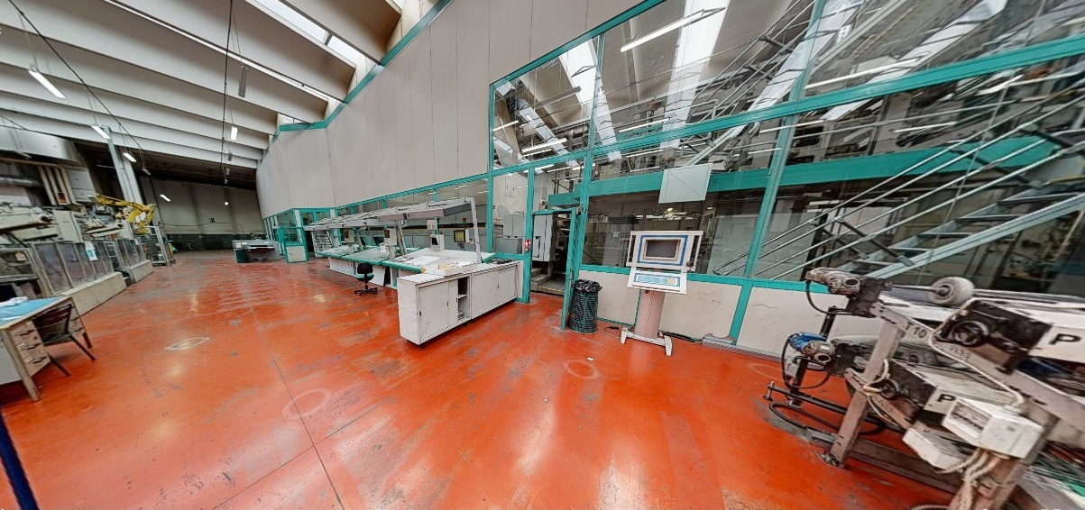
Photo 3
3D tour of a printing company dissolved in 2022: The large offset printing machine along with control systems (right), robotics technology and the automated packaging unit (back left), which palletises the print products, along with other operational inventory, were auctioned off via Surplex.
(© Surplex).

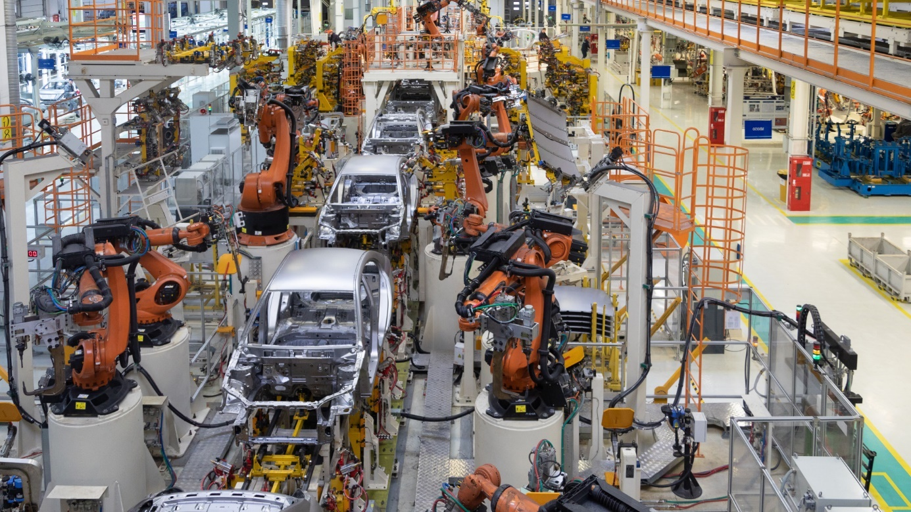
Photo 4
Evaluating a complex production line, with its myriad of highly specialised machinery and equipment such as those found in a traditional automotive manufacturing line, poses a challenge. It requires not only an understanding of each component but also of their interplay within the entire production process.
(© Jasen Wright / Shutterstock.com)

FAQ: Answers to Common Questions about EBA/GL/2020/06 and Valuplex
- EBA/GL/2020/06: What is it about?
The EBA/GL/2020/06 guidelines establish a comprehensive framework for lending and monitoring, aiming to improve credit processes and strengthen the stability of the EU banking sector. The guidelines include detailed provisions on data management, lending standards, and customer relationships.
- What are the key points of Section 7 in the EBA/GL/2020/06?
Section 7 focuses on the valuation of collateral in the lending process. It sets out how banks should assess the value of collateral such as real estate and movable assets. This includes requirements for valuation methods, monitoring and revaluation of collateral, as well as the role and qualification of experts.
- What qualifies someone as an expert according to the new regulations?
To qualify as an expert under the EBA/GL/2020/06 guidelines, specific criteria are crucial: professional competence, compliance with relevant professional standards, and comprehensive knowledge in the valuation area. This typically requires a combination of professional education, practical experience, specific certifications, and memberships in professional and trade associations for ongoing education. Moreover, experts must act independently from the lending decision and be free from conflicts of interest.
- Is Valuplex a neutral valuator?
Yes, because valuation is fundamentally independent of potential follow-up orders and possible cooperations with others. However, for a market-appropriate valuation, it is essential for Valuplex to have access to disposal results, databases, and market participants. Without the experience from disposals, no well-founded valuations can be made.
- How are values determined?
The staff of Valuplex and from the existing network have access to various databases with real disposal results – for example, the extensive database of Surplex, an online auction house for trading used machinery with almost 25 years of experience and 55,000 items auctioned per year. Additionally, market participants and publicly accessible portals are used to determine values. Often, especially in core industries, there is a very good partnership with many well-known manufacturers.
- What certifications can Valuplex present?
Valuplex is DQS certified according to ISO 9001:2015 for the limited scope of "appraisal creation as well as purchase and marketing of insolvency assets". Employees of Valuplex are also members of the Royal Institution of Chartered Surveyors (RICS), the professional body for property professionals and building surveyors.
- In which countries is Valuplex active?
Valuplex has locations in 16 European countries and is capable of conducting and offering valuations in every EU member state, England, and Switzerland through its network. The branches are in Germany, the United Kingdom, Spain, Portugal, Italy, France, Austria, Switzerland, the Netherlands, Belgium, Poland, Hungary, Serbia, Romania, the Czech Republic, and Sweden.
- What does Valuplex evaluate?
Basically, the area of evaluations can be described as “everything found in companies and production facilities”. In accounting terms, it is called the fixed assets of a business. However, if necessary, the so-called current assets, i.e., merchandise or manufactured products, can also be included in an evaluation. This is usually based on existing inventory values.

