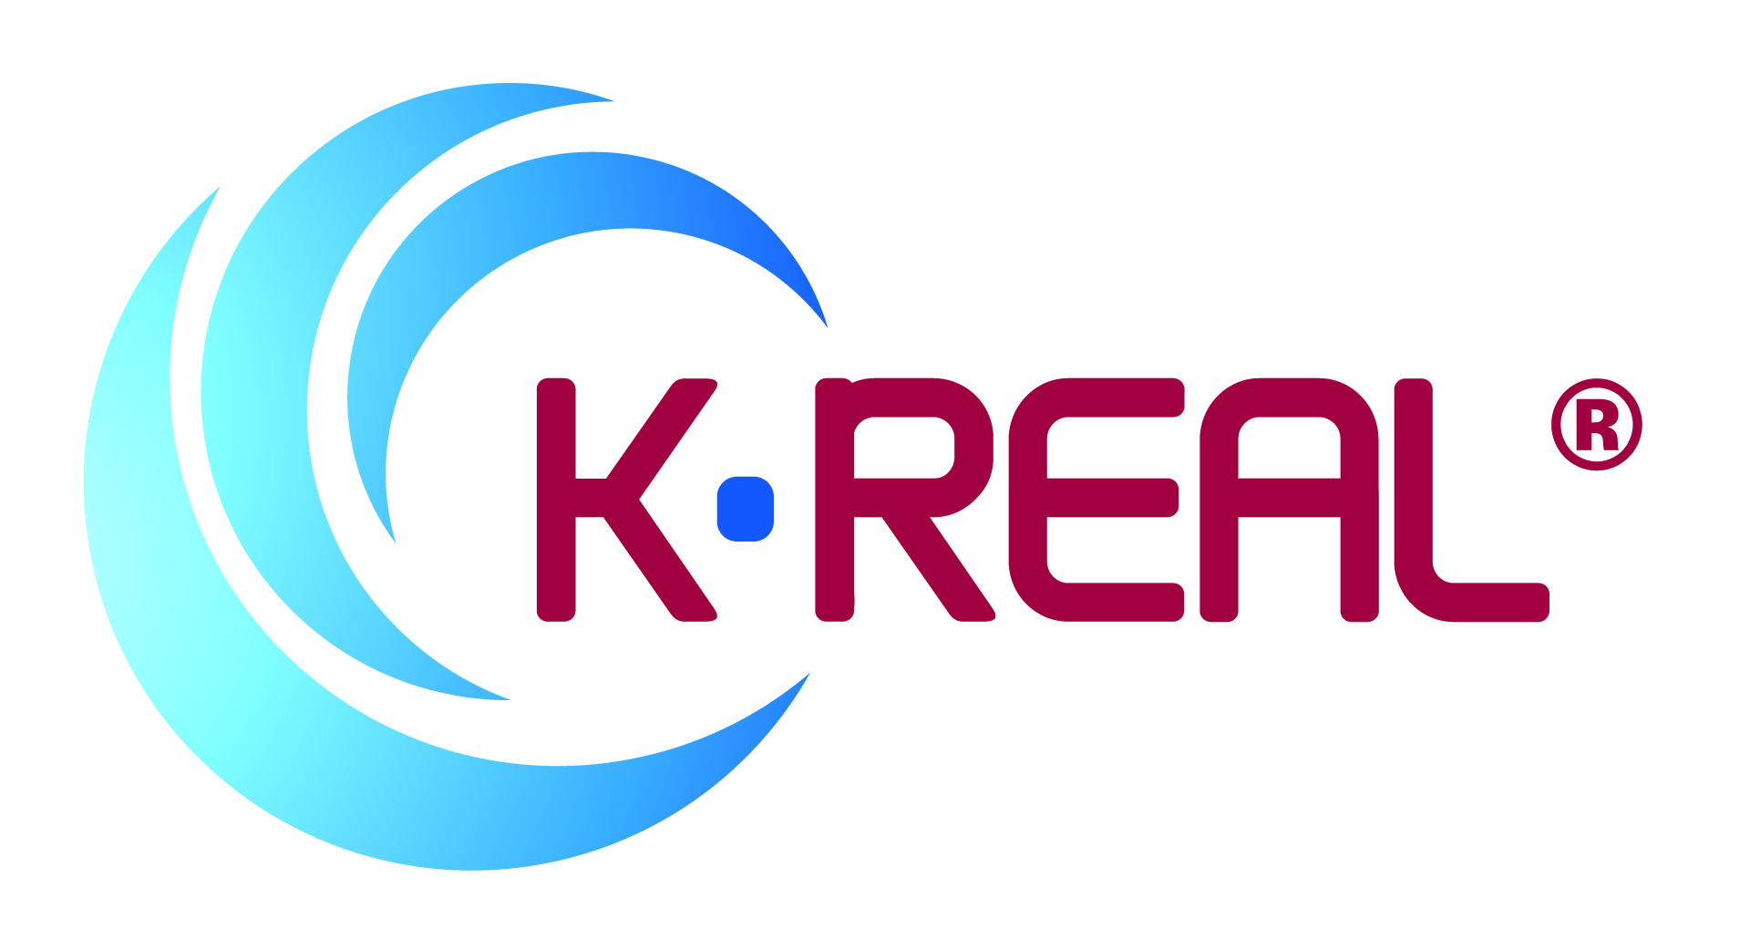

**20 December 2016**

**PRESS RELEASE**

**Krill oil goes TMAO-free with   
Enzymotec’s improved K•REAL®**

Enzymotec has unveiled an improved grade of its K•REAL**®** krill oil, which offers enhanced levels of freshness and is guaranteed to be ‘T-free’[1].

Produced using Enzymotec’s MSO® 2.0 process, K•REAL**®** contains no trimethylamine (TMA), the volatile molecule that gives rotting fish its unpleasant smell. It is also free of trimethylamine-oxide (TMAO), a compound found in marine products that has been linked with an increased risk of cardiovascular disease.

Scientific and popular awareness of the dangers of TMAO is rising and there is likely to be increased demand for ‘T-free’ supplements in the coming years. Enzymotec’s TMAO-free process is patent pending, which means the company is perfectly positioned to supply its customers with krill oil that meets consumers’ needs in the future.

Tests using an *in vitro* stomach model have also shown K•REAL**®**to be five to ten times more resistant to oxidation than competitor krill products[2]. The rate of oxidation is important because it determines the efficacy of the krill oil when it is consumed in a dietary supplement.

Avner Avissara, VP Marketing & Sales for Enzymotec’s Nutrition Division, said: “MSO 2.0® is a unique multi-stage oil extraction process that results in a krill oil with exceptional freshness, superb oxidation resistance and which is both T-free and may bear the low sodium claim in EU. K•REAL® responds to consumer demand for dietary supplement products that are efficacious, safe and easy to use. It is produced according to USP monograph and I believe that no other krill oil delivers such a compelling package of benefits.”

K•REAL**®** krill oil is available in wide variety of grades.

**ENDS**

**For more information, please contact:**

**Richard Clarke, Ingredient Communications**

**Tel: +44 1293 886291**

**Email: richard@ingredientcommunications.com**

**@ingredientcomms**

**About Enzymotec**

Enzymotec is a leading global supplier of specialty lipid-based products and solutions. Based in Israel, the company develops, manufactures and markets innovative bio-functional lipid ingredients, as well as final products, based on sophisticated proprietary processes and technologies. For more information, visit [www.enzymotec.com](http://www.enzymotec.com/).

1. *'T free' means TMAO and TMA free. Limit of detection of both TMAO and TMA is 1mgN/100g. TMAO and TMA levels in krill oil samples were tested by an external laboratory, Nofima BioLab, Norway. Measurements were conducted in Conway dishes according to a modified version of Conway and Byrne’s micro-diffusion method (Conway & O’Malley, Microdiffusion Methods. Biochem, 36, 656-661(1942)).*
2. *Based on results from in-vitro stomach model conducted by Enzymotec, where the levels of Malondialdehyde (MDA) generated during the digestion of krill oils from various producers were tested.*