Successful weekend for Andreas Bäckman with two victories and pole-position
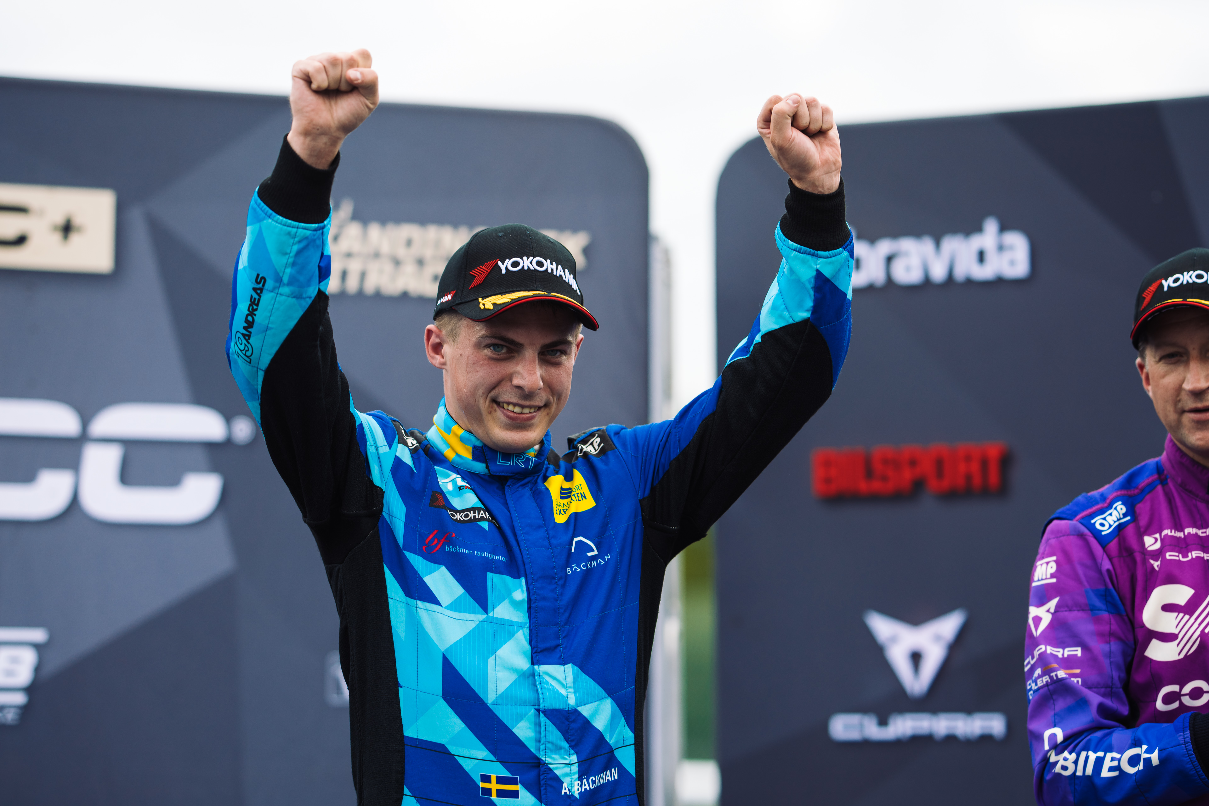
Andreas Bäckman had a strong race day with two wins on the classic Scandinavian Raceway track in Anderstorp, Sweden last Sunday.
Photo: Martin Öberg (Free rights to use the images)
This year's fifth STCC event was held last weekend, September 9th-11th, at Scandinavian Raceway in Sweden. Andreas Bäckman had a strong weekend with pole-position in the Qualifying and he won two out of three races.
– Fantastic weekend at Anderstorp. The speed was there in all conditions throughout the weekend, and it was great fun to get two wins on the race day, Andreas Bäckman says.
Last weekend, September 9th-11th, it was time for this year's fifth and penultimate round of the STCC championship at Scandinavian Raceway and Sweden National Team driver Andreas Bäckman was on the starting line, competing for the Lestrup Racing Team in an Audi RS 3 LMS TCR car. The historic Scandinavian Raceway track is located in Anderstorp, which is close to Gislaved, Sweden, and was inaugurated in 1968. It is the only track in the Nordics with Formula 1 history, where famous names such as Ronnie Peterson and Niki Lauda have previously competed.
Pole-position in the Qualifying
The weekend started with practice on Friday, where it rained during practice and rain tyres was used in the wet conditions at Anderstorp. Andreas had good speed in the rainy conditions. Also, on the practice sessions on Saturday, there were wet conditions on the track.
During the Qualfying on Saturday afternoon, the rain stayed away from the track, and it was a dry qualifying, and thus also the first time during the weekend that the drivers had to drive on tires for dry conditions (slicks). In the first Qualifying round, Q1, Andreas immediately found the speed and got the second-best time, which meant 2nd starting position for Sunday's first race. The top eight drivers then progressed to the second qualifying round, Q2, to fight for pole-position for the second race.
In Q2, Andreas set the fastest time by a big margin and took his second pole-position of the season, which meant 1st starting position for Race 2 on Sunday and also five extra points to the championship standings.
- Great fun to get my second pole-position of the season. I felt I had the speed throughout qualifying and at the end of Q2 I got a good lap. Great starting position and opportunity for the race day, Andreas Bäckman says.
Double wins in the races
In the first race on Sunday, Race 1, Andreas started in 2nd starting position. It was wet conditions and a drying track with everyone driving on rain tyres. He got off to a good start and was in 2nd position out of the first corner. He then chased the leader while he had look behind as well. After a few laps he saw an opportunity and tried to overtake on the outside into Turn 6, a overtake that was successful, and he took the lead. He was then able to extend his lead to 4.4 seconds across the finish line to take a convincing victory.
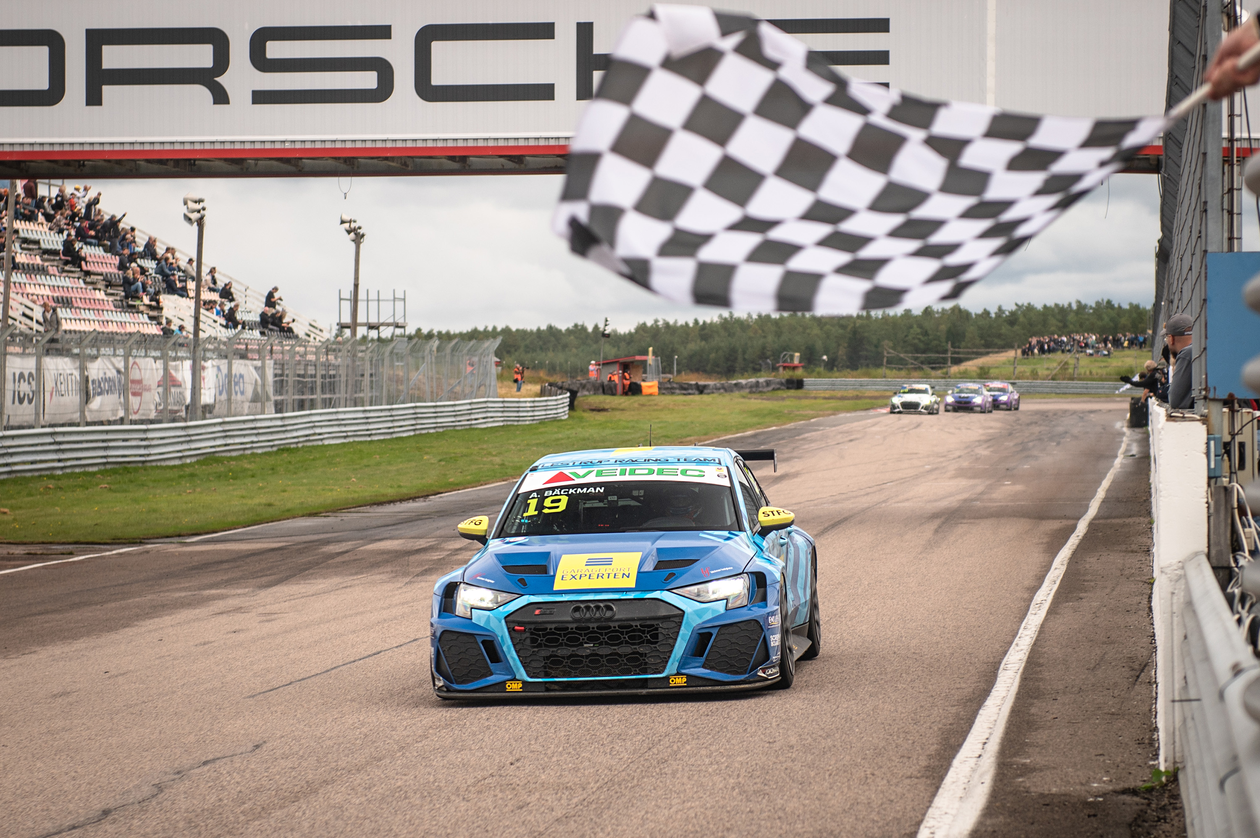
Andreas Bäckman crossed the finish line as the winner in Race 1 and Race 2 at Scandinavian Raceway.
Photo: STCC (Free rights to use the images)
For Race 2, the track had become a bit drier, so most drivers including Andreas opted for slicks. Andreas started in pole-position and took the start into the first corner. He was then attacked from behind in the first lap but was then able to break away to build up a gap and crossed the finish line as the winner, again this time with a 4.4 second margin to the next car.
- Great fun to win two races in a row in the first two races of the day, I enjoy competing in these challenging conditions and the car felt great, Andreas Bäckman says.
Before the final race of the day, Race 3, the results from the top eight drivers in Race 2 are reversed, which meant that Andreas started 8th in Race 3. Race 3 turned out to be a tough race as there was a heavy downpour that lasted itself for a long time and made the conditions very challenging for the drivers as everyone was out on slicks. Andreas took no risks and finished in 6th place, scoring important points in the championship.

- I didn't want to risk anything in Race 3, as it was very easy to make a mistake that could end up sending you off the track. So, with that in mind, I'm happy with the result, although of course I wanted to climb higher in the race, Andreas Bäckman says.
Andreas also picked up the most points during the weekend and thus also won the Autocirc Weekend Winner award. His points haul over the weekend also saw him move from fifth to second in the championship, 24 points up to the leader ahead of the season finale in three weeks' time at Mantorp Park, with 65 points to still left to fight for.
- Fantastic weekend here at Anderstorp. Pole position, two wins and a sixth place I am happy with, and it shows the speed we have when everything is working. Already looking forward to the final at Mantorp Park. It's a track I like, and I feel at home on, so I'll give everything to do well there. Many thanks to my team Lestrup Racing Team for all the support during the weekend, Andreas Bäckman says.

Next up for Andreas is the final round of the STCC championship in three weeks’ time, September 29th-October 1st, at Mantorp Park, which is located near Linköping, Sweden.

Andreas’ results:
Official Test (Test 1): 4th place
Official Test (Test 2): 1st place
Free Practice 1 (Test 3): 3rd place
Qualifying (Q1): 2nd place
Qualifying (Q2): 1st place
Race 1: 1st place
Race 2: 1st place
Race 3: 6th place

STCC Championship Standings
STCC – TCR Scandinavia – Drivers’ Championship Standings – Overall (Top 3)
STCC 2022 (After 5 of 6 race weekends)
1: Robert Dahlgren (SWE), 219 p.
2: Andreas Bäckman (SWE), 195 p.
3: Mattias Andersson (SWE), 182 p.
See the full standings here
STCC – TCR Scandinavia – Teams’ Championship Standings – Overall (Top 3)
STCC 2022 (After 5 of 6 race weekends)
1: CUPRA Dealer Team - PWR Racing, 371 p.
2: Lestrup Racing Team, 359 p.
3: Brink Motorsport, 326 p.
See the full standings here

Did you miss this weekend’s STCC race?
Click here to see the replay from this weekend’s STCC race at STCC+

Follow the STCC season at:
Live-stream: plus.stcc.se
Other information: stcc.se
Facebook: facebook.com/STCCOfficial/
Twitter: twitter.com/stcc_official
Instagram: instagram.com/stcc_official/
YouTube: youtube.com/c/STCCTV

Free rights to use the images.

Download press-photos here:
http://bit.ly/jabaeckman-photos
https://www.mynewsdesk.com/se/ja-backman/images

