MEDIA RELEASE

Pan Pacific Hotels Group appoints Bernard Sebastian as General Manager, PARKROYAL Serviced Suites Kuala Lumpur

Bernard will be responsible for overseeing the daily operations of the property

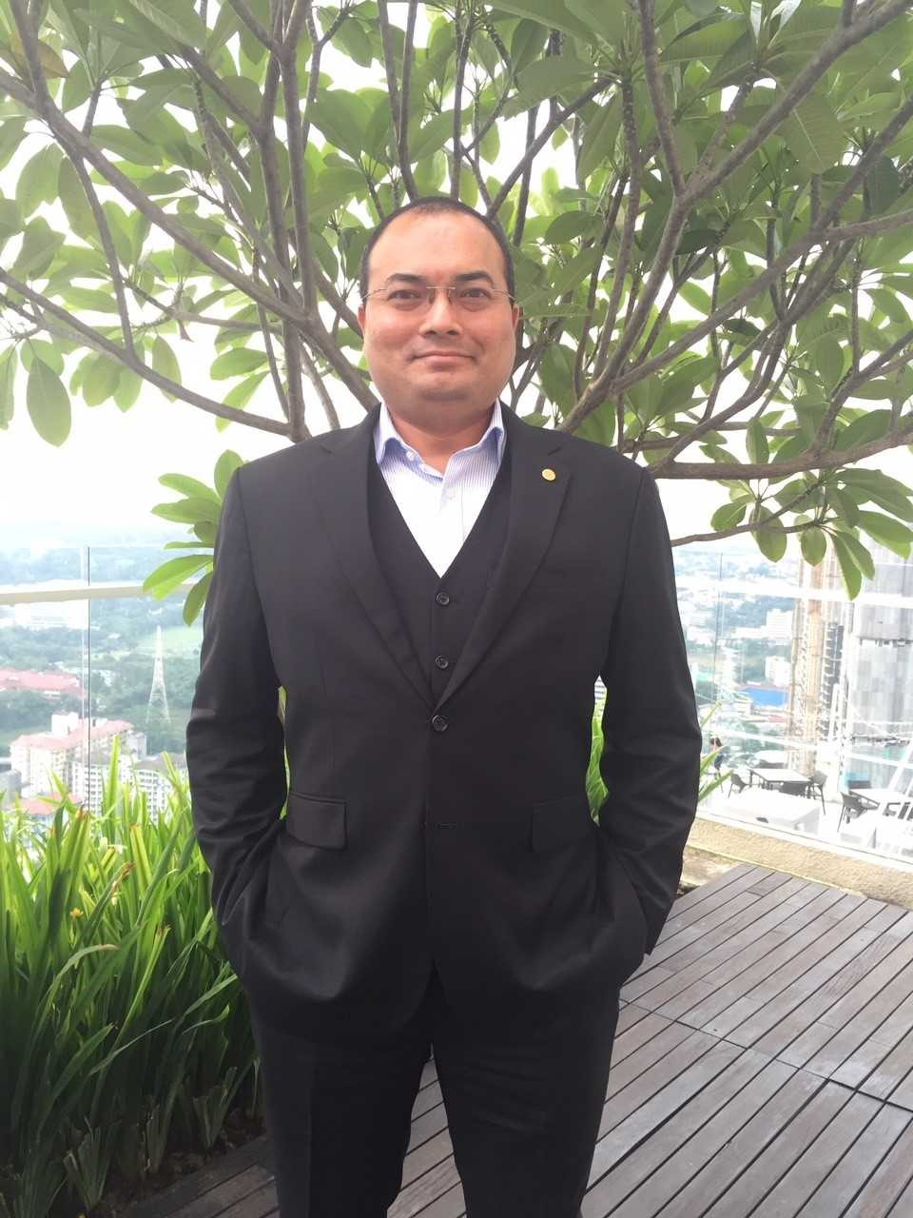

24 July 2018, Singapore – PARKROYAL Serviced Suites Kuala Lumpur, part of Pan Pacific Hotels Group, is delighted to announce the appointment of Bernard Sebastian as its General Manager.

A Malaysian-born Ceylonese, Bernard is no stranger to Pan Pacific Hotels Group where he first started his career and brings 20 years of extensive regional expertise from various hospitality chains. Prior to joining us, Bernard spent close to 6 years with Frasers Hospitality, and was most recently the General Manager of Capri by Fraser Kuala Lumpur. He was also part of the pre-opening team at Raffles Town Club, before joining The Ascott Group, where he took on roles as Residence Manager in various properties in Singapore, Malaysia and Philippines.

In his new role, Bernard will manage the operations of PARKROYAL Serviced Suites Kuala Lumpur, which is consistently listed as one of TripAdvisor’s top hotels in the Malaysian capital city. “I am honoured to be back with Pan Pacific Hotels Group, and a homecoming for me, as I started my career in hospitality right here. The serviced suites team is dynamic and energetic, and our daily passion is to make travel a celebration of life for our guests who choose to experience this vibrant city. Delivering heartfelt service is how we endeavour to bring out the best in our guests – whether they are staying with us for a day or months – who motivate us to be our best, too!” Bernard explains.

Richard Tan, Vice President, Serviced Suites, Pan Pacific Hotels Group, said, “We’re pleased to welcome Bernard on board and to lead the team at PARKROYAL Serviced Suites Kuala Lumpur. Bernard is intimately familiar with Southeast Asia, where he has spent many years, and the serviced suites will benefit from his experience and knowledge of this region as a market. Attracting industry professionals and strong operational leaders such as Bernard is part of our talent acquisition plans, which will support our strategic expansion here and the larger Asia Pacific.”

Pan Pacific Hotels is the only Asia-based hotel chain to offer three products: hotels, resorts and serviced suites, under both its Pan Pacific and PARKROYAL brands. In addition to Kuala Lumpur, the Group operates serviced suites in Singapore and China. The Group will debut its Pan Pacific and PARKROYAL brand of serviced suites in Jakarta, Indonesia in 2020/2021.

Located within Bukit Bintang, one of the city’s trendiest shopping and entertainment districts, the 287-PARKROYAL Serviced Suites Kuala Lumpur comprises fully furnished studios, as well as one and two-bedroom suites designed to meet the needs of leisure and business travellers, whether they are travelling by themselves or with family and friends.

End

For media queries, please contact:
Wong Liyan
Marketing & Communications Manager
Pan Pacific Serviced Suites Singapore
DID: +65 6678 8889
E: wong.liyan@pphg.com

Pan Pacific Hotels Group
Pan Pacific Hotels Group is a wholly-owned hotel subsidiary of Singapore-listed UOL Group Limited, one of Asia’s most established hotel and property companies with an outstanding portfolio of investment and development properties.
Based in Singapore, Pan Pacific Hotels Group owns and/or manages 40 hotels, resorts and serviced suites with more than 12,000 rooms including those under development in Asia, Oceania, North America and Europe.
Voted “Best Regional Hotel Chain” by readers in Asia in 2017, Pan Pacific Hotels Group comprises two acclaimed brands: its signature brand, Pan Pacific and its deluxe brand, PARKROYAL.
Sincerity is the hallmark of Pan Pacific Hotels Group. The Group is known to its guests, partners, associates and owners for its sincerity in people and the sense of confidence which alleviates the stresses of today’s complex world.

Pan Pacific Hotels and Resorts
With hotels, resorts and serviced suites across Asia, Oceania and North America, Pan Pacific provides a safe harbour in an ever-changing world. Places with less to worry about because, when you stay with us, rest assured that all will be taken care of. For this is where you will find your balance.

PARKROYAL Hotels & Resorts
A big city or cosy enclave – where there is a PARKROYAL hotel, resort or serviced suite, there is a celebration of people. Our passion for creating real connections and joyous moments can be felt when you enter any of our properties across Asia and Australia. After all, this is the place to bring out the best of you, by us.

