**PRESS RELEASE**

**Indulge in a Refreshed Nostalgic Weekend High Tea Buffet at Atrium, Pan Pacific Singapore**

*An East Meets West Spectacle of Unlimited English and Peranakan Delights*

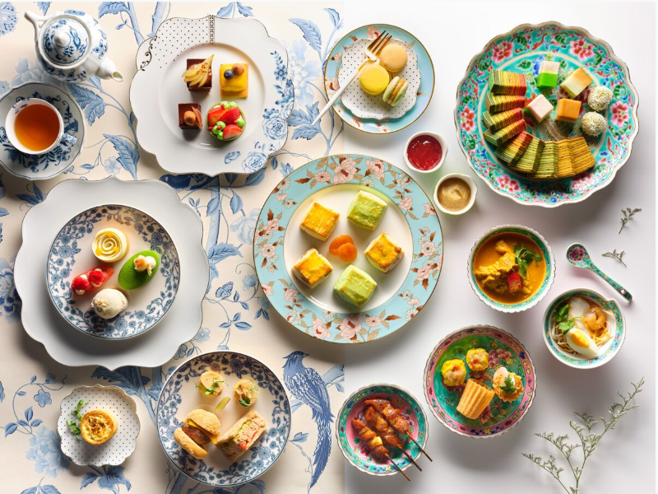

**Singapore, 20 August 2019** – From **7 September 2019**, Atrium bar at Pan Pacific Singapore will launch a refreshed version of its popular **Nostalgic Weekend High Tea Buffet**. **Every weekend** from **2:30pm to 5:30pm**, the glorious 22-metre long bar transforms into a gastronomic line of all-you-can-eat English and Peranakan signatures, featuring live stations helmed by the hotel’s skilled chefs.

Mouth-watering Peranakan Delights and Live Stations

The sumptuous afternoon tea spread will showcase authentic Peranakan dishes evoking comforting memories of childhood. Highlights include the classic **Nyonya Curry Chicken with house-made French Baguette**, hearty **Signature Prawn Laksa**, **freshly-wrapped Popiah with Braised Sweet Turnips** as well as the sweet and savoury ***Kecap Manis* (Sweet Soy Sauce) Chicken Skewers**. The buffet will also feature interactive **D-I-Y Kueh Pie Tee** and **Singapore Rojak** live stations, enhancing the dining experience.

Presenting an interesting twist to the classics, guests can look forward to tantalising fusion creations of **Nyonya Sausage with Achar** freshly-made by the hotel’s **Master Butcher Kurt Roelli** and aromatic **Laksa Quiche**.

Dessert lovers will have their cravings satisfied with the assortment of delicious Peranakan desserts such as colourful **Nyonya Kueh** and **Kueh Lapis**, **Pandan Scones with Kaya and Strawberry Jam**, as well as Pan Pacific Singapore’s **Signature** **Pandan Gula Melaka Chiffon Cake**.

English Delicacies

Diners who prefer a quintessential English afternoon tea will be delightfully indulged with Atrium bar’s line-up of finger sandwiches made with **bread freshly baked in-house by Chief Baker Chef Ang**, savouries and desserts. Savoury specialties include **Tuna Mushroom Feuilleté**, **Foie Gras Terrine, Fig Marmalade on Brioche Crostini**, juicy **Mini Wagyu Beef Sliders with Cheese and Caramelised Onions** as well as **Zucchini and Emmental Quiche**.

For the dessert spread, Executive Pastry Chef Eddy Yau has a created a stunning dessert repertoire inspired by the cheerful vibrancy of summer. Diners can look forward to flavourful treats of **Coffee Caramel Roulade**, **Chocolate Fudge Cake,** zesty **Passion Fruit Ivory Tart, Raspberry** **Bahibé Éclair, Apricot Scones** and more!

Aromatic Beverages

The tantalising buffet experience comes with two complimentary beverages of choice. Guests may select from two special cold brew teas – the **Earl Grey infused with Orange, Cinnamon and Ginger** as well as **Chamomile infused with Berries**. Also available for enjoyment are freshly brewed coffee and a range of **TWG teas**.

Edible Fashion - Peranakan Chocolate Boutique

Guests can expect a breath-taking assortment of edible chocolate accessories and fashion wear skilfully crafted by the hotel pastry team that incorporates the iconic elements of Peranakan culture - vibrant colours, intricate beading and rich embroidery. Available from **SGD28 each** and perfect for gifting, the delicious range is made up of irresistible truffles and are designed to resemble a **High Heel Diamanté Shoe**, a **gentlemen’s shoe**, a **handbag**, **woman’s hat** and more!

Date: From 7 September 2019, every Saturday and Sunday, 2:30pm to 5:30pm

Venue: Atrium (Level 1), Pan Pacific Singapore, 7 Raffles Boulevard Singapore 039595

Price: SGD50 per person, includes two beverages from the high tea menu

All prices are subject to 10% service charge and 7% GST, unless otherwise stated.

For dining reservations and enquiries, please speak with us at +65 6826 8240 or email [dining.ppsin@panpacific.com](mailto:dining.ppsin@panpacific.com).

High-resolution Images and menu can be downloaded [here](https://www.dropbox.com/sh/9dyrbb33idaim16/AADyI6C1WPUDW2p9IksX-hP7a?dl=0).

**Media Contact**

Ms. Gillian Teo

Assistant Director  
Pan Pacific Singapore

E-mail: [gillian.teo@panpacific.com](mailto:gillian.teo@panpacific.com)

Tel: +65 6826 8095

Melissa Ng

Senior Marketing Communications Executive

Pan Pacific Singapore

Email: [melissa.ng@panpacific.com](mailto:melissa.ng@panpacific.com)

Tel: +65 6826 8094

*Hotel Facebook:* [*https://www.facebook.com/panpacificsingapore*](https://www.facebook.com/panpacificsingapore)

*Twitter:* [*https://twitter.com/panpacificsgp*](https://twitter.com/panpacificsgp)

*Instagram:* [*http://instagram.com/panpacificsingapore*](http://instagram.com/panpacificsingapore)

**Pan Pacific Hotels and Resorts**

With hotels, resorts and serviced suites across Asia, Oceania and North America, Pan Pacific provides a safe harbour in an ever-changing world. Places with less to worry about because, when you stay with us, rest assured that all will be taken care of. For this is where you will find your balance.

**Pan Pacific Hotels Group**

Pan Pacific Hotels Group is a wholly-owned hotel subsidiary of Singapore-listed UOL Group Limited, one of Asia’s most established hotel and property companies with an outstanding portfolio of investment and development properties.

Based in Singapore, Pan Pacific Hotels Group owns and/or manages 40 hotels, resorts and serviced suites with more than 12,000 rooms including those under development in Asia, Oceania, North America and Europe.

Voted “Best Regional Hotel Chain” by readers in Asia in 2017, Pan Pacific Hotels Group comprises two acclaimed brands: its signature brand, Pan Pacific and its deluxe brand, PARKROYAL.

Sincerity is the hallmark of Pan Pacific Hotels Group. The Group is known to its guests, partners, associates and owners for its sincerity in people and the sense of confidence which alleviates the stresses of today’s complex world.

**About Pacific Marketplace**

This gourmet grocery and café provides classic three-tier afternoon tea, croissants and pastries, as well as an extensive selection of cakes, chocolates, Asian delights, sandwiches and salads. The hotel’s signature Pan Pacific sausages and other exquisite deli goods are available for purchase at pacificmarketplace.sg.

**About Atrium**

Located in the heart of the lobby, Atrium presents a curated collection of craft beers, boutique wines and spirits. Guests can enjoy a bespoke cocktail at the captivating 22-metre long bar or have an intimate tête-à-tête at a private pod floating over a reflection pool.

**About Pacific Marketplace**

This gourmet grocery and café provides classic three-tier afternoon tea, croissants and pastries, as well as an extensive selection of cakes, chocolates, Asian delights, sandwiches and salads. The hotel’s signature Pan Pacific sausages and other exquisite deli goods are available for purchase at pacificmarketplace.sg.