FOR IMMEDIATE RELEASE

**Contact:**

|  |
| --- |
| Daniela Karthaus |
| Hitachi Europe, Ltd. |
| +44 (0)1628 585 379 |
| daniela.karthaus@hitachi-eu.com |

**Hitachi develops smaller, lighter rail car inverter for 1,500V DC overhead power supply using SiC**

– *Size and weight reduced by 40% compared to Si-based inverters*–

**Tokyo, April 20, 2012** – Hitachi, Ltd. (NYSE:HIT / TSE:6501) today announced that it has developed a SiC hybrid inverter for rail cars that is compatible with 1,500V DC overhead power supply. Hitachi employed silicon carbide (SiC) to reduce equipment size and weight, and cut power loss. SiC is attracting attention as a next-generation material to replace silicon (Si), as it is expected to lead to smaller power modules and simpler cooling systems.

The SiC hybrid inverter announced today employs Hitachi-developed SiC hybrid modules with a rated voltage of 3.3kV that are approximately two-thirds the size of conventional Hitachi modules. By using SiC hybrid modules, Hitachi has achieved a simple circuit configuration, as well as smaller equipment dimensions by reducing the size of the inverter cooling systems. Furthermore, in order to reduce power loss when switching direct current to alternating current, Hitachi has optimized proprietary soft-gate control technologies for the inverter. In this way, Hitachi has been able to reduce power loss and counter the increased electromagnetic noise generated during switching. Moreover, by employing lightweight oil-free capacitors, Hitachi succeeded in reducing the overall weight of the inverter. As a result of these innovations, the new inverter is 40% smaller and lighter than current mainstream inverters made with Si, and boasts 35% reduced power loss.

Hitachi is determined to contribute to the creation of railcars that are more environmentally sound by using this inverter in all classes of rail car in the future.

Environmental measures have played, and continue to play an important role on a global scale to achieve a low carbon society and prevent further global warming. There is a growing demand for rail transport systems with low environmental impact. By producing rail car inverters which are reduced in size and weight, increased energy efficiency can be achieved.

At present, most rail car inverters use Si diodes in an attempt to deliver both higher energy savings and enhanced performance. However, in order to achieve even higher performance gains, expectations have turned to SiC because it offers high voltage resistance, having approximately 10 times greater dielectric breakdown strength. This enables the creation of thinner devices and, in turn, reduces resistance loss when conducting. Hitachi drew on its in-house expertise in inverter technologies when developing the new compact SiC hybrid inverter. The main features of this inverter are as follows:

**(1) Lower power loss using a 3.3kV SiC hybrid module**

SiC boasts higher voltage resistance than Si, making it effective in reducing conduction loss and switching loss by allowing devices to use thinner layers. Combining SiC diodes and Si-IGBT (insulated gate bipolar transistors), Hitachi developed the 3.3kV SiC hybrid module that not only reduces diode power loss but also IGBT power loss. Hitachi has raised inverter efficiency and reduced inverter size using this lower-loss 3.3kV SiC hybrid module.

**(2) Reduced loss with soft-gate control**

There are two types of power loss in IGBT modules used in inverters: conduction loss as current flows through the device, and switching loss during switching. SiC hybrid modules are particularly effective in reducing IGBT turn-on switching losses and diode switching loss. On the other hand, electromagnetic noise increases upon switching. To address this, Hitachi drew on its proprietary soft-gate control technologies it had previously applied to inverters using Si. Optimizing these technologies for SiC hybrid inverters, effectively reduced IGBT turn-on switching loss and switching-related electromagnetic noise.

**(3) New-type compact cooler minimizes the upwind and downwind temperature difference**

Rail car inverters are generally cooled by the air-flow over the rail cars as they move. Because air flows from the front to the back as rail cars advance, the temperature of coolers is lower upwind when air is taken in and higher downwind. This upwind and downwind temperature difference can be minimized byarranging heat pipes, which carry heat generated by power modules to cooling fins, in the direction the carriage moves. Hitachi used fluid analysis technologies to develop new heat pipe configurations that simultaneously minimize the upwind and downwind temperature difference as well as cool. This advance has resulted in smaller and lighter coolers.

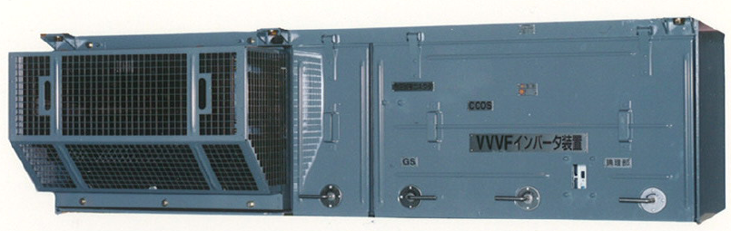

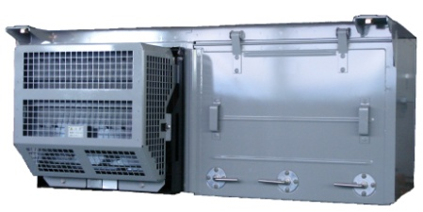

SiC hybrid module-based inverter

(40% smaller and lighter)

Si-based inverter

Rail car inverters

**About Hitachi, Ltd.**

Hitachi, Ltd., (NYSE: HIT / TSE: 6501), headquartered in Tokyo, Japan, is a leading global electronics company with approximately 360,000 employees worldwide. Fiscal 2010 (ended March 31, 2011) consolidated revenues totaled 9,315 billion yen ($112.2 billion). Hitachi will focus more than ever on the Social Innovation Business, which includes information and telecommunication systems, power systems, environmental, industrial and transportation systems, and social and urban systems, as well as the sophisticated materials and key devices that support them. For more information on Hitachi, please visit the company's website at http://www.hitachi.com.

# # #