
Håkan
Press release from Oxyfi AB
9 December 2011

Scania buses go on-line with system solution from Oxyfi
Scania, a Swedish world-leading manufacturer of heavy trucks, buses and coaches, starts bus services to transport its employees between the cities of Stockholm and Södertälje. Naturally, Scania´s staff shall have the ability to email, surf, and carry out other online activities while travelling to work. Hence Oxyfi has got the contract to deliver a robust solution for internet access on-board.
The deal means that Oxyfi´s modular communications solution OxConnect will be installed in four buses, one Scania OmniExpress and three Scania Touring. The solution comes with support for one 3G-network and can be expanded with several networks if necessary.
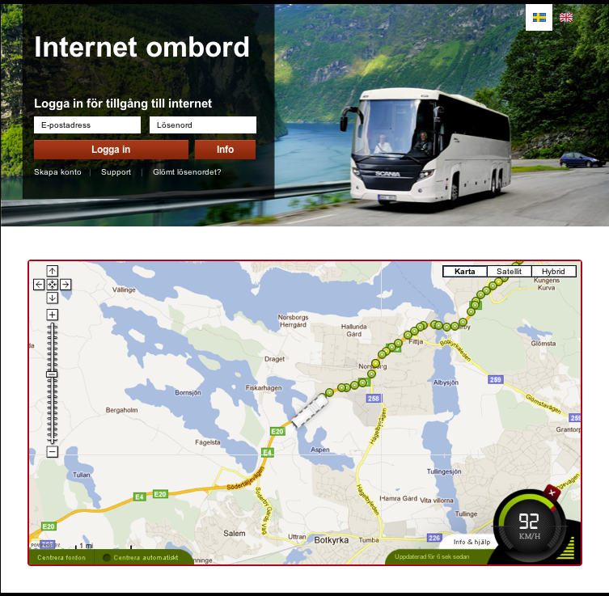
Passengers on-board gets access to a web portal through a wireless wifi-network, here they can log-in to internet as well as check out the bus´s current geographical position and speed on a map. The 3G-network's signal strength is also plotted in the map throughout the journey.
3G-networks do not provide unlimited transmission capacity. Hence the solution has a number of built-in features to manage available capacity. One important aspect of this is the ability to measure and control how much data volume that is being used. The system displays, for each user, just how much data traffic he or she has consumed so far and may limit access at certain threshold levels.
Visma EssCom installed the equipment during November. Scania starts its bus services 2 January 2012.

About Oxyfi AB
We help our customers create modern transportation systems by connecting buses and trains to the internet. With our products, you can inform and entertain your passengers digitally while they travel. And as the vehicle operator or owner you can get essential vehicle information in real-time to your computer-screen.

Contact info: Håkan Larsson, CEO Oxyfi AB, +46(0)73 037 8001, hakan@oxyfi.com

About Scania
Scania is one of the world's leading manufacturer of trucks and buses for heavy transport applications, and industrial and marine engines. Scania operates in about a hundred countries and has 35,500 employees.
About Visma EssCom
Visma EssCom offers nationwide service and installation of advanced equipment within electronics and IT. Visma EssCom is available at 25 locations in Sweden.

