Press release
November 2017

Ellos launches new brand of feminine shoes

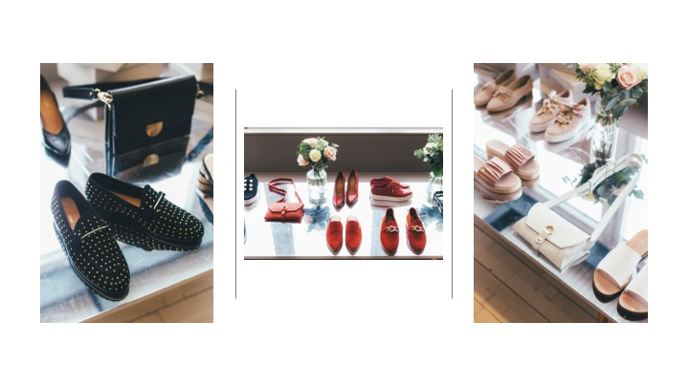
Ellos will be launching its new brand of shoes, Agnes Cecilia, in February. A feminine brand for women who like modern, functional shoes that express their personal style. The first collection from Agnes Cecilia includes everything from leather sandals, slip-ins with tassels, sneakers, loafers with both chains and bows to strappy, heeled sandals. The colourway is dominated by powdery-pink, white, beige, black, navy blue and red.

Most of the intricately detailed shoes are produced in Europe for the best quality at affordable prices. The collection also features a choice selection of bags that match the chic shoes. The launch date of the collection is set for week 7 and the shoes cost SEK 499-899 and the bags SEK 599-899.

The Ellos Group, which includes Ellos, Jotex and Stayhard, is a leading e-commerce group in the Nordic region. Working closely with our millions of customers, we are constantly striving to develop and offer attractive fashion and household items for the entire family. Our focus is always on the customer. The Ellos Group, headquartered in Borås, has operations in all the Nordic countries. The Ellos Group has some 700 employees and generates sales of around SEK 2 billion. The principal owners are Nordic Capital Fund VII and Paul Frankenius with Frankenius Equity AB. The Chairman of the Board is Ketil Eriksen.

For interviews or brand-related enquiries, please contact:
Helén Eriksson, PR manager
Helen.eriksson@ellos.se and +46 (33)160307

