Press images for download

Children's ranges for the enjoyment of both little ones and adults. Kiddy Collection: a touch of tableware culture

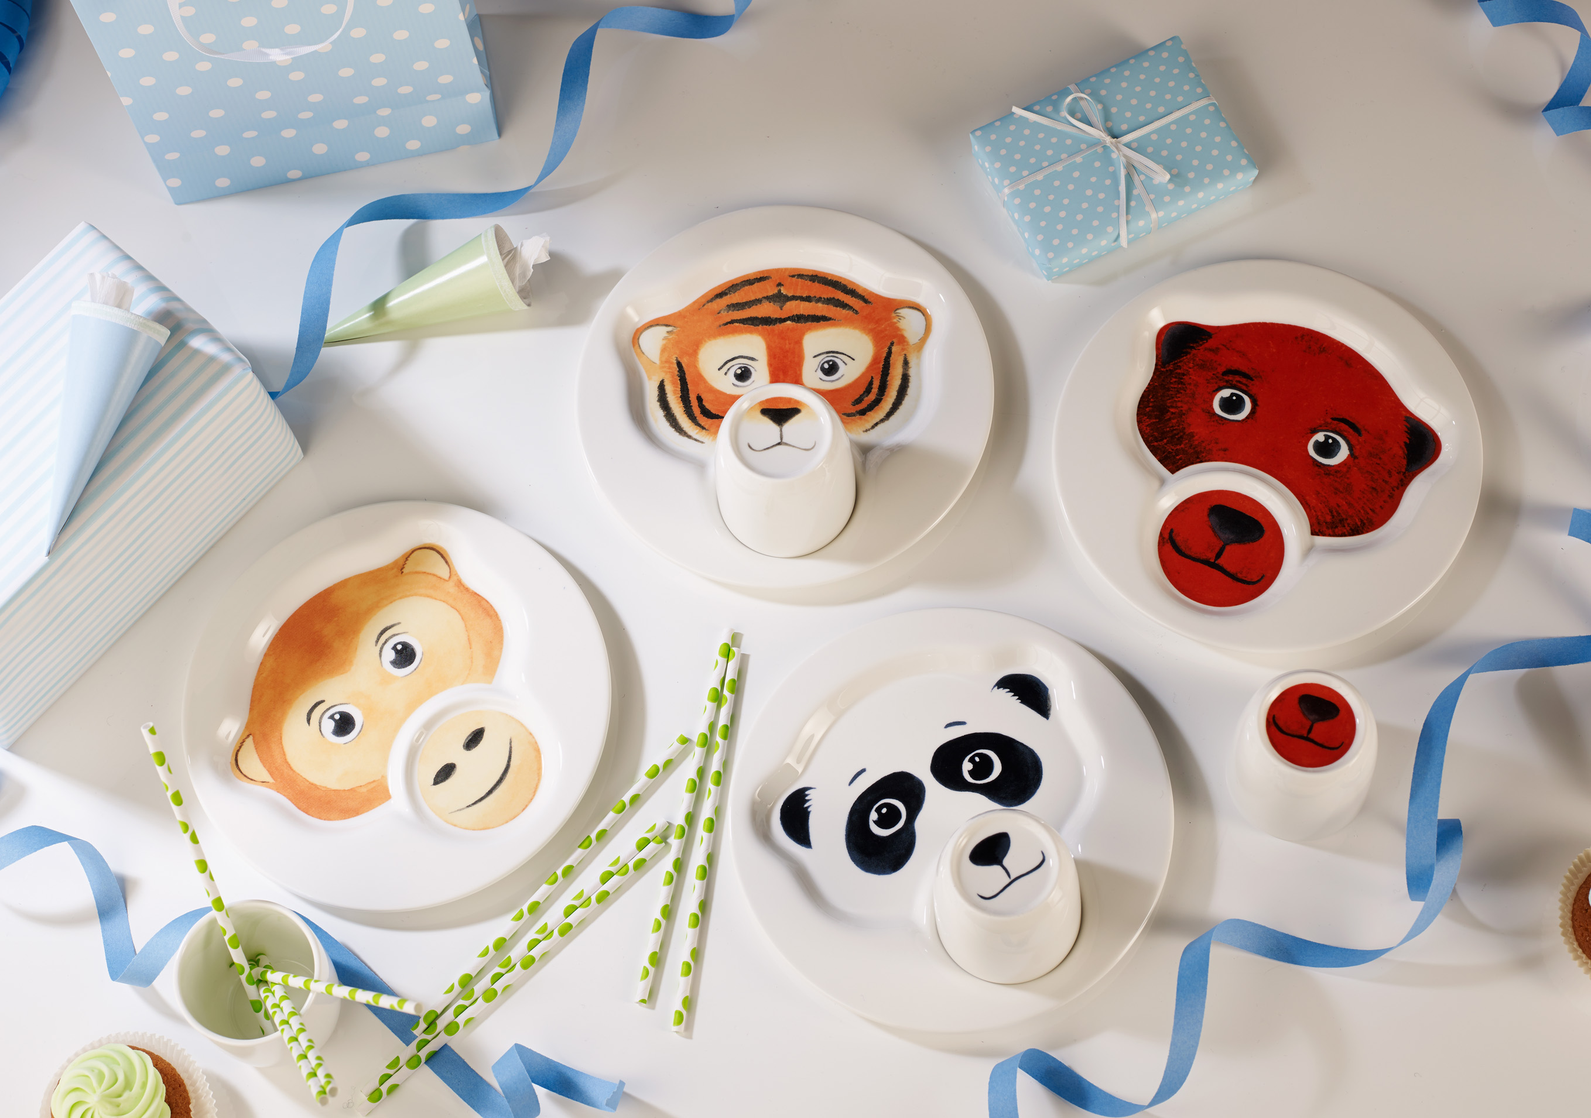

Tableware is not a question of age. In 2016 Villeroy & Boch is therefore once again presenting new children's collections with articles, forms and décors suitable for every taste.

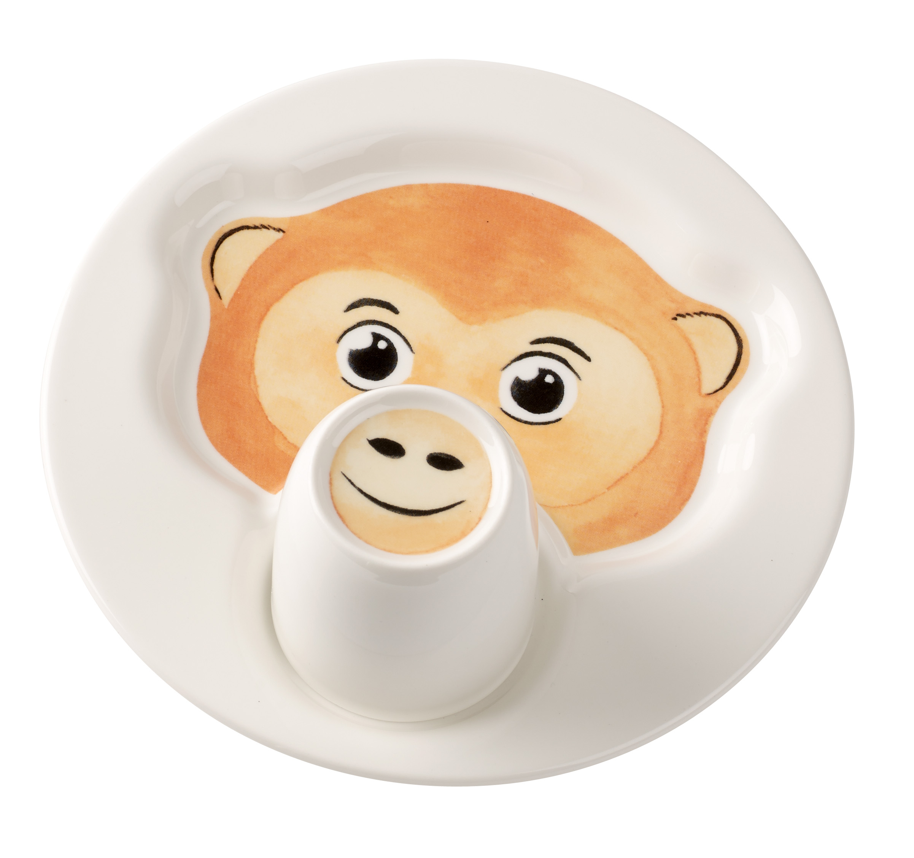
Animal Friends: Eye-catchers at a second glance
The children's collection Animal Friends is an absolute highlight for the little ones. And with its cunning but low-key design it is suitable even for modern minimalist interiors. Animal Friends includes a plate designed as an animal face with two separate areas for food. There is also a cup that fits into the small recess on the plate and that features a surprise that is revealed when drinking. The bottom of the cup shows an animal snout that transforms the child's mouth into an animal's mouth when the cup is held up to drink. The cup can also be placed upside down on the plate to create a three-dimensional effect. No matter whether panda, monkey, tiger or bear – it is not only children who will find their favourite animals in the intelligently designed Animal Friends.
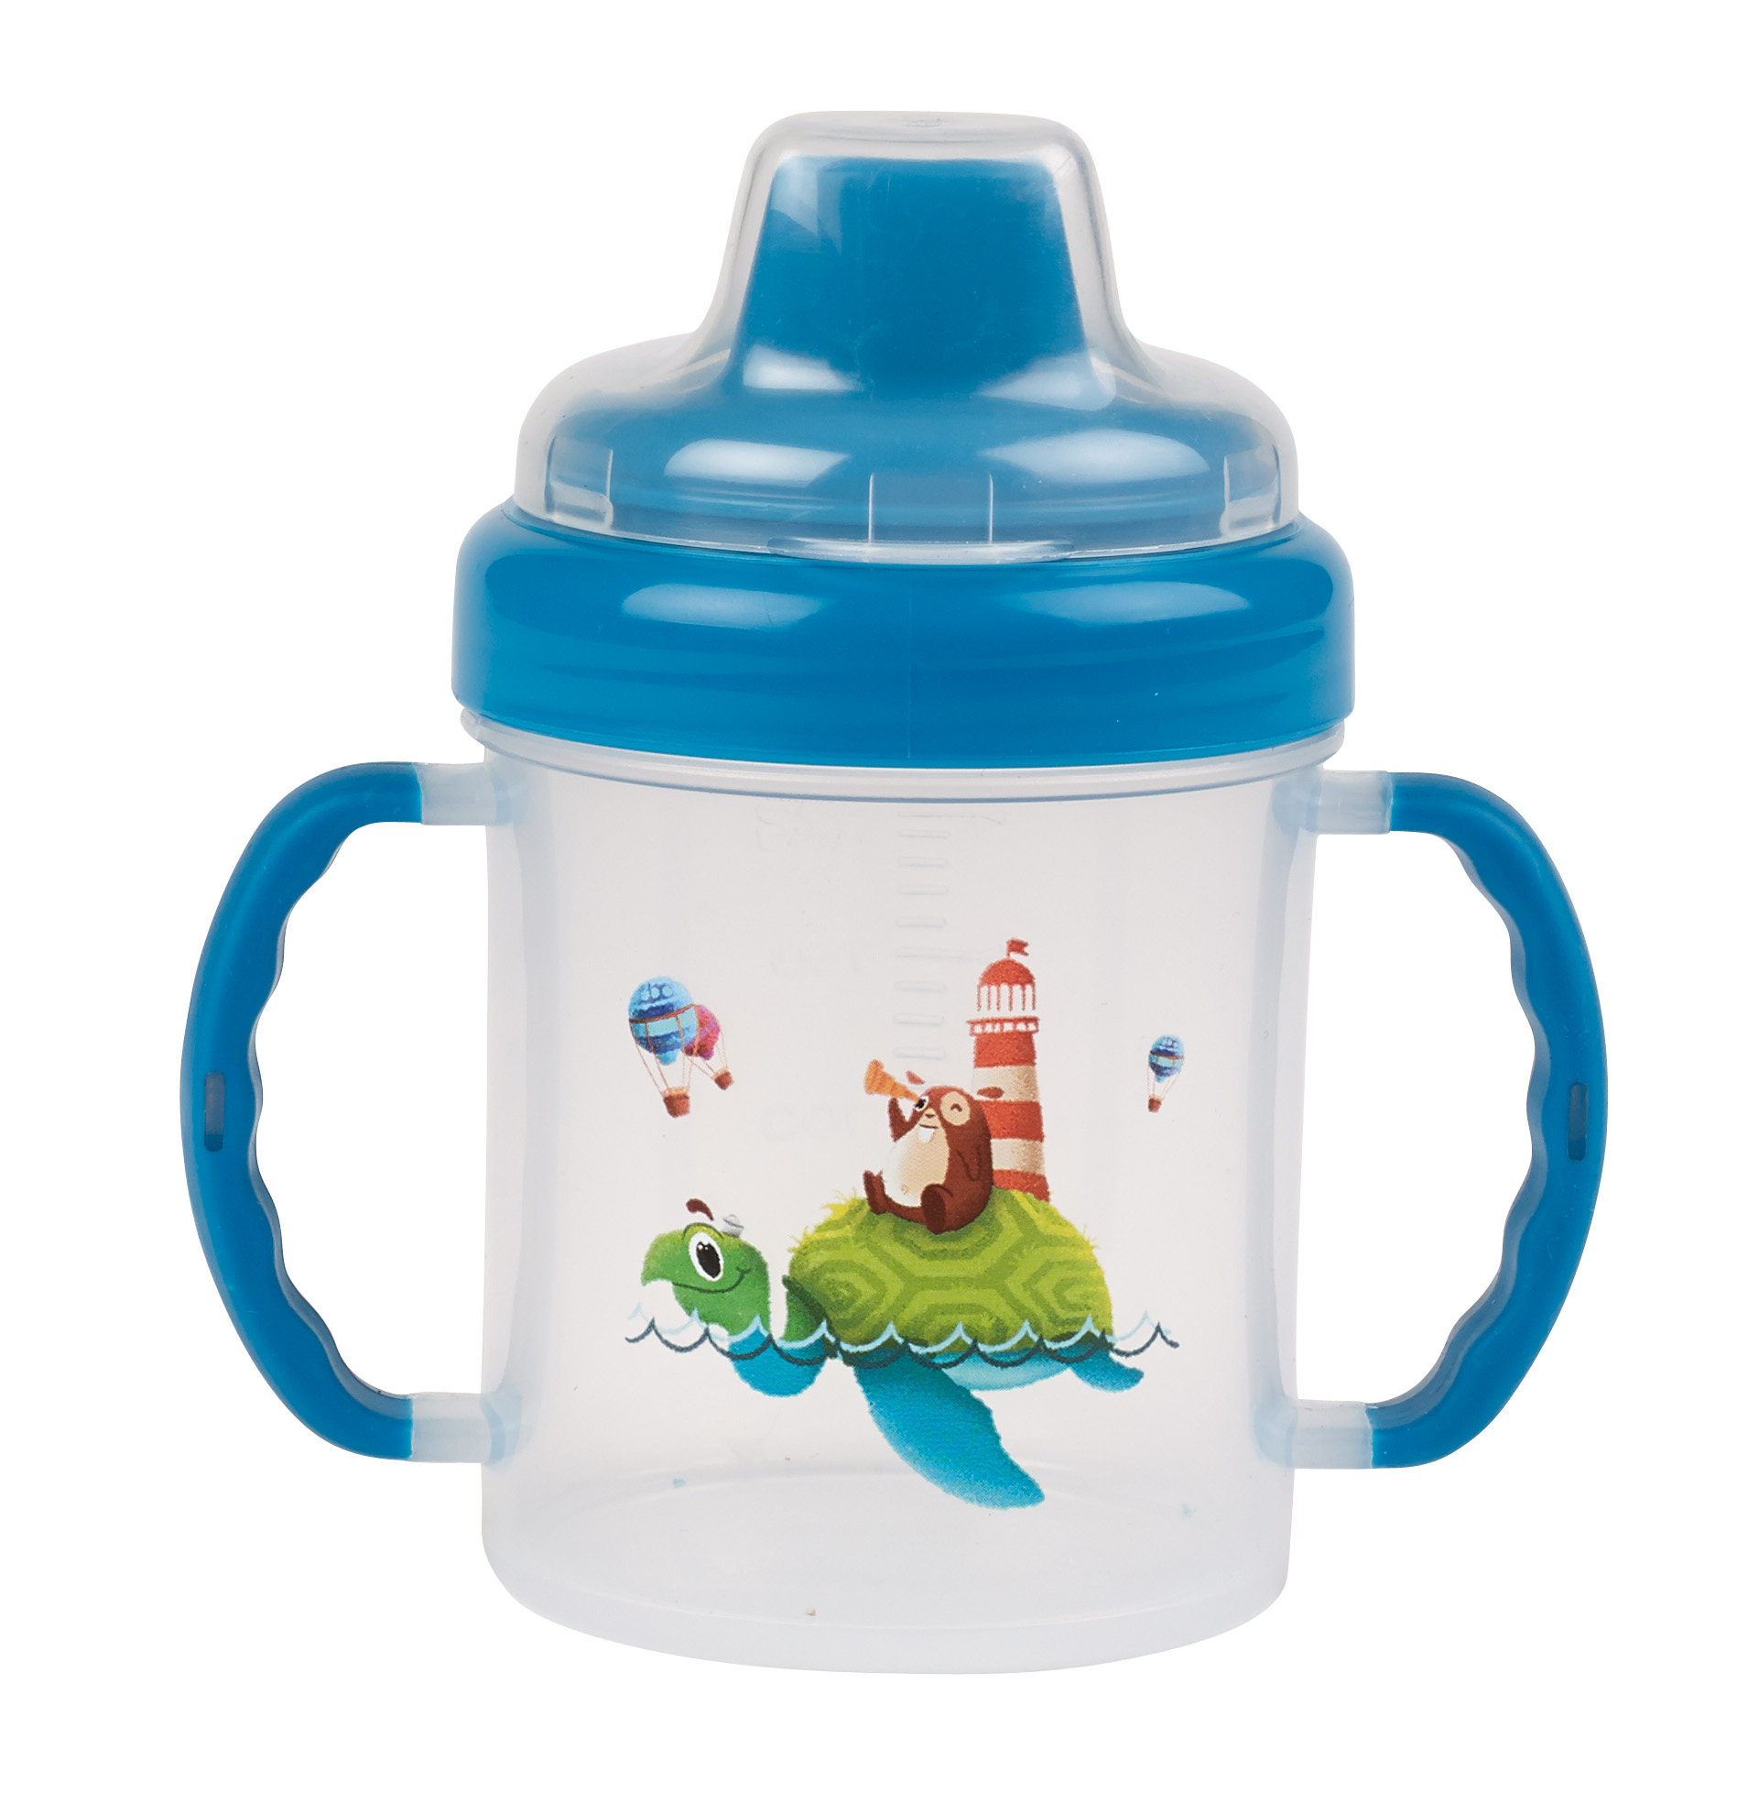
Adventures of Chewy: Stories on porcelain
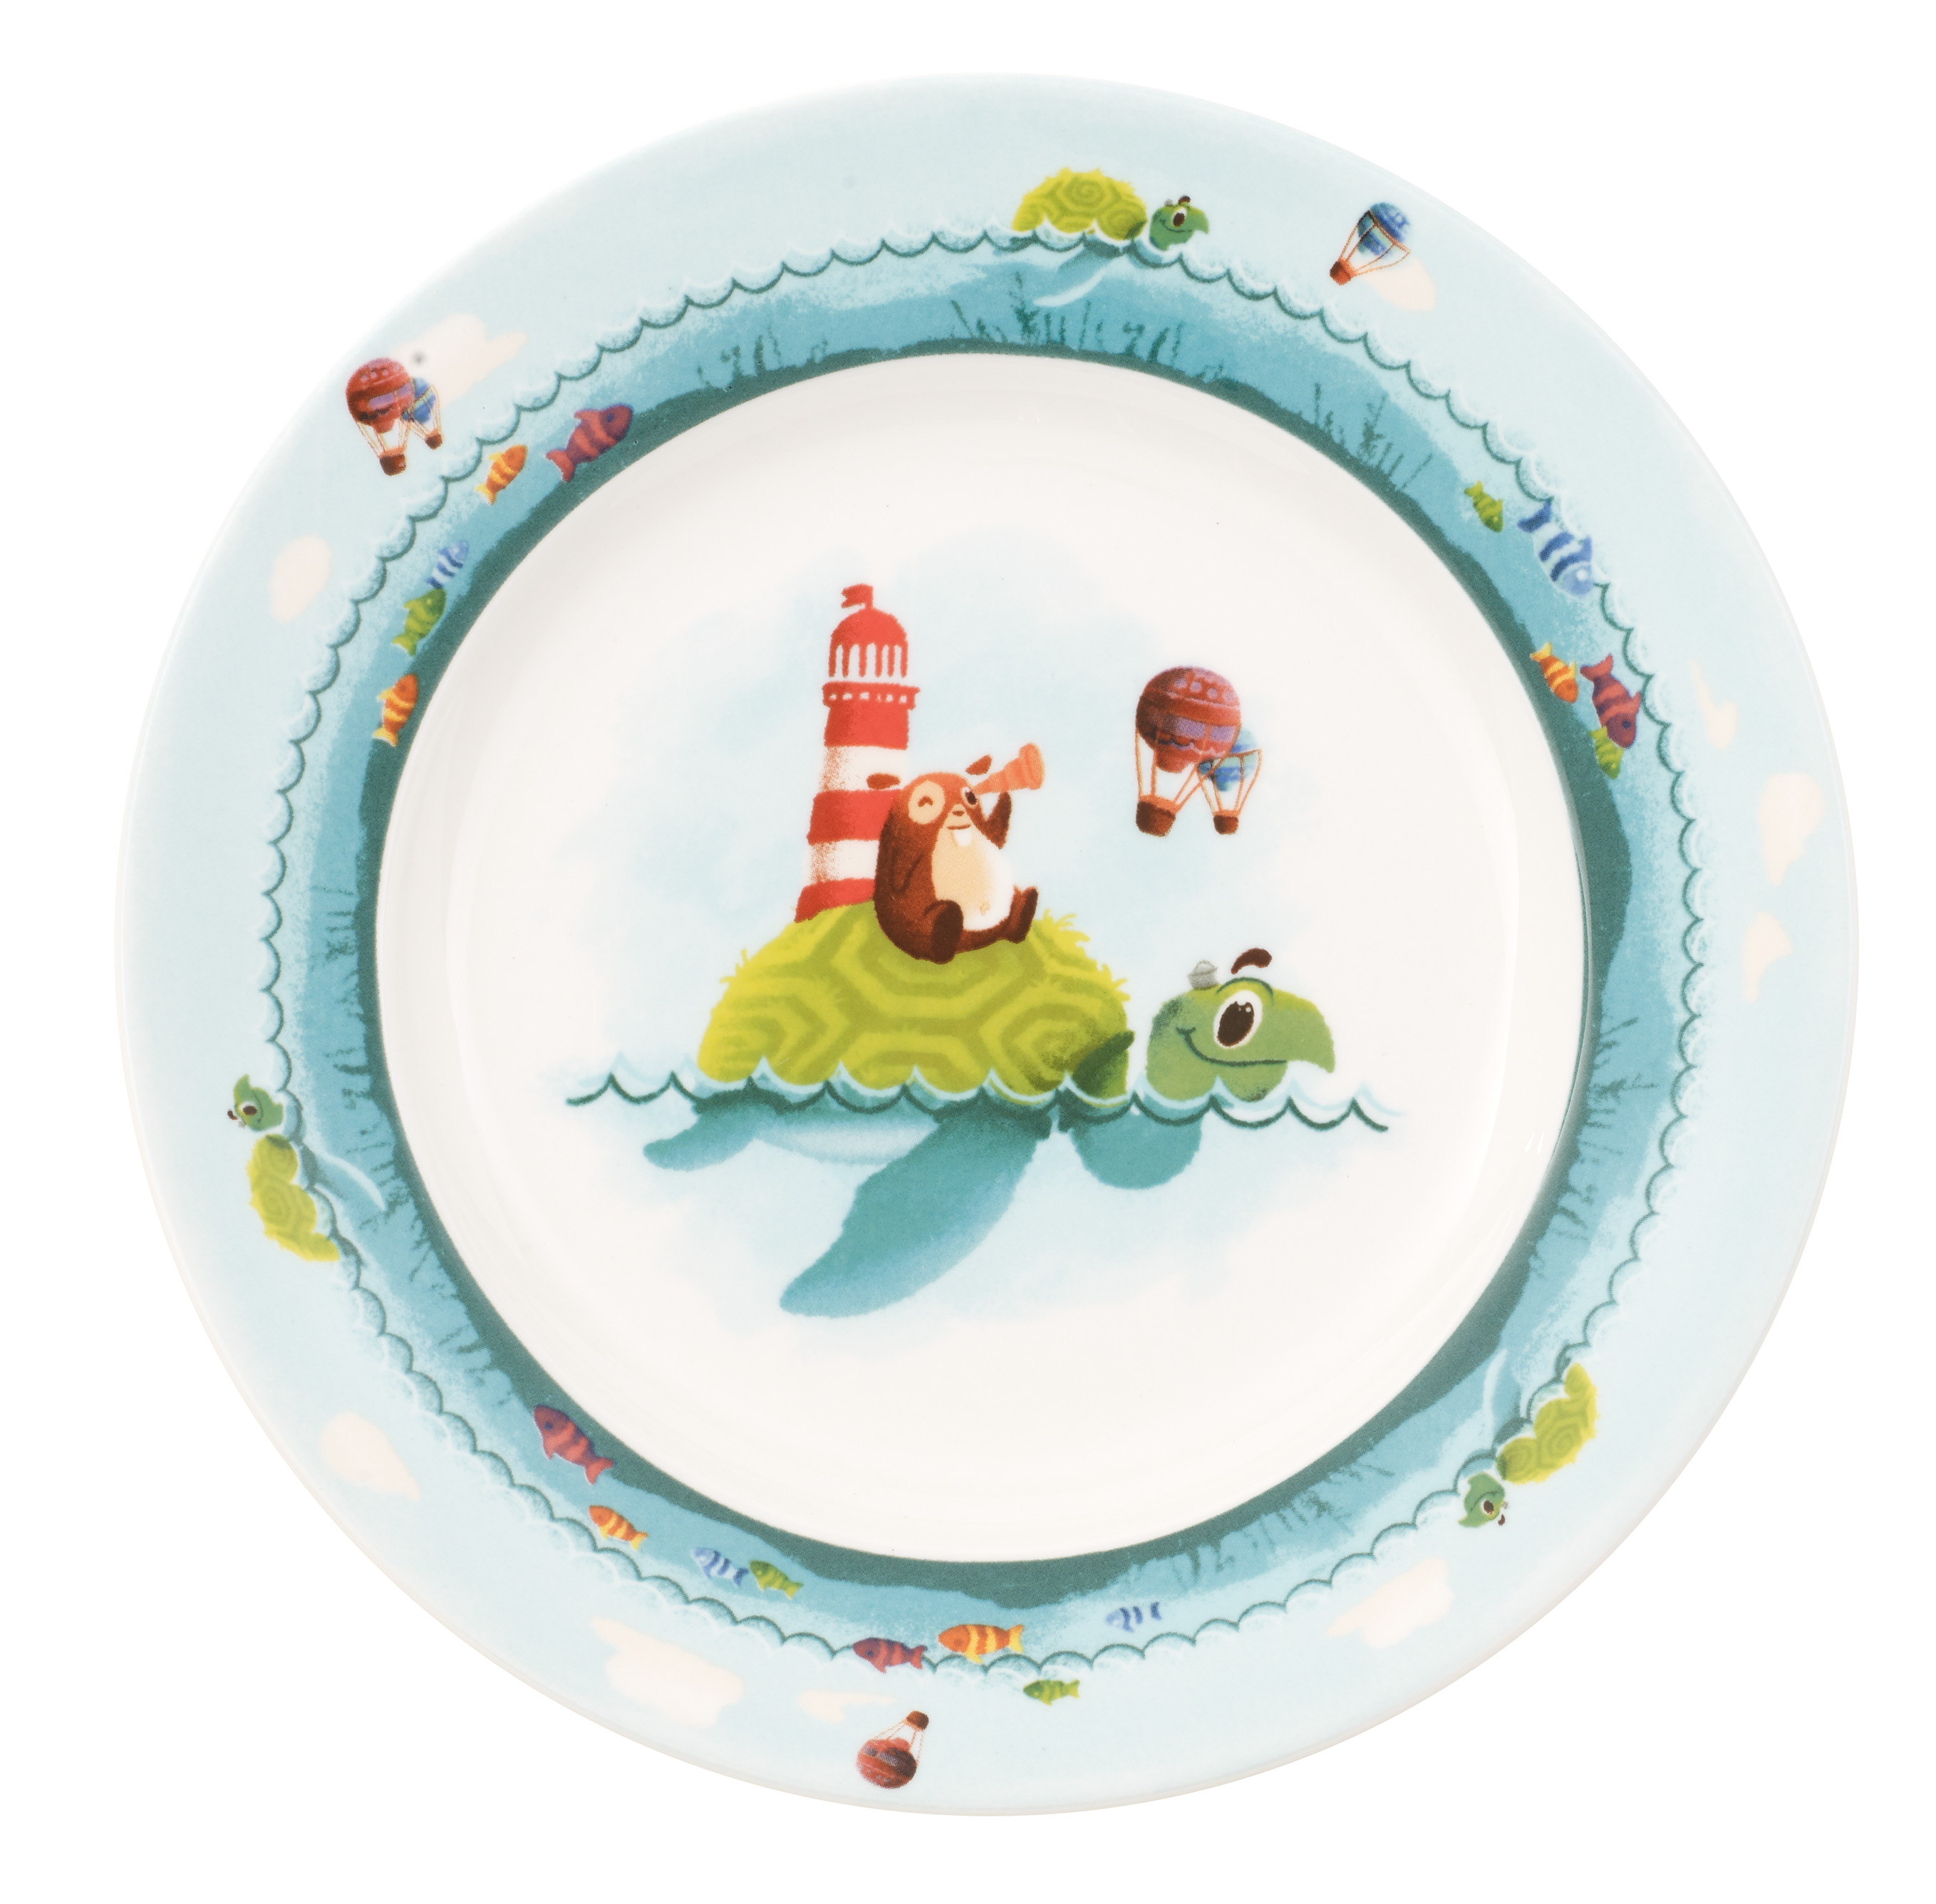
The stars of the two new Kiddy Collection décors, Chewy around the world and Lily in Magicland, are the hamster Chewy and his friend Lily, both lovingly drawn with a fine eye to detail. With colourful motifs Chewy and Lily invite children to discover their world, accompanying them through the day on plates, cereal bowls, children's cups and children's glasses. In the same design there is also a tin for sweets, a little box for milk-teeth, a money box, an eggcup and a music box, all ideal as gifts. And when the children are out and about, they can take along their favourite motif on travel boxes, sandwich boxes and travel mugs. There are, in addition, three-piece baby-sets for the very little ones. In addition, a selection of matching accessories such as bibs, placemats, children's bags, aprons, napkins and children's cutlery is available.

Extended service for the little ones
If one of the cups or bowls from the Animal Friends or Kiddy Collection gets broken, it is covered by the Villeroy & Boch two-year breakage guarantee so that the item will be replaced free of charge.

Product information:
- Children's tableware:
- Premium Porcelain
- decorated using lithographic techniques
- dishwasher safe
- microwave proof

Children's cutlery:
- stainless steel 18/10
- handles decorated using lithographic techniques
- dishwasher safe

Price information – examples:

Product (article no) Price – Chewy around the world & Lily in magicland

Children flat (2650) 179 NOK
Children deep (1901) 189 NOK
Cereal bowl (1901) 189 NOK
Children mug 2 handles (4481) 189 NOK
Children mug large (4887) 189 NOK
Children mug small (4888) 179 NOK

Product (article no) Price – Animal friends
Plate with mug, Panda (8590) 329 NOK
Plate with mug, Bear (8593) 329 NOK
Plate with mug, Monkey (8591) 329 NOK
Plate with mug, Tiger (8592) 329 NOK

For further information please contact Rebecca Duvemyr
PR & Communication Manager Nordics
Tel.: +46 (0) 76-135 83 62
Mail: rebecca.duvemyr@gustavsberg.com

Villeroy & Boch
Villeroy & Boch is one of the world's leading premium brands for ceramic products. The family business, which was founded in 1748 and is headquartered in Mettlach/Germany, stands for innovation, tradition and exceptional style. As a renowned lifestyle brand, Villeroy & Boch offers products from the sectors Bathroom and Wellness and Tableware, and is active in 125 countries.

