**The Bäckman siblings ready to take on WTCR**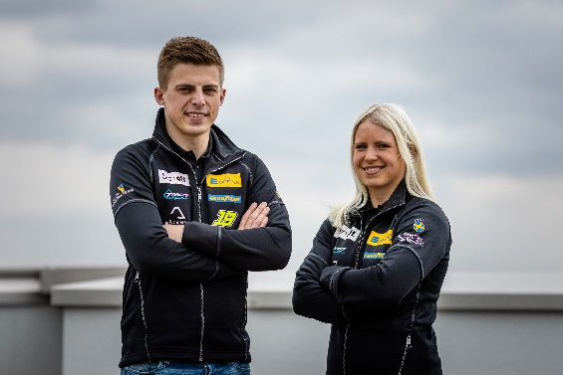Andreas and Jessica Bäckman.  
Photo: FIA WTCR (Free rights to use the image)

**The siblings Andreas and Jessica Bäckman from Sweden are today presenting that they in 2021 are taking the step up to the toughest TCR series in the World – WTCR – FIA World Touring Car Cup.  
– One of my biggest goals in my career has been to compete against the best drivers in the world in the FIA WTCR. It feels unreal that I now can announce that I have reached that goal, Jessica Bäckman says.**

Andreas and Jessica Bäckman have, despite their young age, already achieved great success in karting, rallycross, and racing. In 2018, they both competed in STCC and the British counterpart TCR UK, where Andreas, among other things, took his very first racing victory and finished in third place in the championship. Jessica managed to grab a podium place at Brands Hatch and therefore became the first woman in TCR UK to take a podium place and finished fourth in the championship. In 2019, the siblings took the step up to the European championship “TCR Europe” and competed there in 2020 as well. Over the years, Andreas has taken several wins and pole positions in the European Championship, while Jessica has managed to take podium places in 4 different TCR championships, while making history as the first woman ever to finish on the podium in TCR Europe.

**Reached their big goal - WTCR**The Sweden National Team drivers Bäckman have not been shy to say that they have had a big goal to get to the toughest TCR series - WTCR. Now they can happily announce that they have reached their goal. In 2021, the siblings will compete in WTCR together with the Italian team Target Competition, the same team as they have competed with the last two seasons in TCR Europe. Bäckman continues to compete with the same car brand, Hyundai, but new for this year is that the siblings will compete with the latest TCR car model from Hyundai Motorsport – the Hyundai Elantra N TCR.

**WTCR series structure**The 2021 season will consist of five competitions in Europe and end with three competitions in Asia. The start of the season will take place on one of the world's toughest circuits, the Nürburgring Nordschleife, a 25 km long circuit with over 100 corners and ending on the well-known Macau circuit, located near Hong Kong. The competitions will be broadcast live on Eurosport. Each competition is built on two practice sessions, one timed qualifying and two races. Points are awarded to the top 5 in the timed qualifying and the top 15 in each race. The driver with the most points after the last race in Asia will take home the driver title "FIA Drivers Title" in WTCR.

**The Sweden National Team drivers will together compete for five different titles this season**In addition to the "FIA Drivers Title" and the "FIA Teams Title" for best team that both siblings will compete for, Jessica will make up for the Junior title "FIA Junior Title". It is a title for drivers who are 24 years or younger at the beginning of 2021 and without experience from either WTCR or WTCC before 2019. Both siblings will also compete for the "Independent Cup" also called "WTCR Trophy", which means that they compete against the drivers who have no factory support. New for this year is also that they will have an "FIA Female Driver Title", which Jessica will compete for as well.

**First-ever woman in WTCR**WTCR highlights women in motorsport and has therefore produced the "FIA Female Driver Title", this with a requirement that there must be at least three female drivers registered for the series. Jessica will be the first-ever woman to compete in the WTCR and hopes that more women will compete in the series both to emphasize that more women compete in motorsport but also to compete for the title "FIA Female Drivers Title ".

- One of my biggest goals in my career has been to compete against the best drivers in the world in WTCR. It feels unreal that I now can announce that I have reached that goal. That I am also the first woman ever is something I have always dreamed of and hope to inspire more women to both begin and continue with motorsport. I will give everything I can and looking forward to the start of the season, **Jessica Bäckman** says.

**First siblings ever in WTCR**In addition to Jessica becoming the first woman in WTCR, the Bäckman siblings also write history together as with their start they will also be the first siblings ever to compete in WTCR, which is unique.

- I look forward to taking the next step in my racing career and developing even more as a driver. Taking the step up to WTCR has been a big goal for a long time and I feel more ready than ever to take this step together with our team Target Competition. It will be tough as many of the drivers have many years of experience and several world champions are on the starting line, but I am looking forward to the challenge, **Andreas Bäckman** says.

Andreas and Jessica Bäckman are looking forward to competing against the very best Touring Car drivers in the world and compete on several of the toughest tracks in the world. It will be a tough season where the siblings will give everything they have and continue to develop as drivers. The season starts on June 3-5 at the Nürburgring Nordschleife in Germany.

**WTCR 2021 Calendar:**

***June 3rd-5th*** - Nürburgring Nordschleife, Germany

***June 26th-27th*** - Vila Real, Portugal

***July 10th-11th*** - Motorland Aragón, Spain

***July 31st - August 1st*** - Adria, Italy

***August 21st-22nd*** - Hungaroring, Hungary

***October 16th-17th*** - Inje Speedium, South Korea

***November 6th-7th*** - Ningbo, China

***November 19th-21st*** - Circuito Da Guia, Macau



***Free rights to use the images.***